**MINISTRY OF EDUCATION AND TRAINING**

**FPT UNIVERSITY**

Capstone Project Document

**Information Management website for high school**

|  |  |
| --- | --- |
| **Group 2** | |
| **Group member** | Tran Thi Dieu Thu -Team leader - SE60956  Le Tai Nhat Minh -Team member- SE60982  Nguyen Van Ngoc Truong -Team member- SE61066  Vo Van -Team member- SE60948 |
| **Supervisor** | Mr. Ngo Dang Ha An |
| **Ext. Supervisor** | N/A |
| **Capstone Project code** | IMWHC |

-Ho Chi Minh City, 11/05/2015-

# Table of Contents

Table of Contents 3

List of Tables 6

List of Figures 8

Definitions, Acronyms, and Abbreviations 11

A.Introduction 12

1. Project Information 12

2. Introduction 12

3. Current Situation 12

4. Problem Definition 12

5. Proposed Solution 13

5.1 Feature functions 13

5.2 Advantage and disadvantage 13

6. Functional Requirement 13

6.1 Manage schedule of classes 13

6.2 Manage grade of student 14

6.3 Create statistics and report 14

6.4 Manage account 14

7. Role and Responsibility 14

B.Software Project Management Plan 15

1. Problem Definition 15

1.1 Name of this Capstone project 15

1.2 Problem Abstract 15

1.3 Project Overview 15

2. Project organization 17

2.1 Software Process Model 17

2.2 Roles and responsibilities 18

2.3 Tools and Techniques 18

3. Project Management Plan 19

3.1 Software development life cycle 19

3.2 Phase Detail 20

3.3 All Meeting Minutes 21

4. Coding Convention 21

C.Software Requirement Specification 23

1. User Requirement Specification 23

1.1 Guest requirement 23

1.2 Administrator requirement 23

1.3 Staff requirement 23

1.4 Head teacher requirement 23

1.5 Subject teacher requirement 23

1.6 Principal teacher requirement 23

1.7 Student requirement 24

1.8 Student’s parent requirement 24

2. System Requirement Specification 24

2.1 External Interface Requirement 24

2.2 System Overview Use Case 25

2.3 List of Use Case 26

3. Software System Attribute 76

3.1 Usability 76

3.2 Reliability 76

3.3 Availability 76

3.4 Security 76

3.5 Maintainability 76

3.6 Portability 76

3.7 Performance 76

4. Conceptual Diagram 77

D.Software Design Description 80

1. Design Overview 80

2. System Architectural Design 81

3. Component Diagram 82

4. Detailed Description 83

4.1 Class Diagram 83

4.2 Class Diagram Explanation 84

4.3 Interaction Diagram 93

5. User Interface Design 111

5.1 Guest Interface Design 111

6. Database Design 125

6.1 Logical Diagram 125

6.2 Data Dictionary 126

7. Algorithms 126

7.1 Academic classification 126

7.2 Consider of honor 130

7.3 Consider of upgrading 131

7.4 State Machine Diagram for Student Status 132

7.5 State Machine Diagram for Request Status 133

E.System Implementation & Test 134

1. Introduction 134

1.1 Overview 134

1.2 Test Approach 134

2. Database Relationship Diagram 135

2.1 Physical Diagram 135

2.2 Data Dictionary 136

3. Performance Measures 143

3.1 Send mail performance 143

3.2 Calculate semester/ school year result performance 143

4. Test Plan 143

4.1 Features to be tested 144

4.2 Features not to be tested 144

5. System Testing Test Case 145

5.1 Core Flow 1 147

5.2 Core Flow 2 162

F.Software User’s Manual 169

1. Installation Guide 169

1.1 Setting up environment at server side 169

1.2 Deployment at server side 169

2. User Guide 174

2.1 Configure New School Year 174

2.2 Add Class 175

2.3 Import Student List 176

2.4 Edit Gradebook 177

2.5 Evaluate Behavior 178

2.6 Add New Schedule 179

2.7 Update Schedule Detail 180

2.8 Update Attendance 181

2.9 Add New Teacher 182

2.10 Add New Announcement 183

2.11 Request Day Off 184

2.12 View Statistic of Class 185

G.ソフトウェアユーザーマニュアル 186

1. インストレーションガイド 186

1.1 サーバ側で環境を設定 186

1.2 サーバ側で展開 186

2. ユーザーガイド 191

2.1 新しい学年を設定する 191

2.2 クラスを追加する 192

2.3 学生リストを輸入する 193

2.4 グレードを追加する 194

2.5 学生の行動を評価する 195

2.6 新しいスケジュールを追加する 196

2.7 スケジュール詳細をアップデートする 197

2.8 出席をアップデートする 198

H.Appendix 200

# List of Tables

Table 1: Roles and Responsibility 14

Table 2: Hardware Requirement for client 16

Table 3: Hardware Requirement for Server 17

Table 4: Roles and Responsibilities Details 18

Table 5: Software Development Life Cycle Detail 19

Table 6: Phase 1 - Requirement Analysis 20

Table 7: Phase 2 - Design 20

Table 8: Phase 3 - Implementation 21

Table 9: Phase 4 - Testing 21

Table 10: Phase 5 - Maintenance 21

Table 11: <Admin> Configure New School Year 29

Table 12: <Admin>Add Class 30

Table 13: <Admin>Edit Class 32

Table 14: <Admin>Delete Class 33

Table 15: <Admin>Add Student Profile 36

Table 16: <Admin>Import Student List 38

Table 17: <Admin>Export Student List 40

Table 18: <Admin>Add teacher Profile 42

Table 19: <Admin>Edit Teacher Profile 44

Table 20: <Admin> Assign Teaching 45

Table 21: <Staff>Add Announcement 47

Table 22: <Staff> Add Schedule 49

Table 23: <Staff> Update Schedule Detail 51

Table 24: <Head teacher> View Statistic of Whole School 54

Table 25: <Head teacher> View Statistic of Grade 55

Table 26: <Subject teacher> Edit Gradebook 58

Table 27: <Homeroom teacher>Update Attendence 61

Table 28: <Homeroom teacher>Approve Absence Request 62

Table 29: <Homeroom teacher>Disapprove Absence Request 64

Table 30: <Homeroom teacher>Evaluate Behaviour 65

Table 31: <Homeroom teacher>Choose Retake Subject 67

Table 32: <Student’s parent>Send Absence Request 69

Table 33: <Student’s parent>Cancel Absence Request 70

Table 34: View Statistic of Class 72

Table 35: View Report of Class 74

Table 36: <System> Auto Calculate Result 75

Table 37: Data dictionary 79

Table 38: Component Dictionary 82

Table 39: Data Dictionary 137

Table 40: Attribute Data Dictionary 143

Table 41: Configure New School Year 148

Table 42: Import Teacher List. 149

Table 43: Export Teacher List 150

Table 44: Add Teacher Profile 151

Table 45: Assign Teaching 152

Table 46: Add Class 153

Table 47: Add Student Profile 155

Table 48: Import Student List. 156

Table 49: Export Student List 157

Table 50: Add Schedule 159

Table 51: Update Schedule Detail 160

Table 52: Delete Schedule 161

Table 53: Edit Gradebook 162

Table 54: Update Attendance 163

Table 55: Evaluate Behavior 164

Table 56: Approve Absence Request 164

Table 57: DisApprove Absence Request 165

Table 58: Choose Retake Subject 166

Table 59: Send Absence Request 167

Table 60: Cancel Absence Request 168

# List of Figures

Figure 1: Sashimi Waterfall Model 17

Figure 2: Overview Use Case 25

Figure 3: Admin Overview Use Case 26

Figure 4: <Admin> Configure New School Year 26

Figure 5: <Admin> Add Class 29

Figure 6: <Admin> Edit Class 31

Figure 7: <Admin>Delete Class 32

Figure 8: <Admin>Add Student Profile 34

Figure 9: <Admin>Import Student List 37

Figure 10: <Admin>Export Student List 39

Figure 11: <Admin>Add Teacher Profile 40

Figure 12: <Admin>Edit Teacher Profile 42

Figure 13: <Admin>Assign Teaching 44

Figure 14: Staff Overview Use Case 46

Figure 15: <Staff>Add Announcement 46

Figure 16: <Staff>Add Schedule 48

Figure 17: <Staff> Update Schedule Detail 49

Figure 18: Head Teacher, Homeroom Teacher, Subject Teacher Overview Use Cas 52

Figure 19: <Head teacher> View Statisctic Of Whole School 52

Figure 20: <Head teacher>View Statistic Of Grade 54

Figure 21: <Subject teacher>Edit gradebook 55

Figure 22: <Subject>Update Retake Grade 58

Figure 23: <Homeroom teacher>Update Attendence 59

Figure 24: <Homeroom teacher>Approve Absence Request 61

Figure 25: <Homeroom teacher>Disapprove Absence Request 62

Figure 26: <Homeroom teacher>Evaluate Behaviour 64

Figure 27: <Homeroom teacher>Choose Retake Subject 66

Figure 28: Student, Student’s Parent Overview Use Case 67

Figure 29: <Student’s parent>Send Absence Request 67

Figure 30: <Student’s parent> Cancel Absence Request 69

Figure 31: View Statistic of Class 71

Figure 32: View Report of Class 72

Figure 33: <System>Auto Calculate Result 74

Figure 34: Conceptual Diagram 77

Figure 35: IMWHC System Architectural 81

Figure 36: Component Diagram 82

Figure 37: Class Diagram 83

Figure 38: Sequence Diagram <Guest> Login 93

Figure 39: Sequence Diagram <Admin> Configuration School Year 94

Figure 40: Sequence Diagram <Staff> Add Class 95

Figure 41: Sequence Diagram <Admin> Add Student Profile 96

Figure 42: Sequence Diagram <Admin> Import Student List 97

Figure 43: Sequence Diagram<Admin> Export Student List 98

Figure 44: Sequence Diagram <Admin> Add Teacher Profile 99

Figure 45: Sequence Diagram <Admin> Edit Student Profile 100

Figure 46: Sequence Diagram <Staff> Add Announcement 101

Figure 47: Sequence Diagram <Staff> Add Schedule 102

Figure 48: Sequence Diagram <Staff> Update Schedule Detail 103

Figure 49: Sequence Diagram <Staff> Delete Schedule 104

Figure 50: Sequence Diagram <Head Teacher> View Statistic of Grade 105

Figure 51: Sequence Diagram <Subject Teacher> Edit Gradebook 106

Figure 52: Sequence Diagram <Homeroom Teacher> Approve Absence Request 107

Figure 53: Sequence Diagram <Homeroom Teacher> Disapprove Absence Request 108

Figure 54: Sequence Diagram <Homeroom Teacher> Evaluate Behavior 109

Figure 55: Sequence Diagram <Student’s Parent> Send Absence Request 110

Figure 56: Login Page 111

Figure 57: Admin Home Page 112

Figure 58: School Year List Page 113

Figure 59: Add New School Year Page 114

Figure 60: Teacher List Page 115

Figure 61: Class List Page 116

Figure 62: Student List of Class Page 117

Figure 63: Assign Teaching Page 118

Figure 64: Manage Account Page 120

Figure 65: Manage Announcement Page 121

Figure 66: Manage Schedule Page 122

Figure 67: Statistic of Grade Page 124

Figure 68: Logical Diagram 125

Figure 69: Academic classification main flow 127

Figure 70: Academic classification sub-flow 1, 2, 3, 5 128

Figure 71: Academic classification sub-flow 4, 6 129

Figure 72: Consider Honor 130

Figure 73: Consider Upgrading 131

Figure 74: State Machine Diagram for Student Status 132

Figure 75: State Machine Diagram for Request Status 133

Figure 76: Database Relationship Diagram 135

Figure 77: Core Flow 1 145

Figure 78: Core Flow 2 146

Figure 79: Prepare deployment package 169

Figure 80: Internet Information System 1 170

Figure 81: Internet Information System 2 170

Figure 82: Internet Information System 3 171

Figure 83: Internet Information System 4 171

Figure 85: Add Website 1 172

Figure 86: Add Website 2 173

Figure 87: Configure New School Year 174

Figure 88: Add Class 175

Figure 89: Import Student List 176

Figure 90: Edit GradeBook 177

Figure 91: Evaluate Behavior 178

Figure 92: Add New Schedule 179

Figure 93: Update Schedule Detail 180

Figure 94: Update Attendance 181

Figure 95: Add New Teacher 182

Figure 96: Add New Announcement 183

Figure 97: Request Day Off 184

Figure 98: View Statistic Of Class 185

Figure 99: デプロイメントパッケージの準備 186

Figure 100: 「Internet Information System」 1 187

Figure 101: 「Internet Information System」 2 187

Figure 102: 「Internet Information System」 3 188

Figure 103: 「Internet Information System」 4 188

Figure 104: サーバのウェバーアプリケーションをデプロイ。 189

Figure 105: 「Add Website」 １ 189

Figure 106: 「Add Website」 2 190

Figure 107: 新しい学年を設定する 191

Figure 108: クラスを追加する 192

Figure 109: 学生リストを輸入する 193

Figure 110: グレードを追加する 194

Figure 111: 学生の行動を評価する 195

Figure 112: 新しいスケジュールを追加する 196

Figure 113: スケジュール詳細をアップデートする 197

Figure 114: 出席をアップデートする 198

# Definitions, Acronyms, and Abbreviations

|  |  |
| --- | --- |
| **Name** | **Definition** |
| IMWHC | Information Management website for High School |
| PC | Personal Computer |
| Grade-base subject | A subject which evaluate by numerical grade from 0 to 10. |
| Comment-base subject | A subject which evaluate by comment “Đ” which means pass or “CĐ” which means fail. |
| Admin | Administration |
| US | Unicode String |
| GPA | Grade Point Average |
| AC | Academic Classification |

# Introduction

## Project Information

* Project name: **Information Management website for high school**
* Project Code: **IMWHC**
* Product Type: **Website**
* Start Date: **May 11th, 2015**
* End Date: **August 29th, 2015**

## Introduction

Many high schools still do most management work by hand and paper which is a waste of time and encountered many difficulties in statistic, information processing and data back-up. Some high schools still find it hard to apply a more advanced and expensive management system software. Busy parents want to check their children’s study and grades daily on the internet.

Based on the business needs, our team decides to make a simple and low-cost high school information management website. IMWHC (Information Management website for High School) is a web-based application designed to provide a quick and simple information management system for small high school including teachers, parents and students.

## Current Situation

Current user behaviours are listed as below:

* The School:
* Manage all activities mostly by hand and paper.
* Reports are gathered through teacher’s period reports.
* The Teachers:
* The average grade for each student must be calculated manually.
* Inform parents about school’s announcement and student’s study result via parent meetings.
* The Parents:
* Discuss about their children’s study progress at parent meetings.
* Mostly receive notifications and news about the school from their children.

## Problem Definition

* The School:
* The old management method is complex and time consuming.
* Lack of consistency among reports and evaluators.
* Searching data details is difficult.
* The Teacher:
* Spending a lot of time calculate grades and do reports instead of focus on teaching.
* The Principal find it hard to grasp the daily situation of each student to notify their parent promptly.
* Weak communication between teachers and parents.
* The Parents:
* Parents could not grasp the situation and study progress of their children.
* Students inform their parents can lead to false information.

## Proposed Solution

The solution for these problems is to build a website providing not only functions to manage information but also an efficient communication channel between teachers and student’s parents. This system can help management tasks become faster and easier, information can be stored and accessed quickly and safely. Teachers take less time calculating grades. Besides, student’s learning progress can be update frequently so teachers and parents can track student’s academic performance thoroughly.

### **Feature functions**

* Admin can manage information of students and teachers.
* Staff can import schedule for all classes.
* Head teachers can view statistics and report based on study result.
* Teachers can input and update grade.
* Homeroom teachers can input day-off and evaluate behaviour for all student in their responsible class.
* System calculates average grade based on ingredient grades automatically.
* System classifies student based on study result and conduct automatically.
* System sends email about study result and meeting invitation to student’s parents.
* Teachers and parents can exchange opinions.
* Student’s parent can send absence request and homeroom teacher can approve or disapprove that request.
* Teachers, students and parents can view study result.

### **Advantage and disadvantage**

* Advantages:
* Time saving
* Effective communication channel between teachers and parents.
* Calculate average grade quickly and accurately.
* Many users can access at the same time.
* Disadvantages:
* Interaction between users and system is influenced by internet connection.
* The imported excel files must be matched with the system predetermine template

## Functional Requirement

Function requirements of the system are listed as below:

### **Manage schedule of classes**

* Staff can input formatted schedules.
* Teachers can see their schedules.

### Manage grade of student

* Subject teacher can input grade for classes they are assigned.
* System can calculate average grade, classify students by their grades, behaviours which were inputted by teachers.
* Students and parents can see all grades of students.

### Create statistics and report

* Head teacher can create statistics based on students study result.
* Head teacher can export those statistics and report to excel files.

### Manage account

* System automatically creates account for teachers, students and student’s parents based on inputted or imported information. Then, account information includes user name and password will be send to their email. (Assumption that all user in the system have email already).
* Admin can change account status of all users.

## Role and Responsibility

|  |  |  |  |  |
| --- | --- | --- | --- | --- |
| No | Full Name | Role | Position | Contact |
| 1 | Ngô Đăng Hà An | Project Managers | Instructor | Anndh@fpt.edu.vn |
| 2 | Trần Thị Diệu Thư | Developer | Leader | Thuttdse60956@fpt.edu.vn |
| 3 | Lê Tài Nhật Minh | Developer | Member | Minhltnse60982@fpt.edu.vn |
| 4 | Nguyễn Văn Ngọc Trường | Developer | Member | Truongnvnse61066@fpt.edu.vn |
| 5 | Võ Văn | Developer | Member | Vanvse60948@fpt.edu.vn |

Table 1: Roles and Responsibility

# Software Project Management Plan

## Problem Definition

### Name of this Capstone project

* **Information Management website for High School (IMWHC)**

### Problem Abstract

Old school information management method requires a lot of paperwork. Staff and teachers must be well trained or experienced to ensure the accuracy and punctuality. However, it takes a lot of time not only to train staff and teachers to get used to their work but also to do the management work itself, also the improvement of social media and technology demands high schools to have a better system. Parent demands to have a clear view of their children study progress and better communication with the school. Many high schools still find it hard to afford a more advanced and expensive system. Many teachers and staff find it hard to get used with the new and complex system. The solution is creating a simpler website which to help them not only easy to get used to but also help them to do work faster and enhance the accuracy and punctuality.

### Project Overview

#### Current Situation

The current most used system in many schools in Vietnam is VEMIS (Vietnamese Educational Management Information System) started from 4/2006 based on SREM Project with the help of the Europe Community chosen by the Vietnamese Ministry of Education. It’s a software and has to be installed into PC or laptop, it should help staff to manage schedule and activities of teachers and students, manage student grades, manually input data into the system and store information in database, if there are conflicts, the system could notify and leave a warning. The main reason it’s most used because it’s free. However, many staff and teachers still find it not only hard to install but also too complex to use. In order to work, the system requires .NET Framework 3.5, SQL Server 2005 and the software environment itself, it usually causes error when install and takes a lot of time to get used.

#### The proposed system

The IMWHC system is user-friendly and strictly designed to avoid as many errors as possible, it should support the most basic needs in management tasks and provide reports and logs including all activities or errors.

* Data management:
* Admin could fill manually or import data from excel file.
* System could export formatted Excel files.
* Admin could manage information about school year, class, students and teachers.
* Schedule management:
* Staff could create and update schedules.
* System could check and notify when there are conflicts.
* Student’s study result management:
* Teachers should be able to input and modify student’s grade in their responsible class only.
* System could calculate average grade based on inputted ingredient grades.
* System could evaluate student based on average grade.
* Teachers should be able to manually evaluate the conduct of student in their class only.
* Account management:
* System could create account based on the inputted information.
* Admin could active/inactive an account.
* Admin should be able to modify the account’s profile.
* Statistics and reports management:
* Head teacher could view report and statistics based on student result.

#### Boundaries of the System

* The system could be used by staffs and teachers, students and parents with a laptop, PC or MAC.
* The used language of the system is Vietnamese.
* The complete product includes:

+ The website

+ All the process document involved.

#### Development Environment

##### Hardware requirements

**For client**

|  |  |  |
| --- | --- | --- |
| Windows | Minimum Requirements | Recommended |
| Operating System | Windows 7, 8 | Windows 7, 8 |
| Computer Processor | Intel® Core 2(TM) i3 CPU M370 @2.4GHz 3.39GHz | Intel® Core(TM) i5-2410M CPU @ 2.30GHz |
| Computer Memory | 2GB RAM | 4GB or more |
| Internet Connection | Cable, Wi-Fi (2 Mbps) | Cable, Wi-Fi (12 Mbps) |

Table 2: Hardware Requirement for client

**For server**

|  |  |  |
| --- | --- | --- |
| Windows | Minimum Requirements | Recommended |
| Operating System | Window Server 2008 | Window Server 2008 |
| Computer Processor | CPU Intel Xeon E3 2.0GHz | 2.0 GHz CPU 6 core E5-2620 |
| Computer Memory | 2 GB RAM DDR3 | 4 GB RAM DDR2 |
| HDD | 100 GB HDD Raid 0,1 | 500 GB HDD Raid 0,1 |
| Bandwidth | 300Mbps | 500Mbps |
| International bandwidth | 2Mbps | 10Mbps |

Table 3: Hardware Requirement for Server

##### Software requirements

* Window Server 2008: operating system for deploy web service.
* Microsoft Windows 7 Professional: operating system and platform for development.
* SQL Server 2008: used to create and manage the database for system.
* StarUML 5.0.2: used to create models and diagrams.
* Skype 7.0: used for communication and meeting.
* Visual Studio 2013: used to implement web-application

## Project organization

### Software Process Model

Project is developed under Sashimi Waterfall Model.

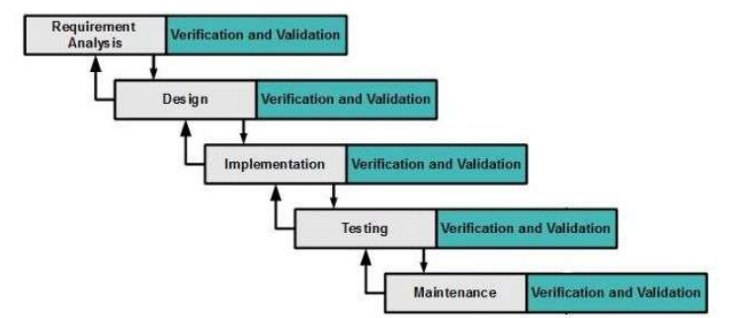

Figure 1: Sashimi Waterfall Model

For more information: <http://www.waterfall-model.com/sashimi-waterfall-model/>

The purpose of applying Sashimi Waterfall model for IMWHC is because of:

* Requirements of the project may be made clearly and difficult to change.
* In current phrase, if the error which in previous phrase or the update occur, we can return and fix it.

### Roles and responsibilities

|  |  |  |  |
| --- | --- | --- | --- |
| **No** | **Full name** | **Role in Group** | **Responsibilities** |
| **1** | Ngo Dang Ha An | Project manager | * Specify user requirement * Control the development process * Give out technique and business analysis support |
| **2** | Tran Thi Dieu Thu | Team Leader, BA, DEV, Tester | * Managing process * Designing database * Clarifying requirements * Prepare documents * GUI Design * Create test plan * Coding * Testing |
| **3** | Le Tai Nhat Minh | Team Member, BA, DEV, Tester | * Designing database * Clarifying requirements * Prepare documents * GUI Design * Create test plan * Coding * Testing |
| **4** | Nguyen Van Ngoc Truong | Team Member, BA, DEV, Tester | * Designing database * Clarifying requirements * Prepare documents * GUI Design * Create test plan * Coding * Testing |
| **5** | Vo Van | Team Member, BA, DEV, Tester | * Designing database * Clarifying requirements * Prepare documents * GUI Design * Create test plan * Coding * Testing |

Table 4: Roles and Responsibilities Details

### Tools and Techniques

* Front-end technologies: HTML5, CSS3, JavaScript, jQuery, AJAX.
* Application is built on .NET platform.
* Web Server: Microsoft IIS version 7.
* Database Management System: MS SQL Server 2008 .

## Project Management Plan

### Software development life cycle

|  |  |  |  |  |  |
| --- | --- | --- | --- | --- | --- |
| **Phase** | **Description** | **Deliverables** | **Resource needed** | **Dependencies and Constrains** | **Risks** |
| **Requirement Analysis** | - Collect requirements base on user’s behaviours  - Identify and clarify requirements for the system in general | - Introduction of project  - Software requirement specification  - Project task plan  - Prototypes | 40 man-days | N/A | - Missing requirement  - Unclear scope  - Not have a clear understanding about business process |
| **Design** | - Design system Architecture  - Design component Diagram, conceptual diagram  - Detail design | - Software design description  - Technology notes | 60 man-days | Depend on  “Requirement  Analysis” | - Lack of experience  - Not full fill requirements |
| **Implementation** | - Implement physical database  - Coding  system core  functions and  other feature  with GUI  - Unit test | - Physical database diagram  - Main user’s  functions on  website | 80 man-days | Depend on  “Design” | - Lack of experience  - Human mistake |
| **Testing** | - Write test case  - Do Integration  test the system test  - Do Alpha test  - Correct bugs  - Beta test  - Acceptance  test | - Test  document | 40 man-days | Depend on  “Implementation” | - Lack of experience  - Missing  test case |
| **Maintenance** | - Deploy on  sever | - Installation guide  - User Manual | 20 man-days | Depend on  “Testing” | - Lack of  experience |

Table 5: Software Development Life Cycle Detail

### Phase Detail

#### Phase 1: Requirement Analysis

|  |  |  |
| --- | --- | --- |
| **Task** | **Description** | **Author** |
| 1. Collect requirements | - Analysis real user’s behaviours  - Find which systems currently  provide similar service, their  strengths and weaknesses | ThuTTD, MinhLTN, TruongNVN, VanV |
| 2. Identify and clarify  main functions | - Define which main functions system  should provide | ThuTTD, MinhLTN, TruongNVN, VanV |
| 3. Create System  Introduction | - Create Introduction Report. | ThuTTD, MinhLTN, TruongNVN, VanV |
| 4. Software Project  Management Plan | - Create Project Management Plan | ThuTTD |
| 5. Prototype | - Build a prototype of propose  website | MinhLTN, VanV |
| 6. SRS | - Create SRS document | ThuTTD, MinhLTN, TruongNVN, VanV |

Table 6: Phase 1 - Requirement Analysis

#### Phase 2: Design

|  |  |  |
| --- | --- | --- |
| **Task** | **Description** | **Author** |
| 1.Design system Architecture | - Design system architecture  - Design component diagram | ThuTTD, MinhLTN, TruongNVN, VanV |
| 2. Database Design | - Based on parsed data to  recommendation  - Based on other needs to  recommendation | ThuTTD, MinhLTN, TruongNVN, VanV |
| 3.Detail design | - Design for each function | ThuTTD, MinhLTN, TruongNVN, VanV |
| 4. Technology  research | - Note some technology will be applied in project | TruongNVN |
| 5. Design Document | - Create software design document | ThuTTD, MinhLTN, TruongNVN, VanV |

Table 7: Phase 2 - Design

#### Phase 3: Implementation

|  |  |  |
| --- | --- | --- |
| **Task** | **Description** | **Author** |
| 1. Physical database | - Implement physical database | ThuTTD |
| 2. Front-end web  functions | - Implement front-end functions  on web | ThuTTD, MinhLTN, TruongNVN, VanV |
| 3. Back-end web  functions | - Implement back-end functions on  web | ThuTTD, MinhLTN, TruongNVN, VanV |
| 4. Unit testing | - Write test case and testing for  web functions | ThuTTD, MinhLTN, TruongNVN, VanV |

Table 8: Phase 3 - Implementation

#### Phase 4: Testing

|  |  |  |
| --- | --- | --- |
| **Task** | **Description** | **Author** |
| 1. Integration testing | - Write test case and testing  modules | ThuTTD, MinhLTN, TruongNVN, VanV |
| 2. System testing | - Write test case and testing  system | ThuTTD, MinhLTN, TruongNVN, VanV |
| 2. Alpha testing | - Do alpha test with customer | ThuTTD, MinhLTN, TruongNVN, VanV |

Table 9: Phase 4 - Testing

#### Phase 5: Maintenance

|  |  |  |
| --- | --- | --- |
| **Task** | **Description** | **Author** |
| 1. Installation guide | - Write installation guide | ThuTTD, MinhLTN, TruongNVN, VanV |
| 2. User manual | - Write user manual | ThuTTD, MinhLTN, TruongNVN, VanV |

Table 10: Phase 5 - Maintenance

### All Meeting Minutes

Refer to Meeting Minutes folder in CD.

## Coding Convention

Using C# language to develop website:

* Naming Convention:

+Using Camel Case for method arguments and local variables.

+Using Pascal Case for class names and method names.

* Layout Convention:

+ Write only one statement per line.

+ Write only one declaration per line.

+ If continuation lines are not indented automatically, indent them one tab stop (four spaces).

+ Add at least one blank line between method definitions and property definitions.

+ Use parentheses to make clauses in an expression apparent, as shown in the following code.

* Commenting Convention:

+ Place the comment on a separate line, not at the end of a line of code.

+ Begin comment text with an uppercase letter.

+ End comment text with a period.

+ Insert one space between the comment delimiter (//) and the comment text, as shown in the following example.

Ex: // Here is your comment.

+ Do not create formatted blocks of asterisks around comments.

* Languages Guideline:

Using C# Coding Convention from:

<https://msdn.microsoft.com/en-us/library/ff926074.aspx>

# Software Requirement Specification

## User Requirement Specification

### Guest requirement

Guest can only log in and reset password. After logging in, Guest will become a member of the system that belongs to one of following kinds of member:

* Admin
* Staff
* Head teacher
* Teacher has one or both of two roles: subject teacher as default and principal teacher as optional.
* Student.
* Student’s parent.

### Administrator requirement

Admin is the person who manages the system. Admin is super user who can use the following functions:

* Manage account.
* Mange student.
* Manage teacher.
* Configure for new school year.
* Assign teaching.
* Change account status.

### Staff requirement

Staff is the person who imports and manages schedule, manages others information. Staff can use these functions:

* Manage schedule
* Manage announcement

### Head teacher requirement

Head teacher is the leaders of school. Head teacher can:

* View teacher information
* View class information
* View student information
* View statistic and report regarding study result of student.
* View schedule of all class and teacher
* View announcement.

### Subject teacher requirement

Subject teacher is a person who is responsible for student’s grade. He/she can use these functions:

* Update grade
* View own schedule
* View announcement.

### Principal teacher requirement

Subject teacher is the person who manages students in their responsible class. Principal teacher can use these functions:

* Input day off.
* Evaluate student’s behaviour (conduct).
* View announcement.
* Choose retake subject for students in the class he/she manage.
* View and approve absence request from student’s parent.
* View statistic and report about the class he/she manages.

### Student requirement

Student can use following functions:

* View own schedule.
* View study result.
* View day off.
* View announcement.
* View individual profile

### Student’s parent requirement

Student’s parents can use student’s function and use one more function:

* Send absence request form.
* Give comment

## System Requirement Specification

### External Interface Requirement

#### User Interface

* General requirement for graphics user interface of website is the GUI should be simple, clear, intuitive, and reminiscent.
* Some design principle will be taken into consideration:
* UI for business web applications - Janko Jovanovic [Ref: Appendix 1]
* Ten principles of effective web design – Vitaly Friedman [Ref: Appendix 2]

#### Hardware Interface

* N/A

#### Software Interface

* Chromes (version 41.0.2272.118), Firefox (version 37.0.1) with resolution (1024 x 768) or bigger and must support JavaScript and HTML5.

#### Communication Protocol

* Using HTTP/HTTPS and SMTP protocol.

### System Overview Use Case

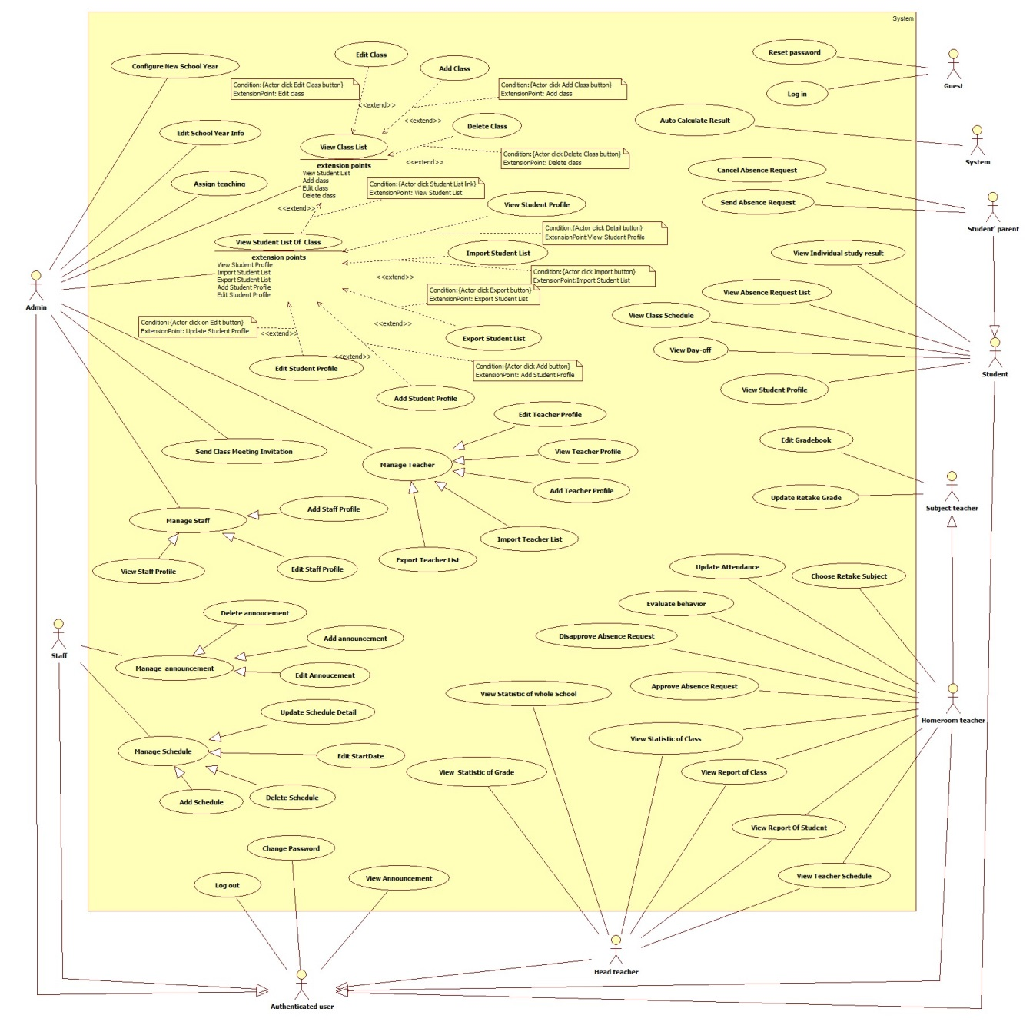

Figure 2: Overview Use Case

### List of Use Case

#### <Guest>Overview Use Case

Please refer full document in CD.

#### <Admin>Overview Use Case

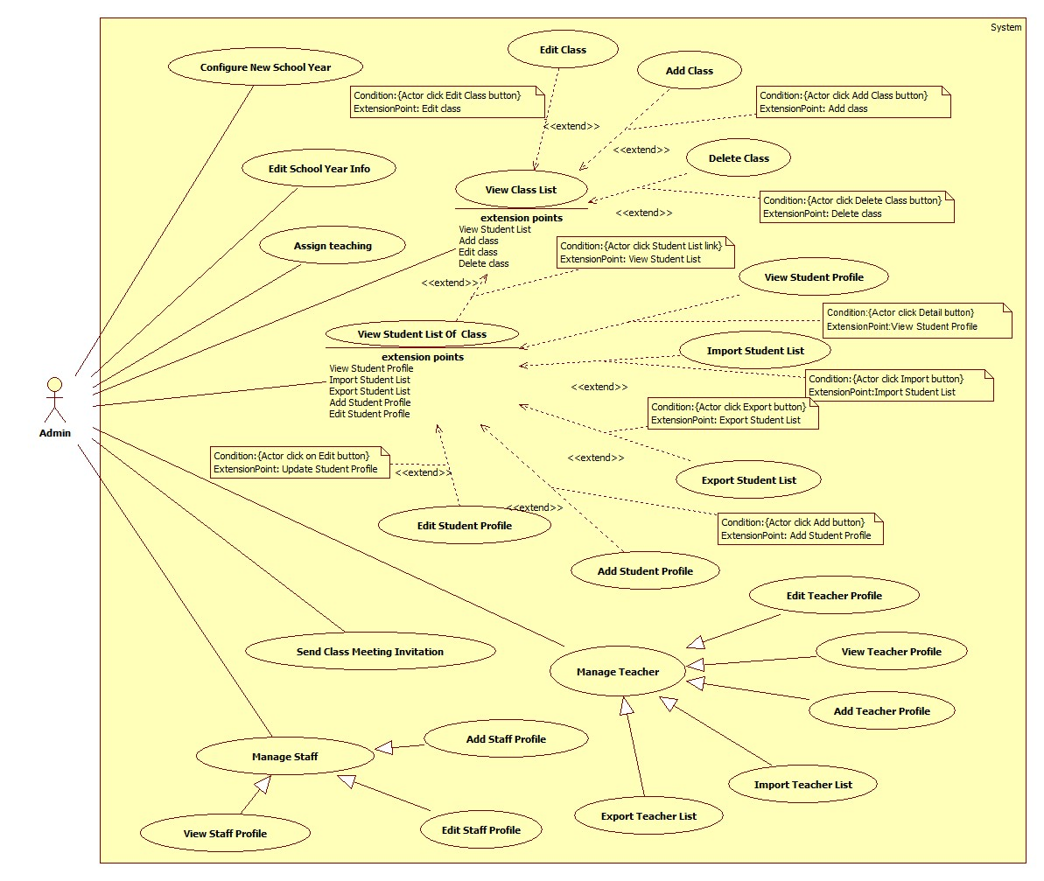

Figure 3: Admin Overview Use Case

##### <Admin>Configure New School Year

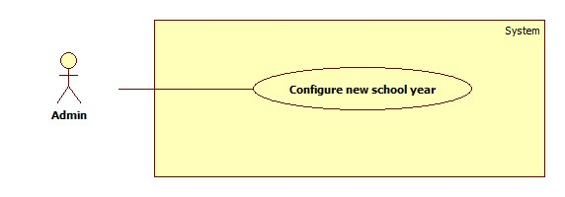

Figure 4: <Admin> Configure New School Year

|  |  |  |  |
| --- | --- | --- | --- |
| **USE CASE – UC003** | | | |
| **Use Case No.** | UC003 | **Use Case Version** | 2.0 |
| **Use Case Name** | Configure New School Year | | |
| **Author** | Le Tai Nhat Minh | | |
| **Date** | 01/06/2015 | **Priority** | High |
| **Actor:**   * Admin   **Summary:**   * This use case allows admin to add new school year and then system will be configuration a new school year.   **Goal:**   * Admin can add new school year then save data into database successfully.   **Triggers:**   * Admin clicks “Cấu hình năm học mới” link on “Hệ thống” menu of navigation. * Admin clicks “Thêm năm học” button on “Danh sách năm học” page.   **Preconditions:** Log in to the system with admin roles.  **Post Conditions:**  **Success:** All data were saved successfully and show success message.  **Fail:** System shows error message.  **Main Success Scenario:**   |  |  |  | | --- | --- | --- | | Step | Actor Action | System Response | | 1 | Teacher clicks “Cấu hình năm học mới” link | System display new page contains:  A table with 7 column:   * “STT”: text * “Năm học”: text * “Ngày bắt đầu HKI”: text * “Ngày kết thúc HKI”: text * “Ngày bắt đầu HKII”: text * “Ngày kết thúc HKII”: text * “Sửa”: button   “Thêm năm học”: button. | | 2 | Admin click “Thêm năm học” button. | System display “Thêm mới năm học” popup which contains:   * “Ghi chú”: text * “Tên năm học”: text, required * “Ngày bắt đầu HKI”: datepicker, required. * “Ngày kết thúc HKI”: datepicker, required. * “Ngày bắt đầu HKII”: datepicker, required. * “Ngày kết thúc HKII”: datepicker, required. * “Thêm”: button * “Đóng”: button | | 3 | Teacher input data and click “Thêm” button.  [Alternative 1] | System display “Đã lưu” message.  [Exception 1,2,3,4,5,6,7,8,9] |   **Alternative Scenario:**   |  |  |  | | --- | --- | --- | | No | Actor Action | System Response | | 1 | Admin clicks “Hủy” button | System closes “Thêm năm học” popup and show “Danh sách năm học” page which have no change. |   **Exceptions:**   |  |  |  | | --- | --- | --- | | No | Actor Action | System Response | | 1 | School year name is duplicate | System shows message “Tên lớp đã tồn tại”. | | 2 | Begin date of 1st semester of current school year is not later than the end date of 2nd semester of school year before. | System shows message “Ngày bắt HKI không hợp lệ”. | | 3 | Begin date of 1st semester of current school year is later 30 date than the time when admin add new school year. | System shows message “Ngày bắt đầu HKI không hợp lệ”. | | 4 | In current school year, end date of 1st semester is earlier than start date of 1st semester. | System shows message “Ngày kết thúc HKI không hợp lệ”. | | 5 | In current school year, total weeks form start date to end date of 1st semester is not more than 16 weeks. | System shows message “Thời gian của HKI tối thiểu là 16 tuần”. | | 6 | In current school year, start date of 2nd semester is earlier than end date of 1st semester. | System shows message “Ngày bắt đầu HKII không hợp lệ”. | | 7 | In current school year, end date of 2nd semester is earlier than start date of 1st semester. | System shows message “Ngày kết thúc HKII không hợp lệ”. | | 8 | In current school year, total weeks form start date to end date of 2nd semester is not more than 16 weeks. | System shows message “Thời gian của HKII tối thiểu là 16 tuần”. | | 9 | Cannot save data in to database | System shows message ““Đã có lỗi xảy ra trong hệ thống. Xin thử lại!””. |   **Relationships:** N/A  **Business Rules:**   * List is sort by descending based on school year name. * When admin add new school year successfully, all classes in grade 10, 11 in the old school year will be change to classes in grade 11, 12 at the current year keeping the old class type and homeroom teacher, new course will be create for each new class. Old data of these will not be deleted. * The role of all homeroom teachers of classes in grade 12 in old school year will be changed to Subject Teacher. * All students who of class 10, 11 in school years before and had status “Được lên lớp” will transfer to new class 11, 12. * For each student the system will create course result for every subject which he/she will study in the new school year. * All students with status “Được lên lớp” in grade 10, 11 in the last school year, their status will be changed to “Đang học”. * For each student with status “Đã ra trường” in grade 12 in the last school year, their account will be deactivated. Their parent account also is deactivated if they do not have any children who have active account. | | | |

Table 11: <Admin> Configure New School Year

##### <Admin>Edit School Year Info

Please refer full document in CD.

##### <Admin>Add Class

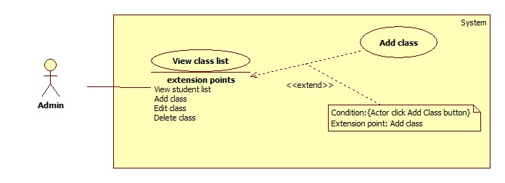

Figure 5: <Admin> Add Class

|  |  |  |  |
| --- | --- | --- | --- |
| **USE CASE –UC005** | | | |
| **Use Case No.** | UC005 | **Use Case Version** | 2.0 |
| **Use Case Name** | Add Class | | |
| **Author** | Le Tai Nhat Minh | | |
| **Date** | 01/06/2015 | **Priority** | Normal |
| **Actor:**   * Admin   **Summary:**   * This use-case allows admin to add class in to class list.   **Goal:**   * Admin can add new class and save data into database successfully   **Triggers:**   * Admin click “Thêm lớp” button on “Danh sách lớp” page.   **Preconditions:**   * User login to system with admin role.   **Post Conditions:**  **Success:** All data were saved successfully and show success message.  **Fail:** System shows error message.  **Main Success Scenario:**   |  |  |  | | --- | --- | --- | | **Step** | **Actor Action** | **System Response** | | 1 | Admin click “Thêm lớp” button on “Danh sách lớp”. | System show the pop up “Thêm mới lớp học” which contains information of:   * “Khối”: Dropdown list contain all group of class of high school, required. * “Tên lớp”: A text box which have permission for staff input, min length 2, max length 10, required. * “GVCN”: Dropdown list contain all of teacher of high school, required. * “Năm học”: A textbox, disable, required. * “Chuyên ban”: Dropdown list contain all of type of class, required. * “Tạo mới lớp học” button for staffs confirm add new class. * “Đóng” button for staff cancels process. | | 2 | Staff input all of data and click “Thêm” button.  [Alternative 1] | System closes “Thêm mới lớp học” popup and show “Danh sách lớp” page which have new data in list and then, system show a successful message.  [Exception 1,2,3,4,5] |   **Alternative Scenario:**   |  |  |  | | --- | --- | --- | | **No** | **Actor Action** | **System Response** | | 1 | Staff click “Hủy” button. | System closes “Thêm mới lớp học” popup and show “Danh sách lớp” page which have no change. |     **Exceptions:**   |  |  |  | | --- | --- | --- | | No | Actor Action | System Response | | 1 | Name of class is contains special prefix character like 10, 11 and 12. | System shows error message “Tên lớp không hợp lệ”. | | 2 | Name of class had already existed. | System shows error message “Tên lớp đã tồn tại”. | | 3 | Name of class over range. | System shows error message “Tên lớp quá dài”. | | 4 | Name of class is empty. | System shows error message “Tên lớp không được để trống”. | | 5 | Cannot save data into database | System shows message “Đã có lỗi xảy ra trong hệ thống. Xin thử lại!”. |   **Relationships:** Extend for View Class List (Add Class)  **Business Rules:**   * There are 3 grades: 10, 11, 12, the lowest grade is 10, the highest grade is 12. * The class which have added by admin must be the only one, class name is not duplicate with anyone else in the same grade in current school yearThe homeroom teacher of new class is the teacher who had roles is homeroom teacher and he/she haven’t manages any other class at current school year, that means a homeroom teacher can manage one and only one class. * While the new class had been create, new course will be created. * The teacher, who was chose for new class, will be update status to homeroom teacher. | | | |

Table 12: <Admin>Add Class

##### <Admin>Edit Class

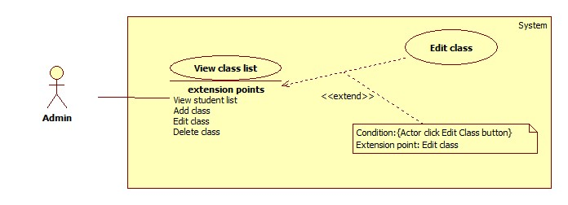

Figure 6: <Admin> Edit Class

|  |  |  |  |
| --- | --- | --- | --- |
| **USE CASE –UC006** | | | |
| **Use Case No.** | UC006 | **Use Case Version** | 2.0 |
| **Use Case Name** | Edit Class | | |
| **Author** | Le Tai Nhat Minh | | |
| **Date** | 01/06/2015 | **Priority** | Normal |
| **Actor:**   * Admin   **Summary:**   * This use-case allows admin to update class information.   **Goal:**   * Admin can update class information and save data into database successfully   **Triggers:**   * Admin click “Sửa” button on any row on “Danh sách lớp” page.   **Preconditions**:   * User login to system with admin role.   **Post Conditions:**  **Success**: All data were saved successfully and show success message.  **Fail**: System shows error message.    **Main Success Scenario:**   |  |  |  | | --- | --- | --- | | Step | Actor Action | System Response | | 1 | Admin click “Sửa” button on any row on “Danh sách lớp” page. | System show the pop up “Cập nhật thông tin lớp học” which contains information of:   * “Khối”: Dropdown list, disabled. * “Tên lớp”: A text box, min length 2, max length 10, required. * “GVCN”: Dropdown list contain all of teacher of high school, required. * “Năm học”: textbox, disable. * “Chuyên ban”: Dropdown list, disabled. * “Cập nhật” button * “Đóng” button | | 2 | Staff input all of data and click “Cập nhật” button.  [Alternative 1] | System closes “Cập nhật thông tin lớp học” popup and show “Danh sách lớp” page which have modified data in list and then, system show a successful message.  [Exception 1,2,3,4,5] |   **Alternative Scenario:**   |  |  |  | | --- | --- | --- | | No | Actor Action | System Response | | 1 | Staff click “Hủy” button. | System closes “Cập nhật thông tin lớp học” popup and show “Danh sách lớp” page which have no change. |   **Exceptions:**   |  |  |  | | --- | --- | --- | | No | Actor Action | System Response | | 1 | Name of class is contains special prefix character like 10, 11 and 12. | System shows error message “Tên lớp không hợp lệ”. | | 2 | Name of class had already existed. | System shows error message “Tên lớp đã tồn tại”. | | 3 | Name of class over range. | System shows error message “Tên lớp quá dài”. | | 4 | Name of class had only one character. | System shows error message “Tên lớp quá ngắn”. | | 5 | Cannot save data into database | System shows message “Đã có lỗi xảy ra trong hệ thống. Xin thử lại!” |   **Relationships**: Extend for View Class List (Edit Class)  **Business Rules:**   * Admin can only changes name of class or homeroom teacher of class. * The homeroom teacher of class is the teacher who had roles is homeroom teacher and he/she haven’t manages any other class at current school year, that means a homeroom teacher can manage one and only one class. * The teacher, who was chosen for new class, will be update status to homeroom teacher. | | | |

Table 13: <Admin>Edit Class

##### <Admin>Delete Class

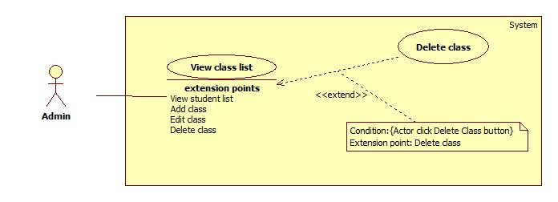

Figure 7: <Admin>Delete Class

|  |  |  |  |
| --- | --- | --- | --- |
| **USE CASE –UC007** | | | |
| **Use Case No.** | UC007 | **Use Case Version** | 2.0 |
| **Use Case Name** | Delete Class | | |
| **Author** | Le Tai Nhat Minh | | |
| **Date** | 01/06/2015 | **Priority** | Normal |
| **Actor:**   * Admin   **Summary:**   * This use-case allows admin to delete class information.   **Goal:**   * Admin can delete class information.   **Triggers:**   * Admin click “Xóa” button on any row on “Danh sách lớp” page.   **Preconditions:**   * User login to system with admin role.   **Post Conditions:**  **Success:** All data were deleted successfully and show success message.  **Fail:** System shows error message.    **Main Success Scenario:**   |  |  |  | | --- | --- | --- | | Step | Actor Action | System Response | | 1 | Admin clicks “Xóa” button on any row on “Danh sách lớp” page. | System show the pop up “Thêm lớp” which contains:  “Bạn có chắc muốn xóa lớp (*) chứ?”  + (*) is a class name: label.  “Xóa” button for admin confirm add new class.  “Đóng” button for admin cancels process. | | 2 | Admin input all of data and click “Xóa” button.  [Alternative 1] | System closes “Xóa lớp học” popup and show “Danh sách lớp” page which don’t have deleted data in list and then, system show a successful message.  [Exception 1] |   **Alternative Scenario:**   |  |  |  | | --- | --- | --- | | No | Actor Action | System Response | | 1 | Staff click “Hủy” button. | System closes “Xóa lớp học” popup and show “Danh sách lớp” page which have no change. |   **Exceptions:**   |  |  |  | | --- | --- | --- | | No | Actor Action | System Response | | 1 | Cannot delete data from database | System shows message ““Đã có lỗi xảy ra trong hệ thống. Xin thử lại!””. |   **Relationships:** Extend for View Class List (Delete Class)  **Business Rules:**   * The class which had chosen to delete must have no student in it. | | | |

Table 14: <Admin>Delete Class

##### <Admin>Add Student Profile

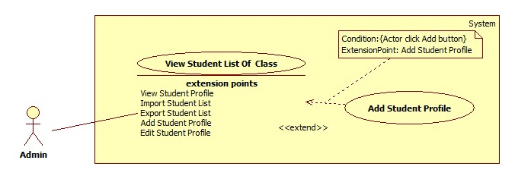

Figure 8: <Admin>Add Student Profile

|  |  |  |  |
| --- | --- | --- | --- |
| **USE CASE –UC008** | | | |
| **Use Case No.** | UC008 | **Use Case Version** | 2.0 |
| **Use Case Name** | Add Student Profile | | |
| **Author** | VÕ VĂN | | |
| **Date** | 01/06/2015 | **Priority** | High |
| **Actor:**   * Admin   **Summary:**   * Allow Admin to add student profile   **Goal:**   * Admin can add student profile successfully   **Triggers:**   * Admin click “Thêm học sinh” button on “Danh sách học sinh” page   **Preconditions:**   * Admin must login into the system with role “Admin”   **Post Conditions:**  **Success:** Student profile will be added to database then show success message  **Fail:** Show error message  **Main Success Scenario:**   |  |  |  | | --- | --- | --- | | Step | Actor Action | System Response | | 1 | On “Danh sách học sinh” page, Admin click “Thêm học sinh” button  [Alternative 1, 2] | Student profile view detail pop-up panel float on the screen, first tab “NỘI DUNG HỌC SINH” will be shown and display a form contain as following:  “Họ & Tên”: textbox, length 5 – 50, required.  “Ngày nhập học”: datepicker  “Email Học Sinh”: textbox, lengh 6 – 20, required.  “Giới tính”:   * “Nam” : radioButton * “Nữ” : radioButton   “Tôn giáo”: drop-down list  “Điện thoại”: textbox, lengh 9 – 11.  “Ngày Sinh”: datepicker  “Tôn giáo”: drop-down list  “Tài khoản phụ huynh (Nếu có)”: textbox, lengh 5 – 20.  “Email phụ huynh”: textbox, lengh 6 – 20, required.  “Địa chỉ”: textbox, lengh 20 – 200, required.  “Đóng”: button | | 2 | Fill in input then Click “Tạo học sinh mới” button | Student profile is added to database  Show success message  Student profile adding pop-up panel float out of the screen  [Exception  1,2,3,4,5,6,7,8,9,10,11,12,13,14,15,16] |   **Alternative Scenario:**   |  |  |  | | --- | --- | --- | | No | Actor Action | System Response | | 1 | Admin click tab “THÔNG TIN GIA ĐÌNH”  [Alternative 2] | Show family detail of student display a form contain as following:  “Tên cha”: textbox, lengh 5 – 20.  “Năm sinh cha”: drop-down list  “Nghề nghiệp cha”: textbox, lengh 5 – 20.  “Tên mẹ”: textbox, lengh 5 – 20.  “Năm sinh mẹ”: drop-down list.  “Nghề nghiệp mẹ”: textbox, lengh 5 – 20.  “Tên người đỡ đầu”: textbox, lengh 5 – 20.  “Năm sinh người đỡ đầu”: drop-down list.  “Nghề nghiệp người đỡ đầu”: textbox, lengh 5 – 20.  “Đóng”: button  [Exception 1] | | 2 | Admin click “Đóng” button | Student profile adding pop-up panel float out of the screen |   **Exceptions:**   |  |  |  | | --- | --- | --- | | No | Actor Action | System Response | | 1 | Admin provide invalid email input “Email học sinh”, “Email phụ huynh” | Show validation message below textbox “ Email không hợp lệ” | | 2 | “Email phụ huynh” input equal “Email học sinh” input | Show validation message below textbox “Email phụ huynh không được trùng với email học sinh” | | 3 | “Điện thoại” input contain less than 9 numbers or more than 11 | Show validation message below textbox “Số điện thoại phải từ 9 - 11” | | 4 | Admin’s input on “Account Phụ Huynh” is invalid | Show validation message below textbox “Sai Account phụ huynh” | | 5 | Admin’s input on “Email Phụ Huynh” is invalid or not contain in database when “Account Phụ Huynh” nếu có input is filled | Show validation message below textbox “Sai Email phụ huynh” | | 6 | “Họ & Tên”, “Tên mẹ”, “Tên cha”, “Tên người đỡ đầu” input are less than 5 characters and more than 50 characters | Show validation message below textbox “Họ & Tên không được dưới 5 và quá 50 ký tự” | | 7 | “Nghề nghiệp mẹ”, “Nghề nghiệp cha”, “Nghề nghiệp người đỡ đầu”, “Email học sinh”, “Email phụ huynh” are more than 50 characters | Show validation message below textbox “Nội dung không được quá 50 ký tự” | | 8 | “Địa chỉ” input are more than 200 characters | Show validation message below textbox “Dữ liệu không được quá 200 ký tự” | | 9 | Input information cannot be saved in the database | Show validation message below textbox “Có lỗi xãy ra trong hệ thống” | | 10 | “Họ & Tên” field is blank | Show validation message below textbox “Họ & Tên không được để trống” | | 11 | “Email học sinh” field is blank | Show validation message below textbox “Email học sinh không được để trống” | | 12 | “Email phụ huynh” field is blank | Show validation message below textbox “Email phụ huynh không được để trống” | | 13 | “Địa chỉ” field is blank | Show validation message below textbox “Địa chỉ không được để trống” | | 14 | “Ngày nhập học” field is blank | Show validation message below textbox “Ngày nhập học không được để trống” | | 15 | “Ngày sinh” field is blank | Show validation message below textbox “Ngày sinh không được để trống” | | 16 | Can’t access database | Show validation message below textbox “Có lỗi xãy ra trong hệ thống, xin hãy thử lại” |   **Relationships:** extend for View Student List Of Class(Add Student Profile) **Business Rules:**   * Date format is dd/MM/yyyy * “Ngày Sinh” input cannot be larger than now date and lesser than now date 14 years * “Ngày nhập học” input are limited on the semester year range * “ Email Phụ Huynh” cannot be the same as “Email Học Sinh” * When Admin Click “Tạo học sinh mới” button, the system will create an account with role “Học sinh” using the input “Họ & Tên” as username and generate random 8 characters password eg: Nguyễn Văn A will be convert to **nguyenvana** as username, password : PZpt8Jhp. Then the system will send an email to the student based on “Email học sinh” input to inform their information about the account * If parent does not have account before, system will create another account for Student’s Parent with the same method except username will add an extra string line “_ph”and generate another random 8 characters password eg: nguyenvana_ph as username, password : xWYefaVY. Then the system will send an email to the student Parent email based on “Email Phụ huynh” input to inform their information about the account * If both “Account Phụ Huynh” and “Email Phụ Huynh” textbox are filled and the filled information contained in database, the new created student will have the same parent who has account as the filled input in “Account Phụ Huynh”. | | | |

Table 15: <Admin>Add Student Profile

##### <Admin>Edit Student Profile

Please refer full document in CD.

##### <Admin>Import Student List

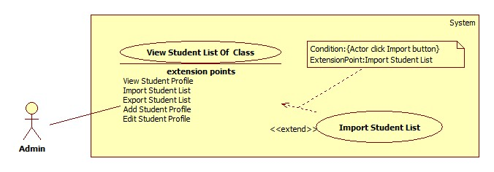

Figure 9: <Admin>Import Student List

|  |  |  |  |
| --- | --- | --- | --- |
| **USE CASE –UC010** | | | |
| **Use Case No.** | UC010 | **Use Case Version** | 2.0 |
| **Use Case Name** | Import Student List | | |
| **Author** | ThuTTD | | |
| **Date** | 01/06/2015 | **Priority** | High |
| **Actor:**   * Admin   **Summary:**   * This use case allows Admin to import a list of student of a class from excel file to system.   **Goal:**   * Admin can add list of student and create accounts for them.   **Triggers:**   * Admin clicks “Nhập excel” button on “Danh sách học sinh” page.   **Preconditions:**   * User has login as Admin role.   **Post Conditions:**  **Success:** Create list of account of student successfully and redirect to list student page of the class which students are imported. In addition, send an email to each account in order to notify about user name and password to log into the system.  **Fail:** Show error message.  **Main Success Scenario:**   |  |  |  | | --- | --- | --- | | Step | Actor Action | System Response | | 1 | Admin clicks “Nhập excel” button. | System display import page contains:  “Chọn file”: choose file button  “Tải file mẫu”: button  “Nhập”: button | | 2 | Admin chooses the file and clicks “Nhập excel” button. [Alternative 1] | Read file and show a table on page. Table contains:   * “STT”: text * “Họ tên”: text * “Tên tài khoản”: text * “Ngày sinh”:text * “Giới tính” : text * “Chi tiết lỗi”: text * Checkbox   [Exception 1, 2, 3,4] | | 3 | Admin checks on checkbox to save students. | Show success pop-up “Đã lưu”  [Exception 5] |   **Alternative Scenario:**  N/A  **Exceptions**:   |  |  |  | | --- | --- | --- | | No | Actor Action | System Response | | 1 | Admin click “Nhập excel” | The format excel is not correct.  Show the error messages “File không đúng định dạng. Xin vui lòng nhập thông tin theo file mẫu và thử lại”. | | 2 | Admin click “Nhập excel” | Imported file is not an excel file.  Show the error message: “File vừa chọn không phải là file excel!” | | 3 | Admin does not choose file and click “Nhập excel” | Show the error message: “Bạn chưa chọn file!” | | 4 | Admin click “Nhập excel” | Imported data is not valid.  Show error table that including error detail of each row. | | 4 | Cannot save data in database | Show error message “Đã có lỗi xảy ra trong hệ thống. Xin thử lại!” |   **Relationships:** Extend for View Student List (Import Student List)  **Business Rules:**   * Excel file should be more than 2003 version and has .xls extension. * Rule to create an account is same with “Add Student Profile” function. * Validate imported data same as “Add student profile” use case. * The system saves data into database if and only if all data was valid. * Format of plan semester excel file should be: | | | |

Table 16: <Admin>Import Student List

##### <Admin>Export Student List

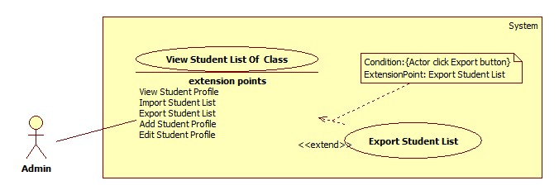

Figure 10: <Admin>Export Student List

|  |  |  |  |
| --- | --- | --- | --- |
| **USE CASE –UC011** | | | |
| **Use Case No.** | UC011 | **Use Case Version** | 2.0 |
| **Use Case Name** | Export Student List | | |
| **Author** | ThuTTD | | |
| **Date** | 01/06/2015 | **Priority** | Normal |
| **Actor:**   * Admin   **Summary:**   * This use case allows admin to export list of student of a class to excel file.   **Goal:**   * Admin can export list of student to excel file with formatted font and comprehensive presentation.   **Triggers:**   * Admin clicks “Xuất excel” button at “Danh sách học sinh” page of one class.   **Preconditions:**   * User log in as admin.   **Post Conditions:**  **Success:** Excel file was created and downloaded from browser automatically.  **Fail:** Show error message.  **Main Success Scenario:**   |  |  |  | | --- | --- | --- | | Step | Actor Action | System Response | | 1 | Admin clicks “Xuất excel” button at “Danh sách học sinh” page. | System creates excel file and sends it to browser.  [Exception 1] |   **Alternative Scenario:**N/A  **Exceptions:**   |  |  |  | | --- | --- | --- | | No | Actor Action | System Response | | 1 | Admin clicks “Xuất excel” button at “Danh sách học sinh” page. | Error occurs in the system.  System shows message “Đã có lỗi xảy ra trong hệ thống, xin thử lại!” |   **Relationships:** Extend for View Student List (Export Student List)  **Business Rules:**  Data in file is a list of all students of one class who have active account.  Default file name is “Danh sách học sinh lớp [class name]”  Default file type is “.xls”  Format of excel file should be: | | | |

Table 17: <Admin>Export Student List

##### <Admin>Add Teacher Profile

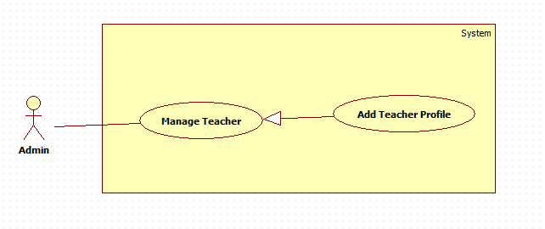

Figure 11: <Admin>Add Teacher Profile

|  |  |  |  |
| --- | --- | --- | --- |
| **USE CASE – UC012** | | | |
| **Use Case No.** | UC012 | **Use Case Version** | 2.0 |
| **Use Case Name** | Add Teacher Profile | | |
| **Author** | Nguyễn Văn Ngọc Trường | | |
| **Date** | 02/06/2015 | **Priority** | High |
| **Actor:**   * Admin   **Summary:**   * This use case allows admin to add new teacher.   **Goal:**   * Admin can add new teacher and save data into database successfully.   **Triggers:**   * Admin clicks “Thêm mới” button on “Hồ sơ giáo viên” page.   **Preconditions:**   * People must have an account to log in the system with roles admin account.   **Post Conditions:**  **Success:** All data will be saving successfully and show success message.  **Fail:** System shows error message.  **Main Success Scenario:**   |  |  |  | | --- | --- | --- | | Step | Actor Action | System Response | | 1 | Admin clicks “Thêm mới” button. | System display new pop up contains:  “Họ và tên”: textbox, required, min length 5, max length 50  “Ngày sinh”: date picker, required dd/MM/yyyy format.  “Giới tính”: required  +Nam: radio button  +Nữ: radio button  “Môn dạy”: drop down list, required  “Địa chỉ”: text box, required  “CMND”: text box, required, min length 9, max length 9  “Nơi cấp”: textbox, required, max length 250  “Ngày cấp”: date picker, required dd/MM/yyyy format.  “Dân tộc”: drop down list, required  “Tôn giáo”: drop down list, required  “Email”: text box, required email format, max length 50  “Điện thoại”: text box , min length 9, max length 11  “Thêm”: button  “Đóng”: button | | 2 | Admin click “Lưu” button to confirm adding.  [Alternative 1] | System will display a pop-up message “Đã lưu” then close popup page, the new inputted teacher information should be added to database and displayed on the table of “Hồ sơ giáo viên” page.At the same time, the system will send a username and password by email which was registered in system.  [Exception 1,2,3,4,5,6,7,8,9,10,11,12,13,14] |   **Alternative Scenario:**   |  |  |  | | --- | --- | --- | | No | Actor Action | System Response | | 1 | Admin click “Đóng” button to cancel adding. | System close “Thêm mới giáo viên” popup page and show again “Hồ sơ giáo viên” page. |   **Exceptions:**   |  |  |  | | --- | --- | --- | | No | Actor Action | System Response | | 1 | “Họ và tên” is blank. | System shows message “*Họ và tên không được để trống”. | | 2 | “Email” is blank. | System shows message “*Email không được để trống”. | | 3 | “Địa chỉ” is blank. | System shows message “*Địa chỉ không được để trống”. | | 4 | “CMND” is bank. | System shows message “*Số chứng minh nhân dân không được để trống”. | | 5 | “Nơi cấp” is blank. | System shows message “*Nơi cấp không được để trống”. | | 6 | Admin inputs length of “Họ và tên” over range. | System shows message “*Họ và tên từ 5 đến 50 ký tự”. | | 7 | Admin inputs length of “Email” over range. | System shows message “*Email không quá 50 ký tự”. | | 8 | Admin inputs length of “Địa chỉ” over range. | System shows message “*Địa chỉ không được quá 250 kí tự”. | | 9 | Admin inputs length of “CMND” over range. | System shows message “*Số chứng minh nhân dân có 9 ký tự”. | | 10 | Admin inputs length of “Nơi cấp” over range. | System shows message “*Nơi cấp không quá 250 ký tự”. | | 11 | Admin inputs which is wrong format of email “<input>@<input>.<input>”. | System shows message “*Email sai định dạng”. | | 12 | Admin inputs length of “Điện thoại” over range. | System shows message “*Số điện thoại là chuỗi số từ 9 đến 11”. | | 13 | Admin inputs characters in “Điện thoại”. | System shows message “*Số điện thoại là chuỗi số từ 9 đến 11”. | | 14 | Cannot save data into database | System shows message “Đã có lỗi xảy ra trong hệ thống. Xin thử lại!”. |   **Relationships:** N/A  **Business Rules:**   * When admin add new teacher into system, each teacher is only responsible for one subject. * Age number of teacher is from 22 year old. * Teacher’s date of birth must be smaller than teacher’s date of issue. * Date of issue must be from 14 years old (it calculated from date of birth). * System auto creates new username with first name and first letters of last name and middle name. * System auto creates random password with eight characters (include letters and numbers). * Each row is displayed one teacher’s information and this information’s error displayed next to this row. | | | |

Table 18: <Admin>Add teacher Profile

##### <Admin>Edit Teacher Profile

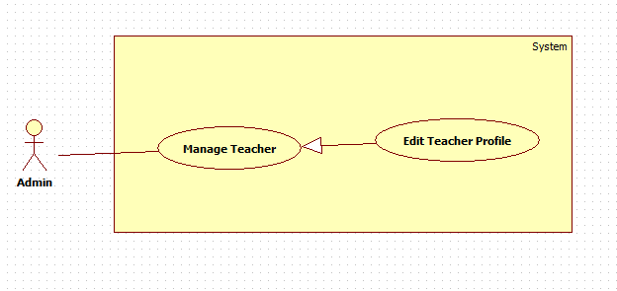

Figure 12: <Admin>Edit Teacher Profile

|  |  |  |  |
| --- | --- | --- | --- |
| **USE CASE – UC013** | | | |
| **Use Case No.** | UC013 | **Use Case Version** | 2.0 |
| **Use Case Name** | Edit Teacher Profile | | |
| **Author** | Nguyễn Văn Ngọc Trường | | |
| **Date** | 02/06/2015 | **Priority** | Normal |
| **Actor:**   * Admin   **Summary:**   * This use case allows admin to edit teacher profile   **Goal:**   * Admin can update new profile teacher and save data into database successfully.   **Triggers:**   * Admin clicks “Sửa” button on “Hồ sơ giáo viên” page.   **Preconditions:**   * People must have an account to log in the system with role admin account. * Teacher accounts existed in the system.   **Post Conditions:**  **Success:** All data will be saving successfully and show success message.  **Fail:** System shows error message.  **Main Success Scenario:**   |  |  |  | | --- | --- | --- | | Step | Actor Action | System Response | | 1 | Admin click “Sửa” button to confirm update. | System display new pop up contains:  “Họ và tên”: textbox, required, in length 5, max length 50  “Ngày sinh”: date picker, required dd/MM/yyyy format  “Giới tính”: required  + Nam:radio button  + Nữ: radio button  “Môn dạy”: drop down list, required  “Địa chỉ”: text box, required  “CMND”: text box, required, min length 9, max length 9  “Nơi cấp”: text box, required, max length 250  “Ngày cấp”: date picker, required dd/MM/yyyy format  “Dân tộc”: drop down list, required  “Tôn giáo”: drop down list, required  “Email”: text box, required email format, max length 50  “Điện thoại”: text box, min length 9, max length 11  “Lưu”: button  “Đóng”: button | | 2 | Admin inputs data and click “Lưu” button to confirm update.  [Alternative 1] | System will display a pop-up message “Đã lưu” then close popup page, the new inputted teacher information should be added to database and displayed on the table of “Hồ sơ giáo viên” page.  [Exception 1,2,3,4,5,6,7,8,9,10,11,12,13,14] |   Alternative Scenario:   |  |  |  | | --- | --- | --- | | No | Actor Action | System Response | | 1 | Admin click “Đóng” button to cancel update. | System closes “Cập nhật thay đổi” popup page and shows again “Hồ sơ giáo viên” page. |   **Exceptions:** Reference Exception “Add Teacher Profile”  **Relationships:** N/A  **Business Rules:**   * When admin add new teacher into system, each teacher is only responsible for one subject. * Age number of teacher is from 22 year old. * Teacher’s date of birth is smaller than teacher’s date of issue. * Date of issue is from 14 years old (it calculated from date of birth). * Admin does not edit username and password in this page. * Each row is displayed one teacher’s information and this information’s error displayed next to this row. | | | |

Table 19: <Admin>Edit Teacher Profile

##### <Admin>Import Teacher List

Please refer full document in CD.

##### <Admin>Export Teacher List

Please refer full document in CD.

##### <Admin>Add Staff Profile

Please refer full document in CD.

##### <Admin>Edit Staff Profile

Please refer full document in CD.

##### <Admin>Send Class Meeting Invitation

Please refer full document in CD.

##### <Admin>Assign Teaching

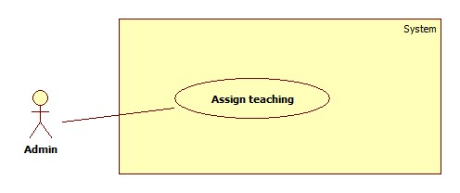

Figure 13: <Admin>Assign Teaching

|  |  |  |  |
| --- | --- | --- | --- |
| **USE CASE –UC019** | | | |
| **Use Case No.** | UC019 | **Use Case Version** | 2.0 |
| **Use Case Name** | Assign Teaching | | |
| **Author** | ThuTTD | | |
| **Date** | 01/06/2015 | **Priority** | High |
| **Actor:**   * Admin   **Summary:**   * This use case allows admin to assign teacher for each course.   **Goal:**   * Admin can assign teacher successfully.   **Triggers:**   * Admin click “Phân công giảng dạy” on “Giáo viên” menu   **Preconditions:**   * User log in to the system with admin role.   **Post Conditions:**  **Success:** Save data in database and show success message.  **Fail:** Show error message.  **Main Success Scenario:**   |  |  |  | | --- | --- | --- | | Step | Actor Action | System Response | | 1 | Admin click “Phân công giảng dạy” on “Giáo viên” menu | System shows “Phân công giảng dạy” page , which contains a tree menu of class on the left side.  On the right side:  “Học kỳ 1”: radio button  “Học kỳ 2”: radio button  A 3-column-table on right side which contains:  + “STT”: text  +”Môn học”: text  +”Cách đánh giá”: text  +”Hệ số”: text  +”Giáo viên”: dropdown list  If it is the second semester page, add “Sao chép HK1”: button  “Lưu” button | | 2 | Admin select dropdown list value and click “Lưu”[Alternative 1] | System shows “Đã lưu” message. [Exception 1] |   **Alternative Scenario:**   |  |  |  | | --- | --- | --- | | No | Actor Action | System Response | | 1 | Admin click on “Sao chép HK1” button | The page of the second semester will load all teacher same as the first semester. |   **Exceptions:**   |  |  |  | | --- | --- | --- | | No | Actor Action | System Response | | 1 | Error occurs in the system. | Show error message “Đã có lỗi xảy ra trong hệ thống, xin vui lòng thử lại!” |   **Relationships:**  **Business Rules:**   * Admin can assign teaching for others class by click on class tree menu. * List of subjects in table depends on class. * In the first time does this function, the system will show the page of first class in grade 10. - And base on real time, there are 3 case: * Case 1: From created new school year date to the end date of 1st semester, the system will show the page of the first semester and teacher can edit on this page. * Case 2: From the date after the end date of the 1st semester to the end date of the 2nd semester, the system will show the page of 1st semester and teacher can edit on this page. * Case 3: From the date after the end date of the 2nd semester to the date create new school year: the system will show the page of 1st semester and teacher cannot edit anything. | | | |

Table 20: <Admin> Assign Teaching

##### <Admin>Change Account Status

Please refer full document in CD.

#### <Staff>Overview Use Case

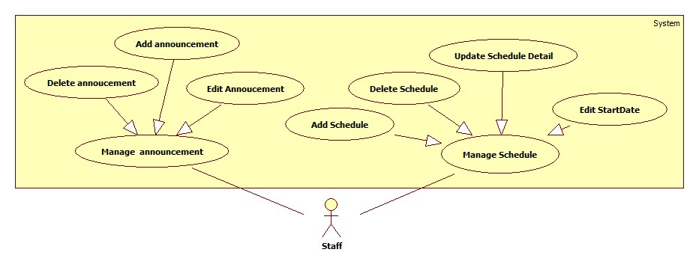

Figure 14: Staff Overview Use Case

##### <Staff>Add announcement



Figure 15: <Staff>Add Announcement

|  |  |  |  |
| --- | --- | --- | --- |
| **USE CASE –UC021** | | | |
| **Use Case No.** | UC021 | **Use Case Version** | 2.0 |
| **Use Case Name** | Add Announcement | | |
| **Author** | VÕ VĂN | | |
| **Date** | 01/06/2015 | **Priority** | Normal |
| **Actor:** Staff  **Summary:**   * Allow Staff to add announcement   **Goal:**   * Staff can add announcement. New announcement is added to database   **Triggers:**   * Staff click “Thêm thông báo” button   **Preconditions:**   * Staff must login into the system with role “Giáo vụ”   **Post Conditions:**  **Success:** New announcement will be added to database then show success message  **Fail:** Show error message  **Main Success Scenario:**   |  |  |  | | --- | --- | --- | | Step | Actor Action | System Response | | 1 | From “Danh sách thông báo” page, Staff Click “Thêm thông báo” button  [Alternative 1] | Announcement adding pop-up panel float on the screen and display a form contains:  “Tiêu đề”: textbox (required)  “Thông báo nội bộ”: checkbox  “Nội Dung”: textarea (required)  “Tạo thông báo mới” button  “Thoát”: button  [Exception 4] | | 3 | Fill in input then Staff Click “Tạo thông báo mới” button | Announcement is added to database  Show success message  Announcement adding pop-up panel float out of the screen  [Exception 1, 2,3,4] |   **Alternative Scenario:**   |  |  |  | | --- | --- | --- | | No | Actor Action | System Response | | 1 | Staff click “Đóng” button | Announcement adding pop-up panel float out of the screen |   **Exceptions:**   |  |  |  | | --- | --- | --- | | No | Actor Action | System Response | | 1 | “Tiêu đề” field is blank | Show validation message beside textbox “Tiêu đề không được để trống” | | 2 | “Nội dung” field is blank | Show validation message beside textbox “Nội dung không được để trống” | | 3 | “Nội dung” field contain more than 5000 characters | Show validation message beside textbox “Nội dung không được quá 5000 từ” | | 4 | Can’t access database | Show validation message below textbox “Có lỗi xãy ra trong hệ thống, xin hãy thử lại” |   **Relationships:** N/A **Business Rules:**  - When checkbox “Thông báo nội bộ” is checked, student and student’s parent can’t see the added announcement | | | |

Table 21: <Staff>Add Announcement

##### <Staff>Edit annoucement

Please refer full document in CD.

##### <Staff>Delete Announcement

Please refer full document in CD.

##### <Staff>Add Schedule



Figure 16: <Staff>Add Schedule

|  |  |  |  |
| --- | --- | --- | --- |
| **USE CASE – UC024** | | | |
| **Use Case No.** | UC024 | **Use Case Version** | 2.0 |
| **Use Case Name** | Add Schedule | | |
| **Author** | Nguyễn Văn Ngọc Trường | | |
| **Date** | 02/06/2015 | **Priority** | High |
| **Actor:**   * Staff   **Summary:**   * This use case allows Staff to add new schedule for applying in the future.   **Goal:**   * Staff can add new schedule and save data into database successfully.   **Triggers:**   * Staff clicks “Thêm mới” button on “Thời khóa biểu” page.   **Preconditions:**   * People must have an account to log in the system with role Staff. * Semester school year must be available in the system.   **Post Conditions:**  **Success:** All data will be saving and show message successfully.  **Fail:** System shows error message.  **Main Success Scenario:**   |  |  |  | | --- | --- | --- | | Step | Actor Action | System Response | | 1 | Staff clicks “Thêm mới” button. | System display new pop up contains:  “Năm học”: textbox, required, disabled  “Học kỳ”: radio button, required  “Ngày bắt đầu”: date picker, required, format dd/MM/yyyy.  “Sao chép TKB hiện tại”: check box, required  “Thêm mới”: button.  “Đóng”: button | | 2 | Staff clicks “Học kỳ” radio button and choose “Ngày bắt đầu” of date picker. | System will check “Ngày bắt đầu” and the system should be not disabled “Thêm lịch mới” button.  [Exception 1,2] | | 3 | Staff clicks check or uncheck “Sao chép TKB hiện tại“check box and clicks “Thêm mới”.  [Alternative 1] | System will save data which Staff inputted, system close “Thêm mới thời khóa biểu” popup page and show again “Thời khóa biểu” page.  [Exception 3] |   **Alternative Scenario:**   |  |  |  | | --- | --- | --- | | **No** | **Actor Action** | **System Response** | | 1 | Staff clicks “Đóng” button to cancel adding. | System close “Thêm mới thời khóa biểu” popup page and show again “Thời khóa biểu” page. |   **Exceptions:**   |  |  |  | | --- | --- | --- | | No | Actor Action | System Response | | 1 | Staff chooses time that is smaller than schedule in the present. | System shows message “TKB đã qua!”. | | 2 | Staff choice time is not in range of semester in school year. | System shows message “Bạn đã chọn ngày không nằm trong học kỳ!”. | | 3 | Cannot save data into database | System shows message ““Đã có lỗi xảy ra trong hệ thống. Xin thử lại!””. |   **Relationships:** N/A  **Business Rules:**   * In default of “Thêm mới lịch” button is disable. * “Thêm mới lịch” button is not disable when system check successfully for input date picker. * “Thêm mới thời khóa biểu” popup page only show two semesters that had been apply in the present. * Staff can add new schedule in future but Staff cannot add new schedule in the present or in the past. | | | |

Table 22: <Staff> Add Schedule

##### <Staff>Edit Start Date

Please refer full document in CD.

##### <Staff>Delete Schedule

Please refer full document in CD.

##### <Staff>Update Schedule Detail



Figure 17: <Staff> Update Schedule Detail

|  |  |  |  |
| --- | --- | --- | --- |
| **USE CASE – UC027** | | | |
| **Use Case No.** | UC027 | **Use Case Version** | 2.0 |
| **Use Case Name** | Update Schedule Detail | | |
| **Author** | Nguyễn Văn Ngọc Trường | | |
| **Date** | 02/06/2015 | **Priority** | High |
| **Actor:**   * Staff   **Summary:**   * This use case allows Staff to view and edit detail that will apply in the future.   **Goal:**   * Staff can view detail schedule, edit schedule detail and save data into database successfully.   **Triggers:**   * Staff clicks “Chi tiết” button on “Thời khóa biểu” page.   **Preconditions:**   * People must have an account to log in the system with role Staff. * System had semester in school year which semester is applying in the present. * System had schedule for the school. * Admin assigned teachers for class.   **Post Conditions:**  **Success:** All data show detail schedule, save successfully.  **Fail:** System shows error message.  **Main Success Scenario:**   |  |  |  | | --- | --- | --- | | Step | Actor Action | System Response | | 1 | Staff clicks “Chi tiết” button. | System display new contains:  “Lớp”: drop down list, required. | | 2 | Staffs choose class in school year. | System display min slot day week of subjects of this class in content above.  Below contain, system show schedule detail of this class by :  A table 5 columns:  + “Thứ ngày”: text  + “Buổi”: text  + “Tiết”: text  + “Tên môn học”: drop down list  + “Giáo viên giảng dạy/ phụ trách”: text  “Kiểm tra TKB”: check box  “Lưu thay đổi”: button | | 3 | Staff selects subject for each slot. | System check subject of this class and should be show teacher for each subject. | | 4 | Staff clicks “Lưu thay đổi” button to save data. | System will save data that Staff inputted.  [Exception 1,2,3] |   **Alternative Scenario:** N/A  **Exceptions:**   |  |  |  | | --- | --- | --- | | No | Actor Action | System Response | | 1 | Staff choices subject that two teacher have same subject but teach at the same slot in a class. | System shows message “Đã trùng giáo viên dạy!” | | 2 | Staff selects number slot of a subject that teaches in a week is smaller than min slot per week of system. | System shows message min slots per week in this class. | | 3 | Cannot save data into database | System shows message ““Đã có lỗi xảy ra trong hệ thống. Xin thử lại!””. |   **Relationships:** N/A  **Business Rules:**   * In default of “Lưu thay đổi” button is disable. * “Lưu thay đổi” button is not disabled when system check successfully for input subjects. * Depending on type of class, number subjects will change for each class. * Number min slot day week depends on type of class and min slot per week was rounded (cell round) to the natural number. * Number slot for each subject depends on min slot per week of system. * Staff can add new schedule in future but Staff cannot add new schedule in the present or in the past. * Staff can edit schedule detail that he/she selected one schedule in the present and future when he/she views schedule detail. * In the process of Staff edits schedule detail, system saves input:   + Case 1: input data for schedule detail in the first time, system creates new schedule detail.  + Case 2: edit data for schedule detail, system updates into database. | | | |

Table 23: <Staff> Update Schedule Detail

#### <Head teacher>Overview Use Case

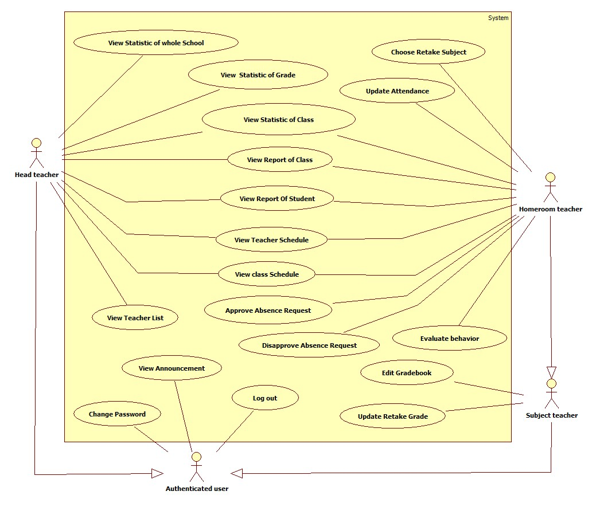

Figure 18: Head Teacher, Homeroom Teacher, Subject Teacher Overview Use Cas

##### <Head teacher>View Statistic of Whole School

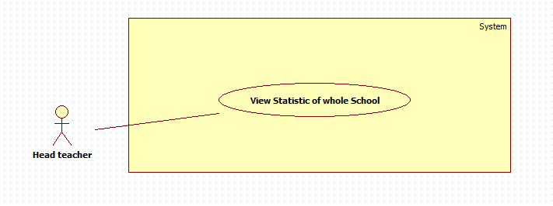

Figure 19: <Head teacher> View Statisctic Of Whole School

|  |  |  |  |
| --- | --- | --- | --- |
| **USE CASE – UC028** | | | |
| **Use Case No.** | UC028 | **Use Case Version** | 2.0 |
| **Use Case Name** | View Statistic Of Whole School | | |
| **Author** | Nguyễn Văn Ngọc Trường | | |
| **Date** | 02/06/2015 | **Priority** | High |
| **Actor:**   * Head teacher   **Summary:**  This use case allows head teacher to view statistic of whole school that is applying in the school year.  **Goal:**  Head teacher can view overview statistic of whole school.  **Triggers:**  Head teacher click “Trường” link on “Xếp loại học lực” of “Thống kê” menu of navigation.  **Preconditions:**   * User log in the system with head teacher role. * All data have to ready for statistic of whole school.   **Post Conditions:**  **Success:** Data get successfully and system displays data calculated under chart type.  **Fail:** System shows error message.  **Main Success Scenario:**   |  |  |  | | --- | --- | --- | | Step | Actor Action | System Response | | 1 | Head teacher clicks”Trường” link. | System displays links on menu content:  “Học kỳ 1”: link  “Học kỳ 2”: link  “Cả Năm”: link | | 2 | Head teacher selects a link to statistic of whole school. | System shows new “Thống kê xếp loại theo trường” page with content:  “Tổng số HS”: text  “Giỏi”: text  “Khá”: text  “TB”: text  “Yếu”: text  “Kém”:text  Pie chart: chart  Column chart: chart  [Exception 1] |   **Alternative Scenario:** N/A  **Exceptions:**   |  |  |  | | --- | --- | --- | | No | Actor Action | System Response | | 1 | Cannot get data form database. | System shows message “Đã có lỗi xảy ra! Vui lòng thử lại!”. |   **Relationships:** N/A  **Business Rules:**   * Statistic has three options: result of semester one, result of semester two and end year result. * Each result statistic only can be summarized by learning process of students of class was completed in the current semester. | | | |

Table 24: <Head teacher> View Statistic of Whole School

##### <Head teacher>View Statistic of Grade



Figure 20: <Head teacher>View Statistic Of Grade

|  |  |  |  |
| --- | --- | --- | --- |
| **USE CASE – UC029** | | | |
| **Use Case No.** | UC029 | **Use Case Version** | 2.0 |
| **Use Case Name** | View Statistic Of Grade | | |
| **Author** | Nguyễn Văn Ngọc Trường | | |
| **Date** | 02/06/2015 | **Priority** | High |
| **Actor:**   * Head teacher   **Summary:**   * This use case allows head teacher to view statistic grade in the school year.   **Goal:**   * Head teacher can view overview statistic grade.   **Triggers:**   * Head teacher click “Khối” link on “Xếp loại học lực” of “Thống kê” menu of navigation.   **Preconditions:**   * People must have an account to log in the system with role head teacher. * All data have to ready for statistic of grade.   **Post Conditions:**  **Success:** Data get successfully and system displays data calculated under chart type.  **Fail:** System shows error message.  **Main Success Scenario:**   |  |  |  | | --- | --- | --- | | Step | Actor Action | System Response | | 1 | Head teacher clicks”Khối” to view statistic class. | System display popup page content:  “Khối”: drop down list, required  “Học kỳ”: radio button, required  “Thống kê”: button, disabled  “Đóng”: button | | 2 | Head teacher clicks all “Khối”, “Học kỳ” button to select a grade. | System checks all select of head teacher and should be unlock “Thống kê”. | | 3 | Head teacher clicks “Thống kê” button to view statistic of this grade.  [Alternative 1] | System will close popup message, shows new “Thống kê xếp loại theo khối” page with content:  “Tổng số HS”: text  “Giỏi”: text  “Khá”: text  “TB”: text  “Yếu”: text  “Kém”:text  Pie chart: chart  Column chart: chart  [Exception 1] |   **Alternative Scenario:**   |  |  |  | | --- | --- | --- | | No | Actor Action | System Response | | 1 | Head teacher click “Đóng” button to cancel view. | System closes popup page. |   **Exceptions:**   |  |  |  | | --- | --- | --- | | No | Actor Action | System Response | | 1 | Cannot get data form database. | System shows message “Đã có lỗi xảy ra! Vui lòng thử lại!” |   **Relationships:** N/A  **Business Rules:**   * Statistic has three options: result of semester one, result of semester two and end year result. * Each result statistic only can be summarized by learning process of students of class was completed in the current semester. * At the popup page content, default of “Thống kê” button is disabled, head teacher has to select fields from top to bottom, and data of field above will open data of field below. If all selections are success then “Thống kê” is not disabled. | | | |

Table 25: <Head teacher> View Statistic of Grade

#### <Subject teacher>Overview Use Case

##### <Subject teacher>Edit GradeBook

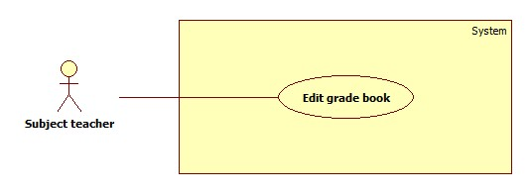

Figure 21: <Subject teacher>Edit gradebook

|  |  |  |  |
| --- | --- | --- | --- |
| **USE CASE – UC030** | | | |
| **Use Case No.** | UC030 | **Use Case Version** | 2.0 |
| **Use Case Name** | Edit Gradebook | | |
| **Author** | Le Tai Nhat Minh | | |
| **Date** | 01/06/2015 | **Priority** | Normal |
| **Actor:**   * Subject teacher   **Summary:**   * This use case allows subject teacher to edit grade of all students in the class that he/she is responsible for during semester.   **Goal:**   * Subject teacher can edit grade then save data into database successfully.   **Triggers:**   * Subject teacher clicks “Sổ điểm bộ môn” link on “Bộ môn” menu of navigation. * Subject teacher clicks “Sổ điểm bộ môn” link on “Quản lý chi tiết” menu for the class that he/she is responsible.   **Preconditions:**   * Log in to the system with teacher role and is responsible for one class at least in current school year. * The real time when he/she login is in the first or second semester of current school year.   **Post Conditions:**  **Success:** All data were saved successfully and show success message.  **Fail:** System shows error message.  **Main Success Scenario:**   |  |  |  | | --- | --- | --- | | Step | Actor Action | System Response | | 1 | Teacher clicks “Sổ điểm bộ môn” link | System display new page contains:   * “Năm học”: text * “Học kỳ 1”: radio button * “Học kỳ 2”: radio button * “Cả năm”: radio button   If “Học kỳ 1” is checked, the page will show:  A table with 19 column:   * “STT”: text * “Họ và tên”: text * “M1”: textbox * “M2”: textbox * “M3”: textbox * “M4”: textbox * “M5”: textbox * “P1”: textbox * “P2”: textbox * “P3”: textbox * “P4”: textbox * “P5”: textbox * “V1”: textbox * “V2”: textbox * “V3”: textbox * “V4”: textbox * “V5”: textbox * “Điểm thi HKI”: textbox * “Điểm trung bình HKI”: text * “Cập nhật”: button   If “Học kỳ 2” is checked, the page will show:  A table with 19 column with 17 column fist like “Học kì 1” table, and 2 column at the end will be:   * “Điểm thi HKII”: text box * “Điểm trung bình HKII”: text * “Cập nhật”: button | | 2 | Teacher input data and click “Cập nhật” | System display “Đã lưu” message.  [Exception 1] |   **Alternative Scenario:** N/A  **Exceptions:**   |  |  |  | | --- | --- | --- | | No | Actor Action | System Response | | 1 | Cannot save data into database | System shows message ““Đã có lỗi xảy ra trong hệ thống. Xin thử lại!””. |   **Relationships:** N/A  **Business Rules:**   * Base on real time, the system would display the data of respective semester: * Case 1: If a new school year is created but the first semester has not started yet, the system shows data of the first semester without change permission. * Case 2: If it is in the first semester, the system shows data of the first semester with change permission. * Case 3: If it is in the time between two semesters, the system shows data of the first semester without change permission. * Case 4: If it is in second semester, the system shows data of the second semester with change permission. * List is sort by alphabet based on student name. * All grade of student must be a number from 1 to 3 characters. * The total grade will be calculate when teacher input final exam and there must be have one grade at least of each oral test, 15 minutes test, 45 minutes/1 slot test exam. * The total score will be calculate in client site and calculate again in server site before saving in to database. * With grade-base subjects: * Subject teacher can input a decimal grade normally; max range of each input field is 3 characters. * Total score will be calculating by formula: get sum of all grades at semester then divide to sum factor of these. * Oral test and 15 minutes test: factor 1 * 45 minutes test: factor 2 * Final exam: factor 3 * With comment-base subjects: * Subject teacher can in put “c” or “d”, “c” is “CĐ” means not OK, fail and “d” is “Đ” means OK, pass. * Total score will be “Đ” when final exam is “Đ” and sum of “Đ” grade divide to sum of all “CĐ” and “Đ” grade must be greater or equal 2/3. The rest case total score will be “CĐ”. * Teacher can view the page of another semester or full year by clicking on radio button. * Input example:  |  |  | | --- | --- | | Input | Display | | 8/80/800/8,/8,,/80, | 8 | | 8,4/84/8,44/8,36/844/836 | 8,4 | | ,/,,/,,, | none | | d/đ/D/Đ/dd/DD/đđ/ĐĐ | Đ | | c/C/cd/CD/cD/Cd/cđ/cĐ/Cđ/CĐ/cc/CC | CĐ | | | | |

Table 26: <Subject teacher> Edit Gradebook

##### <Subject teacher>Update Retake Grade

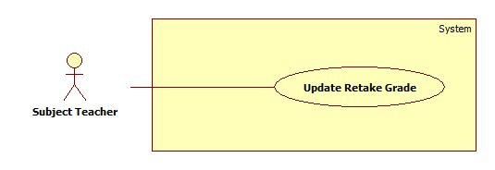

Figure 22: <Subject>Update Retake Grade

|  |  |  |  |
| --- | --- | --- | --- |
| **USE CASE – UC031** | | | |
| **Use Case No.** | UC031 | **Use Case Version** | 2.0 |
| **Use Case Name** | Update Retake Grade | | |
| **Author** | Le Tai Nhat Minh | | |
| **Date** | 01/06/2015 | **Priority** | Normal |
| **Actor:**   * Subject teacher   **Summary:**   * This use case allows subject teacher to update retake grade of student who he/she taught.   **Goal:**   * Subject teacher can update retake score then save data into database successfully.   **Triggers:**   * Subject teacher clicks “Quản lý bộ môn” link on “Giáo viên bộ môn” menu of navigation. * Subject teacher clicks “Sổ điểm bộ môn” link on “Bộ môn” menu for the class that he/she is responsible. * Subject teacher clicks “Cả năm” link on “Sổ điểm bộ môn” page for the class that he/she is responsible.   **Preconditions:**   * Log in to the system with teacher role.   **Post Conditions:**  **Success:** All data were saved successfully and show success message.  **Fail:** System shows error message.  **Main Success Scenario:**   |  |  |  | | --- | --- | --- | | Step | Actor Action | System Response | | 1 | Teacher clicks “Cả năm” radio button in “Sổ điểm bộ môn” page. | If “Cả năm” is checked, the page will show:  A table with 6 column:  “STT”: text  “Họ và tên”: text  “Điểm trung bình HKI”: text  “Điểm trung bình HKII”: label  “Điểm trung bình cả năm”: label  “Thi lại”: label  “Cập nhật”: button | | 2 | Teacher input data and click “Cập nhật” button. | System display “Đã lưu” message.  [Exception 1] |   **Alternative Scenario:** N/A  **Exceptions:**   |  |  |  | | --- | --- | --- | | No | Actor Action | System Response | | 1 | Cannot save data in to database | System shows message ““Đã có lỗi xảy ra trong hệ thống. Xin thử lại!””. |   **Relationships:** N/A  **Business Rules:**   * Each row in table is display the data of one student. List student will be sorted by alphabet * Subject teacher only input data for students who have status “Thi lại” and this subject have been chosen to retake by his/her home room teacher (Homeroom teacher has choosing retake subject function). Other students don’t have retake input fields. * The retake grade of this subject is used to replace for total score of whole year of student when the system re-calculate GPA. * Input style is similar to “Update grade” use case. | | | |

Table 31: < Subject teacher> Update Retake Grade

#### <Homeroom teacher>Overview Use Case

##### <Homeroom teacher> Update Attendance



Figure 23: <Homeroom teacher>Update Attendence

|  |  |  |  |
| --- | --- | --- | --- |
| **USE CASE –UC032** | | | |
| **Use Case No.** | UC032 | **Use Case Version** | 2.0 |
| **Use Case Name** | Update Attendance | | |
| **Author** | VÕ VĂN | | |
| **Date** | 01/06/2015 | **Priority** | High |
| **Actor:**   * Homeroom Teacher   **Summary:**   * Allow Homeroom Teacher to update student’s attendance   **Goal:**   * Homeroom teacher can update student’s attendance * Student’s attendance information is added or modified in database   **Triggers:**   * Homeroom Teacher click “Sổ điểm danh” link on “Chủ nhiệm” menu * Homeroom teacher click “Sổ điểm danh” on the class he/she manages   **Preconditions:**   * Homeroom Teacher must login into the system with Role “Giáo viên” and is homeroom teacher of a class   **Post Conditions:**  **Success:** Student’s attendance is added or modified in database then show success message  **Fail:** Show error message  **Main Success Scenario:**   |  |  |  | | --- | --- | --- | | Step | Actor Action | System Response | | 1 | Homeroom Teacher Click “Điểm danh” button on “Sổ điểm danh” page | Show “Điểm danh” page which display a form contains following information:  “Học kỳ I”: radiobox  “Học kỳ II”: radiobox  “Buổi” : drop-down list  “Tháng/Năm” : drop-down list  A grid table contains following information:   * “STT”: text * “Họ và tên”: text * “1” – “30” : textbox ( day of month ), lengh: 1. * “KP” : text * “CP” : text * “Tổng” : text   “Lưu” : button | | 2 | Fill in input then Homeroom Teacher Click “Lưu” button | Attendance information is added to database  Show success message “ĐÃ LƯU”  [Exception 1] |   **Alternative Scenario:** N/A  **Exceptions:**   |  |  |  | | --- | --- | --- | | No | Actor Action | System Response | | 1 | Can’t access database | Show validation message “Có lỗi xãy ra trong hệ thống, xin hãy thử lại” |   **Relationships:** N/A **Business Rules:**   * Input are limited by “P” or “K”, “P” is for absence with permission, “K” is for absence with no permission * Teacher can’t input “P” or “K” on the day after today * Teacher can’t input “P” or “K” on the day before today 3 days * Teacher can’t input “P” or “K” on any Sunday * After teacher input “P” or “K” on a day, number of absence day with or without permission will be calculated and update on “CP”, “KP”, “Tổng” columns. | | | |

Table 27: <Homeroom teacher>Update Attendence

##### <Homeroom teacher> Approve Absence Request



Figure 24: <Homeroom teacher>Approve Absence Request

|  |  |  |  |
| --- | --- | --- | --- |
| **USE CASE –UC033** | | | |
| **Use Case No.** | UC033 | **Use Case Version** | 2.0 |
| **Use Case Name** | Approve Absence Request | | |
| **Author** | VÕ VĂN | | |
| **Date** | 01/06/2015 | **Priority** | High |
| **Actor:**   * Homeroom Teacher   **Summary:**   * Allow Homeroom Teacher to approve selected absence request   **Goal:**   * Homeroom teacher can approve selected absence request * Selected absence request status is modified in database   **Triggers:**   * Homeroom Teacher click “Chấp nhận” button   **Preconditions:**   * User log in to the system as teacher and he/she is managing a class in current year.   **Post Conditions:**   * **Success:** Selected absence request status is modified in database then show success message * **Fail:** Show error message   **Main Success Scenario:**   |  |  |  | | --- | --- | --- | | Step | Actor Action | System Response | | 1 | Click “Chấp nhận” button | Selected absence request status is modified in database  Show success message “Đơn đã được duyệt”  [Exception 1] |   **Alternative Scenario**:   |  |  |  | | --- | --- | --- | | Step | Actor Action | System Response | | 1 | Click “Không Chấp nhận” button  [Alternative 1] | Selected absence request disapprove confirm pop-up panel float on the screen and display a form contains:  “Lý do”: text area, required, length: 1-500.  “Gửi” :button  “Không”: button | | 2 | Fill Input then Click “Gửi” button | Selected absence request status is modified in database  [Exception 2,3] | | 2’ | Homeroom teacher clicks “Đóng” button to cancel. | System closes popup. |   **Exceptions:**   |  |  |  | | --- | --- | --- | | No | Actor Action | System Response | | 1 | Can’t access database | Show validation message “Có lỗi xãy ra trong hệ thống, xin hãy thử lại” | | 2 | “Lý do” field is blank | Show validation message below text area “Lý do không được để trống” | | 3 | “Lý do” field contain more than 2000 characters | Show validation message below textarea “Lý do không được quá 2000 kí tự.” |   **Relationships:** Extend for “View Request List” (Approve) **Business Rules:**   * Teacher can’t approve request if the requested date passed or the request form deleted. | | | |

Table 28: <Homeroom teacher>Approve Absence Request

##### <Homeroom teacher> Disapprove Absence Request



Figure 25: <Homeroom teacher>Disapprove Absence Request

|  |  |  |  |
| --- | --- | --- | --- |
| **USE CASE –UC033** | | | |
| **Use Case No.** | UC033 | **Use Case Version** | 2.0 |
| **Use Case Name** | Disapprove Absence Request | | |
| **Author** | VÕ VĂN | | |
| **Date** | 01/06/2015 | **Priority** | High |
| **Actor:**   * Homeroom Teacher   **Summary:**   * Allow Homeroom Teacher to disapporve selected absence request   **Goal:**   * Homeroom teacher can disapporve selected absence request * Selected absence request status is modified in database   **Triggers:**   * Homeroom Teacher click “Chấp nhận” button   **Preconditions:**   * User log in to the system as teacher and he/she is managing a class in current year.   **Post Conditions:**   * **Success:** Selected absence request status is modified in database then show success message * **Fail:** Show error message   **Main Success Scenario:**   |  |  |  | | --- | --- | --- | | Step | Actor Action | System Response | | 1 | Click “Không Chấp nhận” button | Selected absence request disapprove confirm pop-up panel float on the screen and display a form contains:  “Lý do”: text area, required, length: 1-2000  “Gửi” :button  “Không”: button  [Exception 1] | | 2 | Fill Input then Click “Gửi” button | Selected absence request status is modified in database  [Exception 2,3] |   **Alternative Scenario**:   |  |  |  | | --- | --- | --- | | Step | Actor Action | System Response | | 1 | Homeroom teacher clicks “Đóng” button to cancel. | Selected absence request disapprove confirm pop-up panel float on the screen and display a form contains:  “Lý do”: text area, required, length: 1-500  “Gửi” :button  “Không”: button |   **Exceptions:**   |  |  |  | | --- | --- | --- | | No | Actor Action | System Response | | 1 | Can’t access database | Show validation message “Có lỗi xãy ra trong hệ thống, xin hãy thử lại” | | 2 | “Lý do” field is blank | Show validation message below text area “Lý do không được để trống” | | 3 | “Lý do” field contain more than 2000 characters | Show validation message below textarea “Lý do không được quá 2000 kí tự.” |   **Relationships:** Extend for “View Request List” (Disaprrove) **Business Rules:**   * Teacher can’t disapprove request if the requested date passed or the request form deleted. | | | |

Table 29: <Homeroom teacher>Disapprove Absence Request

##### <Homeroom teacher> Evaluate Behaviour



Figure 26: <Homeroom teacher>Evaluate Behaviour

|  |  |  |  |
| --- | --- | --- | --- |
| **USE CASE – UC034** | | | |
| **Use Case No.** | UC034 | **Use Case Version** | 2.0 |
| **Use Case Name** | Evaluate Behaviour | | |
| **Author** | ThuTTD | | |
| **Date** | 01/06/2015 | **Priority** | High |
| **Actor:**   * Homeroom teacher   **Summary:**   * This use case allows homeroom teacher to evaluate behaviour (conduct) of all students in the class that he/she is responsible for at the end of semester.   **Goal:**   * Homeroom teacher can evaluate behaviour and save data into database successfully.   **Triggers:**   * Teacher clicks “Xét hạnh kiểm” link on “Chủ nhiệm” menu of navigation. * Teacher clicks “Xét hạnh kiểm” link on “Quản lí chi tiết” menu for the class that he/she is responsible.   **Preconditions:**   * Log in to the system as a homeroom teacher. * The real time is in which stage of a school year   **Post Conditions:**  **Success:** All data is saved successfully and show success message.  **Fail:** System shows error message.  **Main Success Scenario:**   |  |  |  | | --- | --- | --- | | Step | Actor Action | System Response | | 1 | Teacher clicks “Xét hạnh kiểm” link | System display new page contains:  “Năm học”: label  “Học kỳ 1”: radio button  “Học kỳ 2”: radio button  “Cả năm”: radio button  “Rèn luyện hè”: radio button  “Chọn hạnh kiểm để xếp cho tất cả”: dropdown list  A table with 7 column:  “STT”: text  “Họ và tên”: text  “Xếp loại hạnh kiểm”: dropdown list “Nhận xét”: text area, max length: 500  “Lưu”: button | | 2 | Teacher inputs data and clicks “Lưu” | System displays “Đã lưu” message.  [Exception 1,2] |   **Alternative Scenario:** N/A  **Exceptions:**   |  |  |  | | --- | --- | --- | | No | Actor Action | System Response | | 1 | Teacher chooses value for dropdown list but does not fill “Nhận xét” field then click “Lưu”. | System shows message “Phải nhập nhận xét kèm theo hạnh kiểm.” in text area. | | 2 | Teacher click “Lưu” | Cannot save data.  System shows message “Đã có lỗi xảy ra trong hệ thống. Xin thử lại!” |   **Relationships:** N/A  **Business Rules:**   * There are 4 value of conduct: “Tốt”( very good), “Khá”( good), “TB” (fair), “Yếu” (bad) * Base on real time, the system would display as following:  |  |  |  |  |  |  | | --- | --- | --- | --- | --- | --- | |  | New school year has been created but 1st semester has not started yet | In 1st semester | In the time between two semesters | In 2nd semester | Later than the end date of 2nd semester and new school year has not started yet | | Semester1 page | Display  Editable: no | Display  Editable: yes | Editable: no | Editable: no | Editable: no | | Semester2 page | Editable: no | Editable: no | Display  Editable: no | Display  Editable: yes | Editable: no | | Whole year page | Editable: no | Editable: no | Editable: no | Editable: yes | Editable: no | | Summer page | Editable: no | Editable: no | Editable: no | Editable: no | Display  Editable: yes |  * Each row in table is display the data of one student in the class. List is sort by alphabet based on student name. In summer vacation page, list is all students who have “Rèn luyện hè” status. * After evaluating student’s behaviour, teacher must give a comment for that student. * Teacher can only give comment if and only if he/she have already selected value of conduct before. * When teacher select the value of “Chọn hạnh kiểm để xếp cho tất cả” dropdown list, selected value will be set for all student in class. * Teacher can view the page of another semester or a whole year by clicking on radio button. | | | |

Table 30: <Homeroom teacher>Evaluate Behaviour

##### <Homeroom teacher> Choose Retake Subject

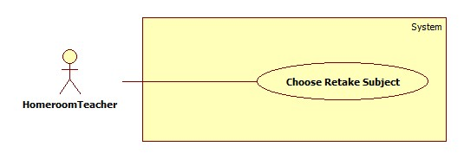

Figure 27: <Homeroom teacher>Choose Retake Subject

|  |  |  |  |
| --- | --- | --- | --- |
| **USE CASE – UC035** | | | |
| **Use Case No.** | UC035 | **Use Case Version** | 2.0 |
| **Use Case Name** | Choose Retake Subject | | |
| **Author** | Le Tai Nhat Minh | | |
| **Date** | 01/06/2015 | **Priority** | High |
| **Actor:**   * Homeroom teacher   **Summary:**   * This use case allows homeroom teacher to choosing retake subject of student who he/she manage.   **Goal:**   * Homeroom teacher can choose retake subject then save data into database successfully.   **Triggers:**   * Homeroom teacher clicks “Quản lý học sinh thi lại” link on “Chủ nhiệm” page for the class that he/she is responsible.   **Preconditions:**   * Log in to the system with homeroom teacher role.   **Post Conditions:**  **Success:** All data were saved successfully and show success message.  **Fail:** System shows error message.  **Main Success Scenario:**   |  |  |  | | --- | --- | --- | | Step | Actor Action | System Response | | 1 | Homeroom teacher clicks “Quản lý học sinh thi lại” link on “Chủ nhiệm” page. | If he/she class have student who must be retake , the page will show:  A table with column:   * “STT”: text * “Họ và tên”: text * A multiple column for each subject which his/her student must retake. * “Cập nhật”: button | | 2 | Teacher tick on some subjects that student has to retake and click “Cập nhật” button. | System display “Đã lưu” message.  [Exception 1] |   **Alternative Scenario:** N/A  **Exceptions:**   |  |  |  | | --- | --- | --- | | No | Actor Action | System Response | | 1 | Cannot save data in to database | System shows message ““Đã có lỗi xảy ra trong hệ thống. Xin thử lại!””. |   **Relationships:** N/A  **Business Rules:**   * Each row in table is display the data of one student in the class who has to retake at least one subject. List is sort by alphabet. * Each column except “STT” and “Họ và tên” in table display a subject which has at least one student in his/her class has to retake. * For each student, when their have any subject with average grade smaller than 5, system will be showing a checkbox and average subject grade for each subject like this. * Homeroom teacher will checking in one or many checkbox, each checkbox is one subject which student must be retake. * When homeroom teacher click update button, the retake exam of student course result will be setting to -1. Which means student’s must be retake this subject, and this is one of many conditions to show a text fields for subject teacher input retake score.( Update retake grade function of subject teacher). | | | |

Table 31: <Homeroom teacher>Choose Retake Subject

#### <Student’s parent>Overview Use Case

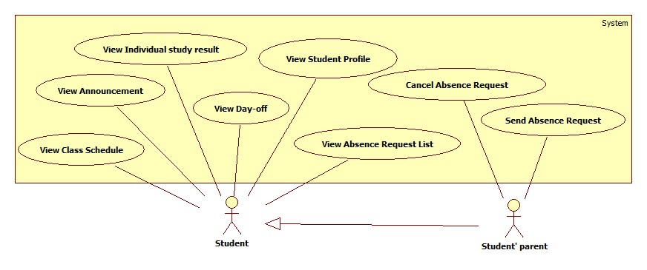

Figure 28: Student, Student’s Parent Overview Use Case

##### <Student’s parent> Send Absence Request



Figure 29: <Student’s parent>Send Absence Request

|  |  |  |  |
| --- | --- | --- | --- |
| **USE CASE –UC036** | | | |
| **Use Case No.** | UC036 | **Use Case Version** | 2.0 |
| **Use Case Name** | Send Absence Request | | |
| **Author** | VÕ VĂN | | |
| **Date** | 01/06/2015 | **Priority** | Normal |
| **Actor:**   * Student’s Parent   **Summary:**   * Allow Student’s Parent to send absence request   **Goal:**   * Student’s Parent can send an absence request * Absence request is added to database   **Triggers:**   * Student’s Parent click “Thêm mới” button   **Preconditions:**   * Student’s Parent must login into the system with role “Phụ huynh”   **Post Conditions:**  **Success:** Absence request will be added to database then show success message  **Fail:** Show error message  **Main Success Scenario:**   |  |  |  | | --- | --- | --- | | Step | Actor Action | System Response | | 1 | From “Danh sách đơn xin nghỉ học” page, Click “Thêm mới” button  [Alternative 1] | Absence request sending pop-up panel float on the screen and display a form contains:  “Gửi tới”: text  “Ngày nghỉ”:  Từ: datepicker.  Buổi: drop-down list  Tới: datepicker.  Buổi: drop-down list  “Nội Dung”: textarea, required.  “Gửi” button  “Đóng”: button | | 2 | Fill in input Student’s Parent Click “Gửi” button | Absence request information is added to database  Show success message  Absence request sending pop-up panel float out of the screen  [Exception 1, 2,3]  [Alternative 2] |   **Alternative Scenario:**   |  |  |  | | --- | --- | --- | | No | Actor Action | System Response | | 1 | Student’s Parent click “Đóng” button | User editing pop-up panel float out of the screen | | 2 | There’s no absence request form | Display message “Chưa có đơn xin nghỉ” |   **Exceptions:**   |  |  |  | | --- | --- | --- | | No | Actor Action | System Response | | 1 | Student’s Parent has already sent the request with the same day | Show validation message beside textbox “Đã có đơn xin nghỉ cho ngày này” | | 2 | “Nội dung” field is blank | Show validation message below textbox “Nội dung không được để trống” | | 3 | “Nội dung” field contain more than 2000 characters | Show validation message below textbox “Nội dung không được quá 2000 từ” |   **Relationships:** N/A **Business Rules:** - Student’s Parent can’t send absence request the same day twice at a time  - Student’s Parent can’t send absence request the day before today  - Student’s Parent can only send absence request from tomorrow  - Student’s Parent can’t send anymore request if the student have been absence for at least 45 days  - Student’s Parent can only send 1 request per day | | | |

Table 32: <Student’s parent>Send Absence Request

##### <Student’s parent> Cancel Absence Request



Figure 30: <Student’s parent> Cancel Absence Request

|  |  |  |  |
| --- | --- | --- | --- |
| **USE CASE –UC037** | | | |
| **Use Case No.** | UC037 | **Use Case Version** | 2.0 |
| **Use Case Name** | Cancel Absence Request | | |
| **Author** | VÕ VĂN | | |
| **Date** | 01/06/2015 | **Priority** | Normal |
| **Actor:**   * Student’s Parent   **Summary:**   * Allow Student’s Parent to cancel selected absence request   **Goal:**   * Student’s Parent can cancel selected absence request   selected absence request is deleted in database  **Triggers:**   * Student’s Parent click “Hủy” button   **Preconditions:**   * Student’s Parent must login with role “Phụ huynh”   **Post Conditions:**  **Success**: Selected absence request will be deleted in database then show success message  **Fail**: Show error message  **Main Success Scenario:**   |  |  |  | | --- | --- | --- | | Step | Actor Action | System Response | | 1 | From “Danh sách đơn xin nghỉ học” page, Student’s Parent Click “Hủy” button  [Alternative 1] | Selected absence request canceling confirm pop-up panel float on the screen and display a form contains:  “HỦY” button  “Không”: button | | 2 | Student’s Parent Click “HỦY” button | Selected absence request information is deleted in database  Show success message  Selected absence request canceling confirm pop-up panel float out of the screen  [Exception 1] |   **Alternative Scenario:**   |  |  |  | | --- | --- | --- | | No | Actor Action | System Response | | 1 | Student’s Parent click “Không” button | Selected absence request canceling confirm pop-up panel float out of the screen |   **Exceptions:**   |  |  |  | | --- | --- | --- | | No | Actor Action | System Response | | 1 | Can’t access database | Show validation message “Có lỗi xảy ra trong hệ thống, xin hãy thử lại” |   **Relationships**: Extend for View Absence Request List **Business Rules:**  Approved or Disapproved Absence Request Information cannot be cancel  ( “Hủy” button will be disable ) | | | |

Table 33: <Student’s parent>Cancel Absence Request

#### <Authenticated User> Overview Use Case

##### <Authenticated User> Log Out

Please refer full document in CD.

##### <Authenticated User> View Announcement

Please refer full document in CD.

##### <Authenticated User>Change password

Please refer full document in CD.

#### General Use Case

##### View Student List of Class

Please refer full document in CD.

##### View Student Profile

Please refer full document in CD.

##### View Teacher Profile

Please refer full document in CD.

##### View Statistic of Class



Figure 31: View Statistic of Class

|  |  |  |  |
| --- | --- | --- | --- |
| **USE CASE – UC044** | | | |
| **Use Case No.** | UC044 | **Use Case Version** | 2.0 |
| **Use Case Name** | View Statistic Of Class | | |
| **Author** | Nguyễn Văn Ngọc Trường | | |
| **Date** | 02/06/2015 | **Priority** | High |
| **Actor:**   * Head teacher, Homeroom teacher   **Summary:**   * This use case allows head/homeroom teacher to view statistic class that is applying in the school year.   **Goal:**   * Head/homeroom teacher can view overview statistic class.   **Triggers:**   * Teacher click “Thống kê” button on“Xếp loại học lực” Menu   **Preconditions:**   * People must have an account to log in the system with role head/homeroom teacher.   All data have to ready for statistic of class.  **Post Conditions:**  **Success:** Data get successfully and system displays data calculated under chart type.  **Fail:** System shows error message.  **Main Success Scenario:**   |  |  |  | | --- | --- | --- | | Step | Actor Action | System Response | | 1 | Head teacher clicks all “Khối”,”Lớp” and “Học kỳ” radio button to select a class.  Homeroom teacher select “Học kỳ” radio button. | System checks all select of teacher and open “Thống kê”. | | 2 | Head/homeroom teacher click “Thống kê” button to view statistic of this class.  [Alternative 1] | System will close popup message, shows new “Thống kê xếp loại theo lớp” page with content:  “GVCN”: text  “Sĩ số”: text  “Giỏi”: text  “Khá”: text  “TB”: text  “Yếu”: text  “Kém”:text  Pie chart: chart  Column chart: chart  [Exception 1] |   **Alternative Scenario:**   |  |  |  | | --- | --- | --- | | No | Actor Action | System Response | | 1 | Head teacher click “Đóng” button to cancel view. | System closes popup page. |   **Exceptions:**   |  |  |  | | --- | --- | --- | | No | Actor Action | System Response | | 1 | Cannot get data form database. | System shows message “Đã có lỗi xảy ra! Vui lòng thử lại!” |   **Relationships:** N/A  **Business Rules:**   * Statistic has three options: result of semester one, result of semester two and end year result. * Each result statistic only can be summarized by learning process of students of class was completed in the current semester. * With head teacher role, at the popup page content, in default of “Thống kê” button is disabled, head teacher has to select fields from top to bottom, data of field above will open data of field below. If all selections are success then “Thống kê” is not disabled. In addition, Head teacher can view statistic all class. * With homeroom teacher role, he/she only views statistic of class that he/she is responsible. | | | |

Table 34: View Statistic of Class

##### View Report of Class



Figure 32: View Report of Class

|  |  |  |  |
| --- | --- | --- | --- |
| **USE CASE –UC045** | | | |
| **Use Case No.** | UC045 | **Use Case Version** | 2.0 |
| **Use Case Name** | View Report of Class | | |
| **Author** | ThuTTD | | |
| **Date** | 01/06/2015 | **Priority** | Normal |
| **Actor:**   * Head teacher, homeroom teacher   **Summary:**   * This use case allows head teacher or homeroom teacher to view a report about study result of class after a semester.   **Goal:**   * Head teacher or homeroom teacher can view report.   **Triggers:**   * Head teacher chooses “Bảng tổng kết của lớp” on “Báo cáo” menu. * Homeroom teacher clicks on “Bảng tổng kết của lớp” on “Chủ nhiệm” menu.   **Preconditions:**   * User has log in as head teacher or homeroom teacher role.   **Post Conditions:**  **Success:** Show report successfully.  **Fail:** Show error message.  **Main Success Scenario:**   |  |  |  | | --- | --- | --- | | Step | Actor Action | System Response | | 1 | -Head teacher select a specific class and semester then click “Báo cáo ”  - Homeroom teacher click “Bảng tổng kết của lớp” on “Chủ nhiệm” menu. | If user selects “Học kỳ 1” or “Học kỳ 2”, displayed table contains:   * “STT”: text * “Họ và tên”: text * A list of all subjects that the class studies. (Include subject name and the factor) * “TBCM” : text (GPA of student) * “Xếp loại” * “HL” : text (academic classification) * “HK”: text (conduct) * “Buổi nghỉ” * “CP”: text (days of absence with permission) * “KP”: text (days of absence without permission) * “Tổng”: text (total number of absence) * “Danh hiệu”: text (title)   If user selects “Cả năm”, displayed table contains:   * “STT”: text * “Họ và tên”: text * “Xếp loại cả năm”: text * “TBCM”: text * “HL” : text * “HK”: text * “Buổi nghỉ”:text * “CP”: text * “KP”: text * “Tổng”: text * “Danh hiệu”:text * “Xếp loại sau khi thu lại hoặc rèn luyện hè” * “TBCM”: text * “HL” : text * “HK”: text * “Ghi chú”: note * “Tính trạng”: student status   [Alternative 1] |   **Alternative Scenario:**   |  |  |  | | --- | --- | --- | | No | Actor Action | System Response | | 1 | There is no data. | System shows message “Không có dữ liệu.” |   **Exceptions:** N/A  **Relationships:** N/A  **Business Rules:**   * Head teacher can view report of all class in school, while homeroom teacher can only view the report of the class he/she manages. * If user is head teacher, he/she can choose the class to view report * If user is homeroom teacher, the system would display the page base on real time: * Case 1: If it is not over the start date of the second semester, the system shows the page of the first semester. * Case 2: If it is in the second semester, the system shows page of second semester. * The subject list depends on the type of class. * “Ghi chú” is used to notes subjects which student has to retake. | | | |

Table 35: View Report of Class

##### View Report of Student

Please refer full document in CD.

#### <System>Auto Calculate Result



Figure 33: <System>Auto Calculate Result

|  |  |  |  |
| --- | --- | --- | --- |
| **USE CASE – UC047** | | | |
| **Use Case No.** | UC047 | **Use Case Version** | 2.0 |
| **Use Case Name** | Auto calculate result | | |
| **Author** | Nguyễn Văn Ngọc Trường | | |
| **Date** | 01/06/2015 | **Priority** | High |
| **Actor:** System  **Summary:** System auto calculate result of all students in appropriate time period.  **Goal:** Calculate result of all students.  **Triggers:**   * At a time determined the system will be activated.   **Preconditions:**   * Admin configured time into system. * Data is prepared to calculate.   **Post Conditions:**  **Success:** Result is added into database and send message to admin.  **Fail:** send error message to admin.  **Main Success Scenario:**   |  |  |  | | --- | --- | --- | | **Step** | **Actor Action** | **System Response** | | 1 | At the time determined, system auto active function calculate result | -System do processes:  + Calculating all result of students.  + Adding to database.  + Send message success to admin.  [Exception 1] |   **Alternative Scenario:** N/A  **Exceptions:**   |  |  |  | | --- | --- | --- | | No | Actor Action | System Response | | 1 | Cannot add new data | Cancel add data then send message error to admin. |   **Relationships:** N/A  **Business Rules:**   * System can only calculate when time at the end of semester. * Based on the current time results will be different ways:   +Case 1:At the end of semester one, system will calculate:   * + - * GPA of semester one       * Academic classify for semester one       * Honor of semester one   +Case 2: At the end of semester two, system will calculate:   * + - * GPA of semester two       * GPA end year       * Academic classify for semester two       * Academic classify for end year       * Consider of upgrading       * Honor of semester two       * Honor of end year   +Case 3: 7 days before end date of each semester, send remind email to all teacher  +Case 4: 30 day after end date of 2nd semester, system will:   * Calculate GPA and classify again for students who have to retake. * Consider of upgrading for students who have to retake or has status “Rèn luyện hè”. * GPA formula:   + n: number of grade subject  + Ti: totalscore of ith subject  + fi: factor of ith subject   * Academic classification, consider of upgrading, consider of honor is presented in Algorithm section. * If data of a student is missing, do not classify for him/her. * In the process, if system’s calculation is fail, system doesn’t add data to database. | | | |

Table 36: <System> Auto Calculate Result

## Software System Attribute

### Usability

#### Graphic User Interface

* Using language should be Vietnamese.

#### Usability

* All users should need less than one training week to interact with website.

#### Installation

* Customer can deploy successfully and learn to configure, maintain the system within one day of training.
* The attached manual guide must be clear. User can read and do themselves without developer’s help.

### Reliability

* Calculating average grade (score) and classifying academic result should base on the rules of Ministry of Education and Training.

### Availability

* The website should be available 24 hours per day, 7 days per week.

### Security

* Only user who has account can access into System.
* Each role of user has a specific permission to interact with system.
* System always checks authorization before process user’s request.

### Maintainability

* Code is easy to maintain and upgrade.

### Portability

* The system can be deployed into many type of servers those have IIS server.

### Performance

* Response time of almost functions should be less than 2s.

## Conceptual Diagram

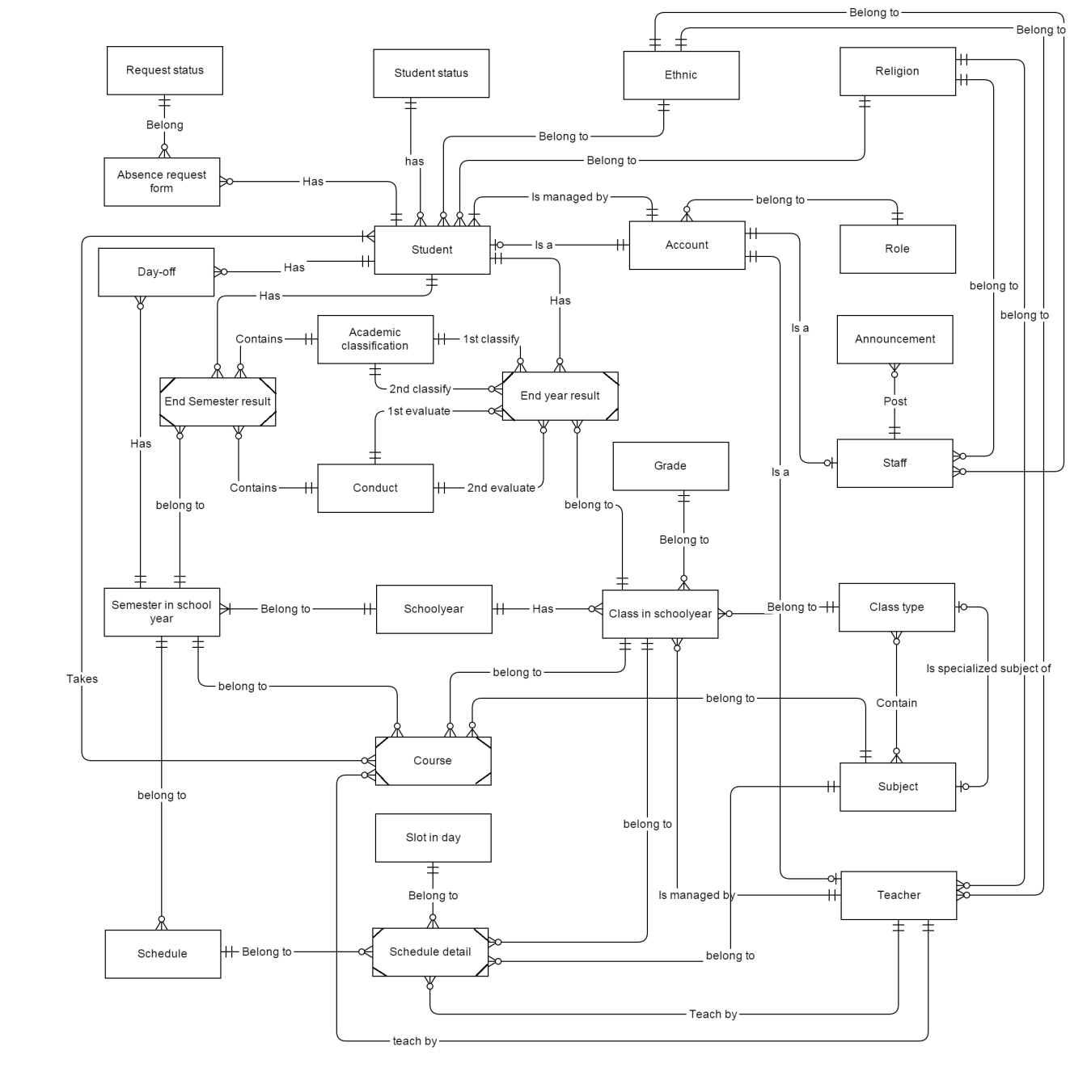

Figure 34: Conceptual Diagram

Data dictionary:

|  |  |
| --- | --- |
| **Entity dictionary** | |
| **Entity Name** | **Description** |
| Absence Request Form | Describe the absence forms of students. |
| Academic Classification | Describe all kind of academic classification base on 5 criteria. It includes: “Giỏi”, “Khá”, “Trung bình”, “Yếu” and “Kém”. |
| Account | Describe all users of the system. Each user has only one account. |
| Announcement | Describe all announcements. An announcement can be general or confidential one. |
| Class In School Year | Describe the specific classes in specific years. Each class has maximum 50 students. |
| Class Type | Describe group of classes which have same courses. |
| Conduct | Describe all kind of conduct. It includes: “Tốt”, “Khá”, “Trung bình” and “Yếu”. |
| Course | Weak entity describes all courses. A course should be answer for these questions: In a specific semester, which class has to study which subject? Who teach? |
| Day-Off | Describe all absent day which had permitted or not of student in specified semester. |
| End Semester Result | Weak entity describes the summary result of student in the end of semester. |
| End Year Result | Weak entity describes the summary result of student in the end of school year. |
| Ethnic | Describe 54 ethnics in Viet Nam. |
| Grade | Describe all grades of a high school, includes: 10, 11, 12 |
| Religion | Describe some religions. |
| Request Status | Describe status of request which includes: “Chờ duyệt”, “Đã được duyệt”, “Không được duyệt”, “Quá hạn”. |
| Role | Describe all roles in the system. |
| Schedule | Describe all versions of schedule. |
| Schedule Detail | Weak entity. A schedule detail should be answer for these questions: In a specific schedule, which class has to study which subject? Who teach? Which slot? |
| School Year | Describe school year. A school year lasts for 9 months, it starts from August and finish at May of the next year. |
| Semester In School Year | Describe the specific semester in a school year. Each school year has exactly 2 semesters. |
| Slot In Day | Describe all study slots in weekdays. Each slot is 45 minutes. |
| Staff | Describe all staff profiles in the system. |
| Student | Describe all students in the system. |
| Student Status | Describe status of student which includes: “Đang học”, ” Được lên lớp”, ”Lưu ban”, ”Đã ra trường”, ”Rèn luyện hè”, “Thi lại”. |
| Subject | Describe all available subjects being taught in high school. |
| Teacher | Describe all teacher profiles in the system. Each teacher has only one account and teaches only one subject. |

Table 37: Data dictionary

Relationship dictionary:

|  |  |
| --- | --- |
| **Relationship dictionary: describe content of relationships** | |
| **Relationship** **Name** | **Description** |
| Takes (between Student and Course) | Describe study result of a student in a course. |
| Contain(between Class Type and Subject) | Each class type has to study a set of subjects with different factor and slot per week. |
| Is specialized subject of(between Class Type and Subject) | A class type can be has specialized subject or not. |
| Is managed by (between Student and Account) | Each student has one parent’s account to follow and manage his/her study result |
| 1st Classify(between Academic Classification and End year result) | Academic classification after the end of a school year. |
| 2st Classify(between Academic Classification and End year result) | Academic classification after retake exam (if student has to retake). |
| 1st Evaluate(between Conduct and End year result) | Academic classification after the end of a school year. |
| 2st Evaluate(between Conduct and End year result) | Conduct is evaluated again after summer vacation (if student has to practice in summer). |

# Software Design Description

## Design Overview

* This document describes the technical and user interface design of **Information Management Website for High School**. It includes the architectural design, the detailed design of common functions and business functions.
* The architectural design describes the overall architecture of the system and the architecture of each main component and subsystem.
* The detailed design describes static and dynamic structure for each component and functions. It includes class diagrams, class explanations and sequence diagrams for each use cases.
* The database design describes the relationships between entities and details of each entity.
* Document overview:
* **Section 2:** The overall description of the system architectural design.
* **Section 3:** Component diagrams that describe the connection and integration of the system.
* **Section 4:** Detail design description, which includes class diagram, class explanation, and sequence diagram to describe the functions.
* **Section 5:** The user interface of application.
* **Section 6:** Database design with logical diagram.
* **Section 7:** The algorithms used for academic classification, considering honor, considering upgrading.

## System Architectural Design

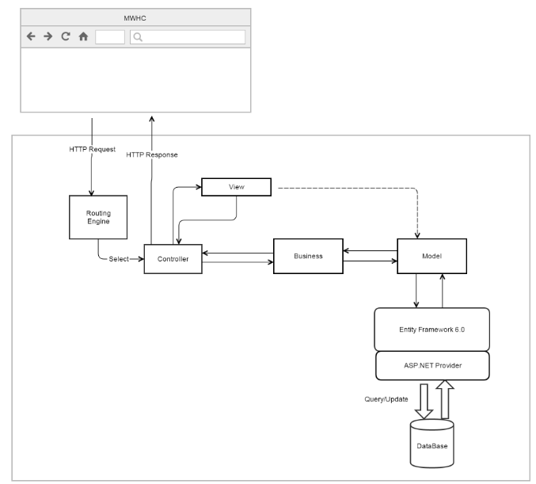

Figure 35: IMWHC System Architectural

We use MVC architecture style to develop IMWHC web. Specifically, customized it as convenient and suitable as possible to meet the customer’s requirement.

Controller: Receive requests from clients and transfers to Business to handle request then use processed result from Business to render View and return view to clients.

View: is responsible for display data from Model.

Model: generated by mapping database, Model is used to solve system data.

Business: Handles the business logic of the high school based on roles.

## Component Diagram

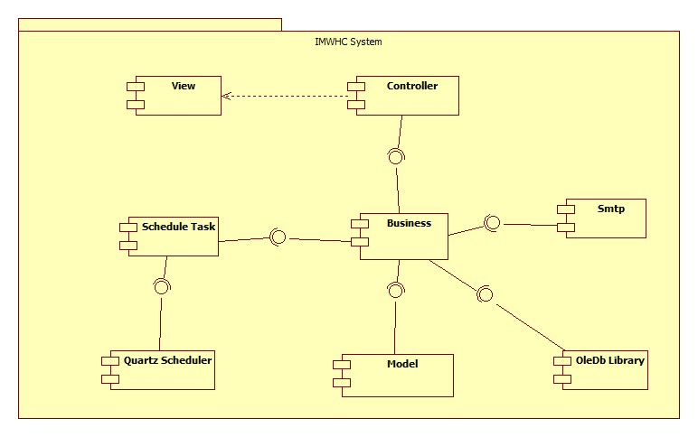

Figure 36: Component Diagram

|  |  |
| --- | --- |
| Component dictionary | |
| Component Name | Description |
| Controller | Contain all controllers in the system. |
| View | Contain all views in the system. |
| Business | Contain all business logic processing in the system. |
| Model | Entity Framework 6 mapping models. |
| OleDb library | Library that is used for importing or exporting excel files. |
| Smtp | Component is used to send asynchronous emails. |
| Schedule Task | Component contains modules that are used for executing sending notification emails to teachers, GPA calculating and academic classification on the end of semester. |
| Quartz Scheduler | A job scheduling library. |

Table 38: Component Dictionary

## Detailed Description

### Class Diagram

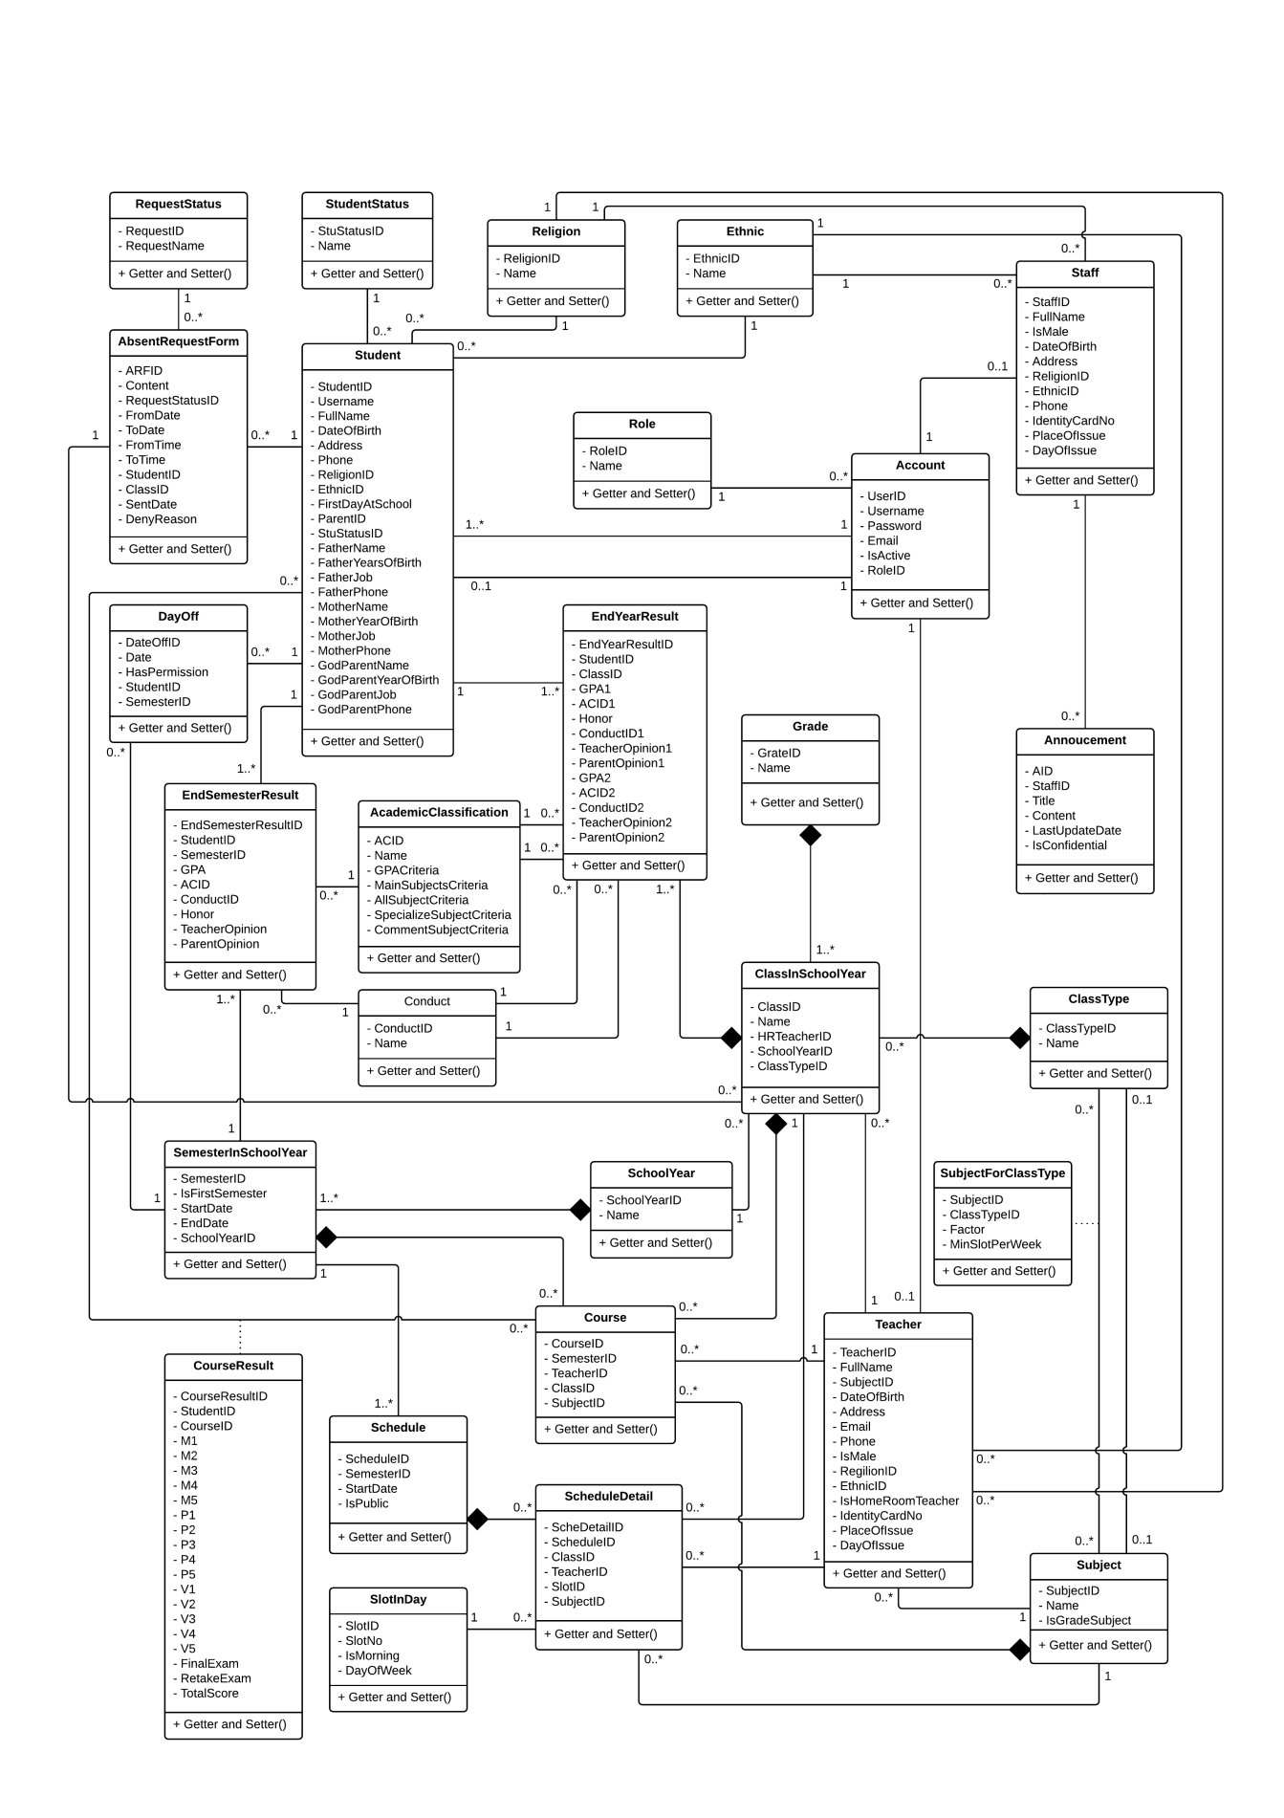

Figure 37: Class Diagram

### Class Diagram Explanation

#### Account

Attribute

|  |  |  |  |
| --- | --- | --- | --- |
| **Attribute** | **Type** | **Visibility** | **Description** |
| UserID | Integer | Private | Unique identifier of account. |
| Username | String | Private | Username of account. |
| Password | String | Private | Password of account. |
| Email | String | Private | Email of account. |
| IsActive | Boolean | Private | State of account. |
| RoleID | Integer | Private | Role of account. |

Method

|  |  |  |  |
| --- | --- | --- | --- |
| **Method** | **Return type** | **Visibility** | **Description** |
| Getter | Attribute type | Public | Get attribute value |
| Setter | Void | Public | Set value of attribute |

#### Student

Attribute

|  |  |  |  |
| --- | --- | --- | --- |
| **Attribute** | **Type** | **Visibility** | **Description** |
| StudentID | Integer | Private | Unique identifier of student. |
| Username | String | Private | Username of student. |
| FullName | US | Private | Full Name of student. |
| DateOfBirth | Date | Private | Birthday of student. |
| Address | US | Private | Address of student. |
| Phone | String | Private | Phone number of student. |
| ReligionID | Integer | Private | Unique identifier of religion. |
| EthnicID | Integer | Private | Unique identifier of ethnic. |
| FirstDayAtSchool | Date | Private | First day at school of student. |
| ParentID | Integer | Private | Unique identifier of parent. |
| StuStatusID | Integer | Private | Unique identifier of student status. |
| FatherName | US | Private | Father name of student. |
| FatherYearOfBirth | Date | Private | Father birthday of student. |
| FatherJob | US | Private | Father job of student. |
| FatherPhone | String | Private | Father phone number of student. |
| MotherName | US | Private | Mother name of student. |
| MotherYearOfBirth | Date | Private | Mother birthday of student. |
| MotherJob | US | Private | Mother job of student. |
| MotherPhone | String | Private | Mother phone number of student. |
| GodParentName | US | Private | God parent name of student. |
| GodParentYearOfBirth | Date | Private | God parent birthday of student. |
| GodParentJob | US | Private | God parent job of student. |
| GodParentPhone | String | Private | God parent phone number of student. |

Method

|  |  |  |  |
| --- | --- | --- | --- |
| **Method** | **Return type** | **Visibility** | **Description** |
| Getter | Attribute type | Public | Get attribute value |
| Setter | Void | Public | Set value of attribute |

#### Staff

Attribute

|  |  |  |  |
| --- | --- | --- | --- |
| **Attribute** | **Type** | **Visibility** | **Description** |
| StaffID | Integer | Private | Unique identifier of staff. |
| FullName | US | Private | Full Name of staff. |
| IsMale | Boolean | Private | Sex of staff. |
| DateOfBirth | Date | Private | Birthday of staff. |
| Address | US | Private | Address of staff. |
| ReligionID | Integer | Private | Unique identifier of religion. |
| EthnicID | Integer | Private | Unique identifier of ethnic. |
| Phone | String | Private | Phone number of staff. |
| IdentityCardNo | String | Private | IC number of staff. |
| PlaceOfIssue | US | Private | Place of issue of staff. |
| DayOfIssue | Date | Private | Day of issue of staff. |

Method

|  |  |  |  |
| --- | --- | --- | --- |
| **Method** | **Return type** | **Visibility** | **Description** |
| Getter | Attribute type | Public | Get attribute value |
| Setter | Void | Public | Set value of attribute |

#### Teacher

Attribute

|  |  |  |  |
| --- | --- | --- | --- |
| **Attribute** | **Type** | **Visibility** | **Description** |
| TeacherID | Integer | Private | Unique identifier of teacher. |
| FullName | US | Private | Full Name of teacher. |
| SubjectID | Integer | Private | Unique identifier of subject. |
| DateOfBirth | Date | Private | Birthday of teacher. |
| Address | US | Private | Address of teacher. |
| Email | String | Private | Email of teacher. |
| Phone | String | Private | Phone number of teacher. |
| IsMale | Boolean | Private | Sex of teacher. |
| ReligionID | Integer | Private | Unique identifier of religion. |
| EthnicID | Integer | Private | Unique identifier of ethnic. |
| IsHomeRoomTeacher | Boolean | Private | Teacher can become homeroom teacher or not. |
| IdentityCardNo | String | Private | IC number of teacher. |
| PlaceOfIssue | US | Private | Place of issue of teacher. |
| DayOfIssue | Date | Private | Day of issue of teacher. |

Method

|  |  |  |  |
| --- | --- | --- | --- |
| **Method** | **Return type** | **Visibility** | **Description** |
| Getter | Attribute type | Public | Get attribute value |
| Setter | Void | Public | Set value of attribute |

#### SemesterInSchoolYear

Attribute

|  |  |  |  |
| --- | --- | --- | --- |
| **Attribute** | **Type** | **Visibility** | **Description** |
| SemesterID | Integer | Private | Unique identifier of semester. |
| IsFirstSemester | Boolean | Private | Semester is 1st or 2nd. |
| StartDate | Date | Private | Date begin semester. |
| EndDate | Date | Private | Date end semester. |
| SchoolYearID | Integer | Private | Unique identifier of school year. |

Method

|  |  |  |  |
| --- | --- | --- | --- |
| **Method** | **Return type** | **Visibility** | **Description** |
| Getter | Attribute type | Public | Get attribute value |
| Setter | Void | Public | Set value of attribute |

#### SchoolYear

Attribute

|  |  |  |  |
| --- | --- | --- | --- |
| **Attribute** | **Type** | **Visibility** | **Description** |
| SchoolYearID | Integer | Private | Unique identifier of school year. |
| Name | US | Private | Name of school year. |

Method

|  |  |  |  |
| --- | --- | --- | --- |
| **Method** | **Return type** | **Visibility** | **Description** |
| Getter | Attribute type | Public | Get attribute value |
| Setter | Void | Public | Set value of attribute |

#### Schedule

Attribute

|  |  |  |  |
| --- | --- | --- | --- |
| **Attribute** | **Type** | **Visibility** | **Description** |
| ScheduleID | Integer | Private | Unique identifier of schedule. |
| SemesterID | Integer | Private | Unique identifier of semester. |
| StartDate | Date | Private | Date begin schedule. |
| IsPublic | Boolean | Private | Schedule is in public or not. |

Method

|  |  |  |  |
| --- | --- | --- | --- |
| **Method** | **Return type** | **Visibility** | **Description** |
| Getter | Attribute type | Public | Get attribute value |
| Setter | Void | Public | Set value of attribute |

#### ScheduleDetail

Attribute

|  |  |  |  |
| --- | --- | --- | --- |
| **Attribute** | **Type** | **Visibility** | **Description** |
| ScheDetailID | Integer | Private | Unique identifier of schedule detail. |
| ScheduleID | Integer | Private | Unique identifier of schedule. |
| ClassID | Integer | Private | Unique identifier of class. |
| TeacherID | Integer | Private | Unique identifier of teacher. |
| SlotID | Integer | Private | Unique identifier of slot. |
| SubjectID | Integer | Private | Unique identifier of subject. |

Method

|  |  |  |  |
| --- | --- | --- | --- |
| **Method** | **Return type** | **Visibility** | **Description** |
| Getter | Attribute type | Public | Get attribute value |
| Setter | Void | Public | Set value of attribute |

#### SlotInDay

Attribute

|  |  |  |  |
| --- | --- | --- | --- |
| **Attribute** | **Type** | **Visibility** | **Description** |
| SlotID | Integer | Private | Unique identifier of slot. |
| SlotNo | Integer | Private | Number of slot. |
| IsMorning | Boolean | Private | Slot is in morning or evening. |
| DayOfWeek | Integer | Private | Day of week. |

Method

|  |  |  |  |
| --- | --- | --- | --- |
| **Method** | **Return type** | **Visibility** | **Description** |
| Getter | Attribute type | Public | Get attribute value |
| Setter | Void | Public | Set value of attribute |

#### Subject

Attribute

|  |  |  |  |
| --- | --- | --- | --- |
| **Attribute** | **Type** | **Visibility** | **Description** |
| SubjectID | Integer | Private | Unique identifier of subject. |
| Name | US | Private | Name of subject. |
| IsGradeSubject | Boolean | Private | Subject is grade-base or comment-base. |

Method

|  |  |  |  |
| --- | --- | --- | --- |
| **Method** | **Return type** | **Visibility** | **Description** |
| Getter | Attribute type | Public | Get attribute value |
| Setter | Void | Public | Set value of attribute |

#### Course

Attribute

|  |  |  |  |
| --- | --- | --- | --- |
| **Attribute** | **Type** | **Visibility** | **Description** |
| CourseID | Integer | Private | Unique identifier of course. |
| SemesterID | Integer | Private | Unique identifier of semester. |
| TeacherID | Integer | Private | Unique identifier of teacher. |
| ClassID | Integer | Private | Unique identifier of class. |
| SubjectID | Integer | Private | Unique identifier of subject. |

Method

|  |  |  |  |
| --- | --- | --- | --- |
| **Method** | **Return type** | **Visibility** | **Description** |
| Getter | Attribute type | Public | Get attribute value |
| Setter | Void | Public | Set value of attribute |

#### CourseResult

Attribute

|  |  |  |  |
| --- | --- | --- | --- |
| **Attribute** | **Type** | **Visibility** | **Description** |
| CourseResultID | Integer | Private | Unique identifier of course result. |
| StudentID | Integer | Private | Unique identifier of student. |
| CourseID | Integer | Private | Unique identifier of course. |
| M1 | Float | Private | Oral test 1 grade. |
| M2 | Float | Private | Oral test 2 grade. |
| M3 | Float | Private | Oral test 3 grade. |
| M4 | Float | Private | Oral test 4 grade. |
| M5 | Float | Private | Oral test 5 grade. |
| P1 | Float | Private | 15 minutes test 1 grade. |
| P2 | Float | Private | 15 minutes test 2 grade. |
| P3 | Float | Private | 15 minutes test 3 grade. |
| P4 | Float | Private | 15 minutes test 4 grade. |
| P5 | Float | Private | 15 minutes test 5 grade. |
| V1 | Float | Private | 45 minutes test 1 grade. |
| V2 | Float | Private | 45 minutes test 2 grade. |
| V3 | Float | Private | 45 minutes test 3 grade. |
| V4 | Float | Private | 45 minutes test 4 grade. |
| V5 | Float | Private | 45 minutes test 5 grade. |
| FinalExam | Float | Private | Final grade. |
| RetakeExam | Float | Private | Retake grade. |
| TotalScore | Float | Private | Total grade. |

Method

|  |  |  |  |
| --- | --- | --- | --- |
| **Method** | **Return type** | **Visibility** | **Description** |
| Getter | Attribute type | Public | Get attribute value |
| Setter | Void | Public | Set value of attribute |

#### RequestStatus

Attribute

|  |  |  |  |
| --- | --- | --- | --- |
| **Attribute** | **Type** | **Visibility** | **Description** |
| RequestID | Integer | Private | Unique identifier of request status. |
| RequestName | US | Private | Name of request status. |

Method

|  |  |  |  |
| --- | --- | --- | --- |
| **Method** | **Return type** | **Visibility** | **Description** |
| Getter | Attribute type | Public | Get attribute value |
| Setter | Void | Public | Set value of attribute |

#### AbsenceRequestForm

Attribute

|  |  |  |  |
| --- | --- | --- | --- |
| **Attribute** | **Type** | **Visibility** | **Description** |
| ARFID | Integer | Private | Unique identifier of absence request form. |
| Content | US | Private | Content of absence request form. |
| RequestStatusID | Integer | Private | Unique identifier of request status. |
| FromDate | Date | Private | Date begin of absence request form. |
| ToDate | Date | Private | Date come of absence request form. |
| FromTime | Integer | Private | Time begin of absence request form. |
| ToTime | Integer | Private | Time come of absence request form. |
| StudentID | Integer | Private | Unique identifier of student. |
| ClassID | Integer | Private | Unique identifier of class. |
| SentDate | Datetime | Private | Date sent absence request form. |
| DenyReason | US | Private | Deny reason of absence request form. |

Method

|  |  |  |  |
| --- | --- | --- | --- |
| **Method** | **Return type** | **Visibility** | **Description** |
| Getter | Attribute type | Public | Get attribute value |
| Setter | Void | Public | Set value of attribute |

#### DayOff

Attribute

|  |  |  |  |
| --- | --- | --- | --- |
| **Attribute** | **Type** | **Visibility** | **Description** |
| DayOffID | Integer | Private | Unique identifier of day off. |
| Date | Date | Private | Date off. |
| HasPermission | Boolean | Private | Date off had pemission or not. |
| StudentID | Integer | Private | Unique identifier of student. |
| SemesterID | Integer | Private | Unique identifier of semester. |

Method

|  |  |  |  |
| --- | --- | --- | --- |
| **Method** | **Return type** | **Visibility** | **Description** |
| Getter | Attribute type | Public | Get attribute value |
| Setter | Void | Public | Set value of attribute |

#### EndSemesterResult

Attribute

|  |  |  |  |
| --- | --- | --- | --- |
| **Attribute** | **Type** | **Visibility** | **Description** |
| EndSemesterResultID | Integer | Private | Unique identifier of end semester result. |
| StudentID | Integer | Private | Unique identifier of student. |
| SemesterID | Integer | Private | Unique identifier of semester |
| GPA | Float | Private | Grade point average. |
| ACID | Integer | Private | Unique identifier of academic classification. |
| ConductID | Integer | Private | Unique identifier of conduct. |
| Honor | US | Private | Honor of end semester result. |
| TeacherOpinion | US | Private | Teacher opinion of end semester result. |
| ParentOpinion | US | Private | Parent opinion of end semester result. |

Method

|  |  |  |  |
| --- | --- | --- | --- |
| **Method** | **Return type** | **Visibility** | **Description** |
| Getter | Attribute type | Public | Get attribute value |
| Setter | Void | Public | Set value of attribute |

#### Conduct

Attribute

|  |  |  |  |
| --- | --- | --- | --- |
| **Attribute** | **Type** | **Visibility** | **Description** |
| ConductID | Integer | Private | Unique identifier of conduct. |
| Name | US | Private | Name of conduct. |

Method

|  |  |  |  |
| --- | --- | --- | --- |
| **Method** | **Return type** | **Visibility** | **Description** |
| Getter | Attribute type | Public | Get attribute value |
| Setter | Void | Public | Set value of attribute |

#### AcademicClassification

Attribute

|  |  |  |  |
| --- | --- | --- | --- |
| **Attribute** | **Type** | **Visibility** | **Description** |
| ACID | Integer | Private | Unique identifier of academic classification. |
| Name | US | Private | Nam of academic classification. |
| GPACriteria | Float | Private | GPA criteria of academic classification. |
| MainSubjectsCriteria | Float | Private | Main subjects criteria of academic classification. |
| AllSubjectCriteria | Float | Private | All subject criteria of academic classification. |
| SpecializeSubjectCriteria | Float | Private | Special subject criteria of academic classification. |
| CommentCriteria | Float | Private | Comment subject criteria of academic classification. |

Method

|  |  |  |  |
| --- | --- | --- | --- |
| **Method** | **Return type** | **Visibility** | **Description** |
| Getter | Attribute type | Public | Get attribute value |
| Setter | Void | Public | Set value of attribute |

#### Grade

Attribute

|  |  |  |  |
| --- | --- | --- | --- |
| **Attribute** | **Type** | **Visibility** | **Description** |
| GradeID | Integer | Private | Unique identifier of grade. |
| Name | US | Private | Name of grade. |

Method

|  |  |  |  |
| --- | --- | --- | --- |
| **Method** | **Return type** | **Visibility** | **Description** |
| Getter | Attribute type | Public | Get attribute value |
| Setter | Void | Public | Set value of attribute |

#### ClassInSchoolYear

Attribute

|  |  |  |  |
| --- | --- | --- | --- |
| **Attribute** | **Type** | **Visibility** | **Description** |
| ClassID | Integer | Private | Unique identifier of class. |
| Name | US | Private | Name of class. |
| HRTeacherID | Integer | Private | Unique identifier of teacher. |
| SchoolYearID | Integer | Private | Unique identifier of school year. |
| ClassTypeID | Integer | Private | Unique identifier of class type. |

Method

|  |  |  |  |
| --- | --- | --- | --- |
| **Method** | **Return type** | **Visibility** | **Description** |
| Getter | Attribute type | Public | Get attribute value |
| Setter | Void | Public | Set value of attribute |

#### ClassType

Attribute

|  |  |  |  |
| --- | --- | --- | --- |
| **Attribute** | **Type** | **Visibility** | **Description** |
| ClassTypeID | Integer | Private | Unique identifier of class type. |
| Name | US | Private | Name of class type. |

Method

|  |  |  |  |
| --- | --- | --- | --- |
| **Method** | **Return type** | **Visibility** | **Description** |
| Getter | Attribute type | Public | Get attribute value |
| Setter | Void | Public | Set value of attribute |

#### SubjectForClassType

Attribute

|  |  |  |  |
| --- | --- | --- | --- |
| **Attribute** | **Type** | **Visibility** | **Description** |
| SubjectID | Integer | Private | Unique identifier of subject. |
| ClassTypeID | Integer | Private | Unique identifier of class type. |
| Factor | US | Private | Factor of subject for class type. |
| MinSlotPerWeek | Float | Private | Minimum slot per week. |

Method

|  |  |  |  |
| --- | --- | --- | --- |
| **Method** | **Return type** | **Visibility** | **Description** |
| Getter | Attribute type | Public | Get attribute value |
| Setter | Void | Public | Set value of attribute |

#### Announcement

Attribute

|  |  |  |  |
| --- | --- | --- | --- |
| **Attribute** | **Type** | **Visibility** | **Description** |
| AID | Integer | Private | Unique identifier of announcement. |
| StaffID | Integer | Private | Unique identifier of staff. |
| Title | US | Private | Title of announcement. |
| Content | US | Private | Content of announcement. |
| LastUpdateDate | Datetime | Private | Last date update of announcement. |
| IsConfidential | Boolean | Private | Announcement is confidential or not. |

Method

|  |  |  |  |
| --- | --- | --- | --- |
| **Method** | **Return type** | **Visibility** | **Description** |
| Getter | Attribute type | Public | Get attribute value |
| Setter | Void | Public | Set value of attribute |

#### Role

Attribute

|  |  |  |  |
| --- | --- | --- | --- |
| **Attribute** | **Type** | **Visibility** | **Description** |
| RoleID | Integer | Private | Unique identifier of role. |
| Name | US | Private | Nam of role. |

Method

|  |  |  |  |
| --- | --- | --- | --- |
| **Method** | **Return type** | **Visibility** | **Description** |
| Getter | Attribute type | Public | Get attribute value |
| Setter | Void | Public | Set value of attribute |

#### StudentStatus

Attribute

|  |  |  |  |
| --- | --- | --- | --- |
| **Attribute** | **Type** | **Visibility** | **Description** |
| StuStatusID | Integer | Private | Unique identifier of student status. |
| Name | US | Private | Name of student status. |

Method

|  |  |  |  |
| --- | --- | --- | --- |
| **Method** | **Return type** | **Visibility** | **Description** |
| Getter | Attribute type | Public | Get attribute value |
| Setter | Void | Public | Set value of attribute |

#### Religion

Attribute

|  |  |  |  |
| --- | --- | --- | --- |
| **Attribute** | **Type** | **Visibility** | **Description** |
| ReligionID | Integer | Private | Unique identifier of religion. |
| Name | US | Private | Name of religion. |

Method

|  |  |  |  |
| --- | --- | --- | --- |
| **Method** | **Return type** | **Visibility** | **Description** |
| Getter | Attribute type | Public | Get attribute value |
| Setter | Void | Public | Set value of attribute |

#### Ethnic

Attribute

|  |  |  |  |
| --- | --- | --- | --- |
| **Attribute** | **Type** | **Visibility** | **Description** |
| EthnicID | Integer | Private | Unique identifier of ethnic. |
| Name | US | Private | Name of ethnic. |

Method

|  |  |  |  |
| --- | --- | --- | --- |
| **Method** | **Return type** | **Visibility** | **Description** |
| Getter | Attribute type | Public | Get attribute value |
| Setter | Void | Public | Set value of attribute |

#### EndYearResult

Attribute

|  |  |  |  |
| --- | --- | --- | --- |
| **Attribute** | **Type** | **Visibility** | **Description** |
| EndYearResultID | Integer | Private | Unique identifier of end year result. |
| StudentID | Integer | Private | Unique identifier of student. |
| ClassID | Integer | Private | Unique identifier of class. |
| GPA1 | Float | Private | Grade point average 1. |
| ACID1 | Integer | Private | Unique identifier of academic classification 1. |
| Honor | US | Private | Honor of end year result. |
| ConductID1 | Integer | Private | Unique identifier of conduct 1. |
| TeacherOpinion1 | US | Private | Teacher opinion of end year result 1. |
| ParentOpinion1 | US | Private | Parent opinion of end year result 1. |
| GPA2 | Float | Private | Grade point average 2. |
| ACID2 | Integer | Private | Unique identifier of academic classification 2. |
| ConductID2 | Integer | Private | Unique identifier of conduct 2. |
| TeacherOpinion2 | US | Private | Teacher opinion of end year result 2. |
| ParentOpinion2 | US | Private | Parent opinion of end year result 2. |

Method

|  |  |  |  |
| --- | --- | --- | --- |
| **Method** | **Return type** | **Visibility** | **Description** |
| Getter | Attribute type | Public | Get attribute value |
| Setter | Void | Public | Set value of attribute |

### Interaction Diagram

#### <Guest> Login

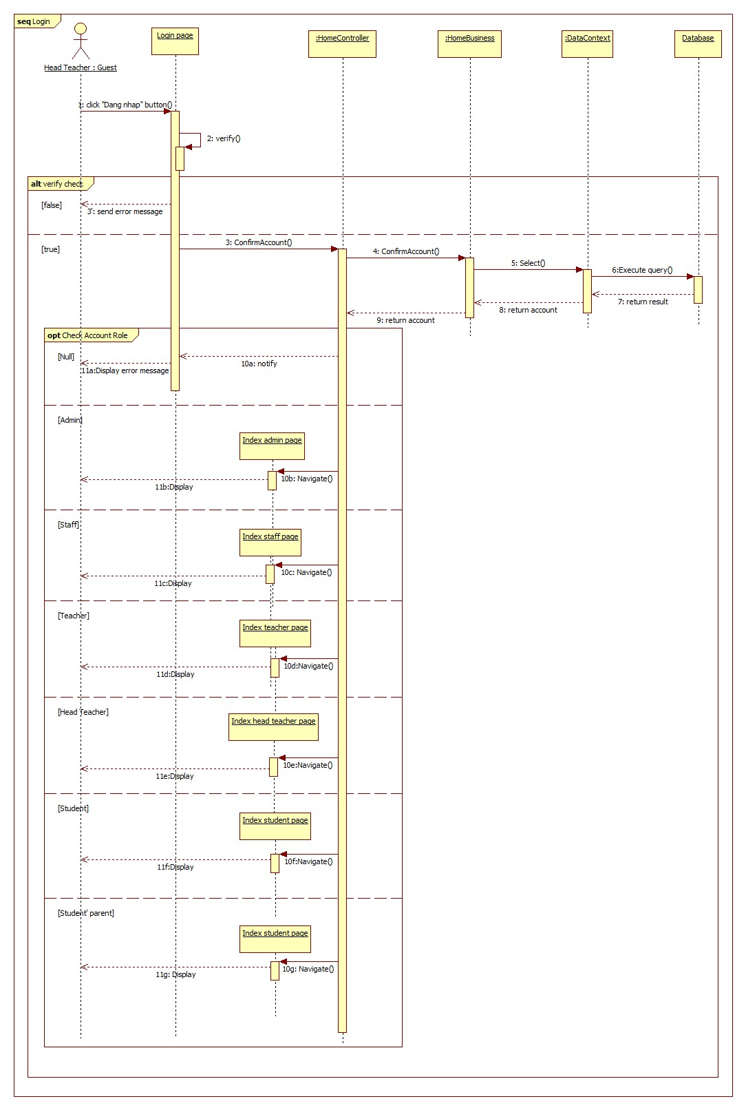**Summary:** This diagram shows how guest login into system.

Figure 38: Sequence Diagram <Guest> Login

#### <Admin> Configuration School Year

**Summary:** This diagram shows how admin configurations new school year into system.

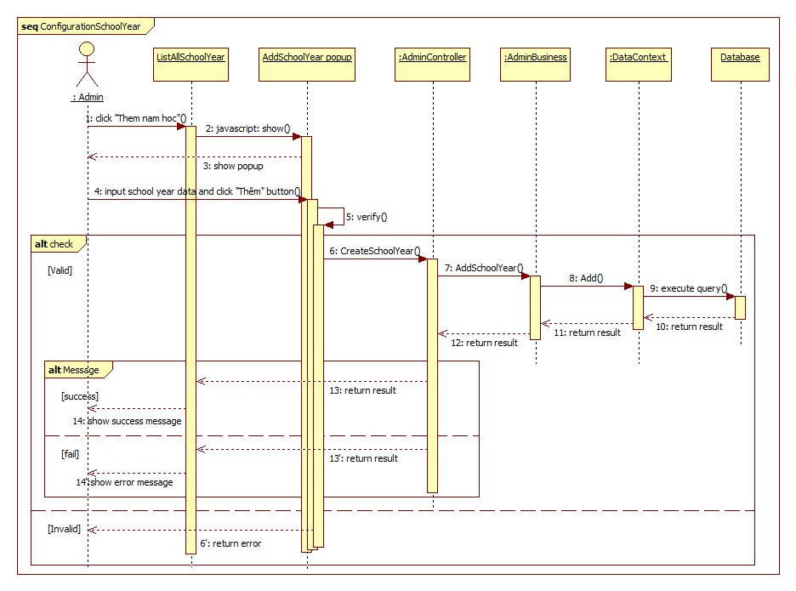

Figure 39: Sequence Diagram <Admin> Configuration School Year

#### <Admin> Add Class

**Summary:** This diagram shows how admin add new class into system.

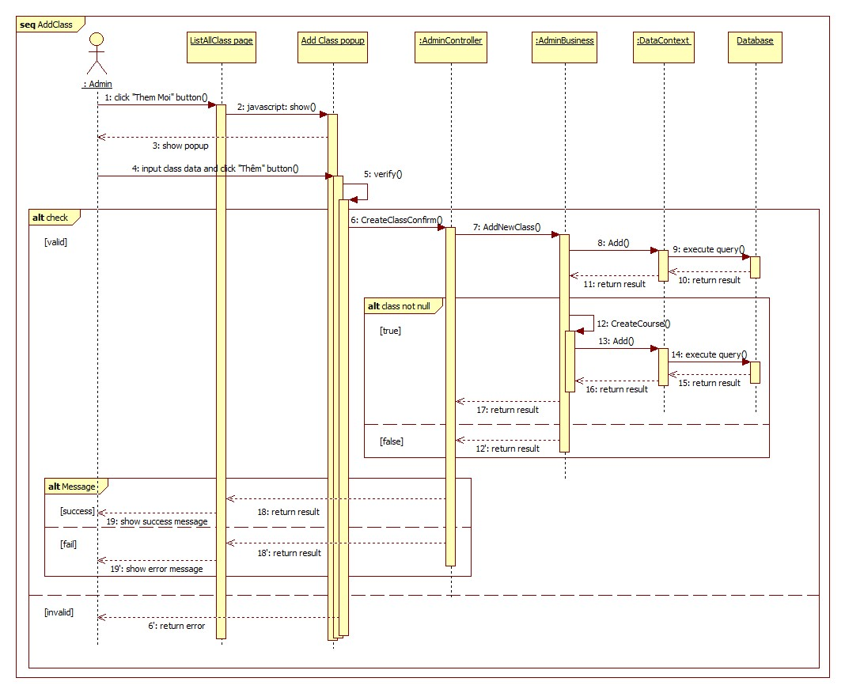

Figure 40: Sequence Diagram <Staff> Add Class

#### <Admin> Add Student Profile

**Summary:** This diagram shows how admin add new student into system.



Figure 41: Sequence Diagram <Admin> Add Student Profile

#### <Admin> Import Student List

**Summary:** This diagram shows how admin import student list into system.

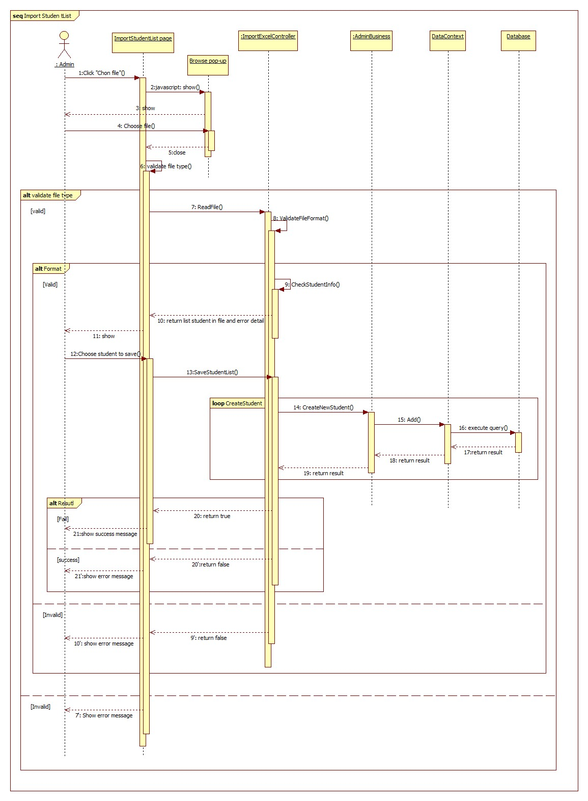

Figure 42: Sequence Diagram <Admin> Import Student List

#### <Admin> Export Student List

**Summary:** This diagram shows how admin export student list from system.

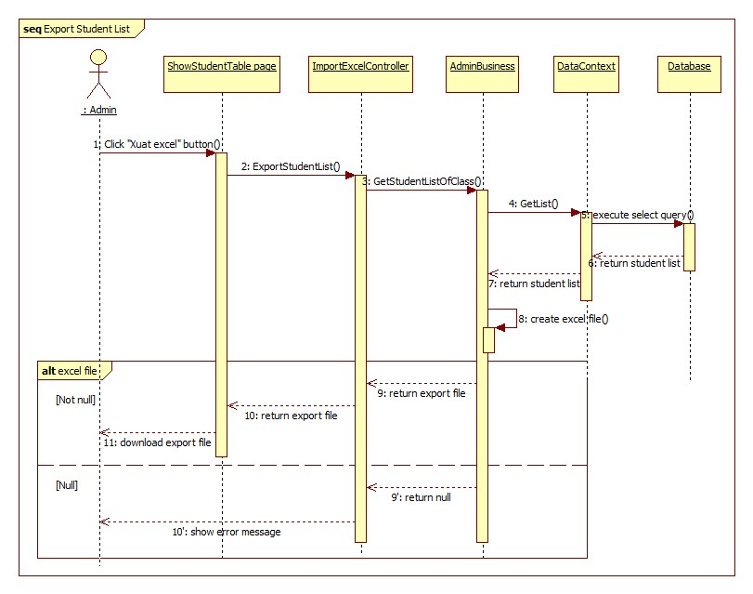

Figure 43: Sequence Diagram<Admin> Export Student List

#### <Admin> Add Teacher Profile

**Summary:** This diagram shows how admin add new teacher into system.

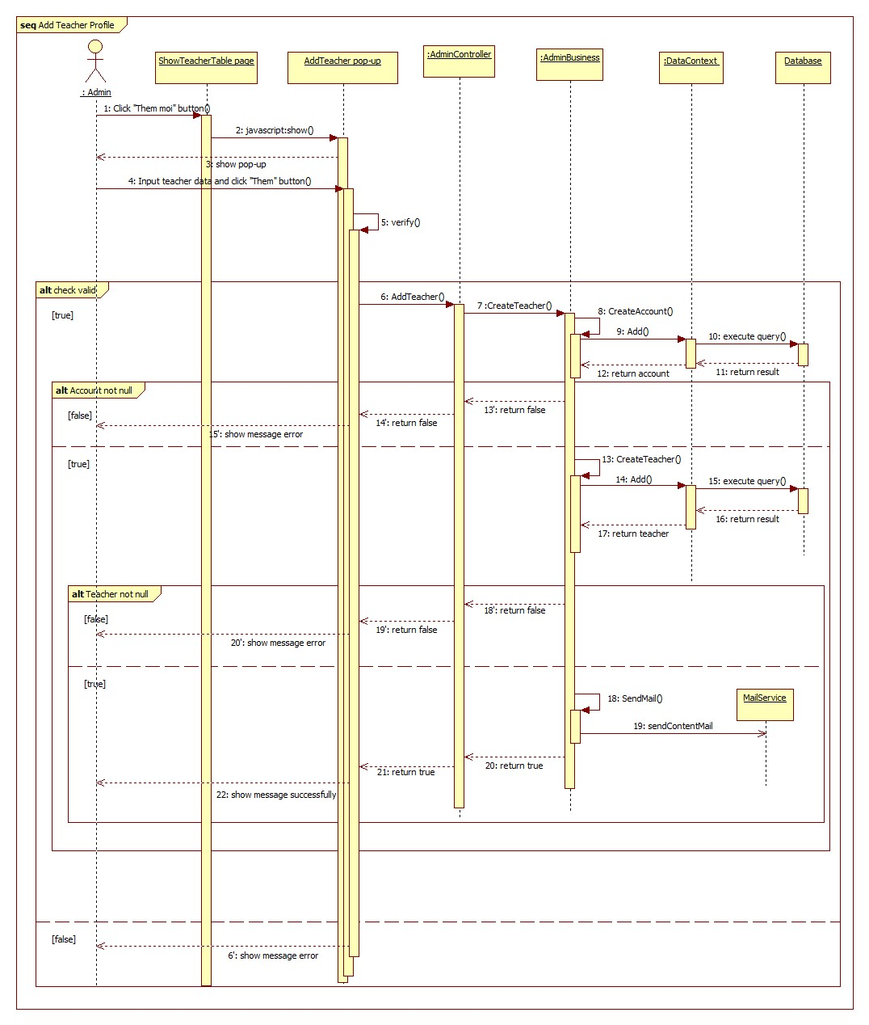

Figure 44: Sequence Diagram <Admin> Add Teacher Profile

#### <Admin> Edit Student Profile

**Summary:** This diagram shows how admin edit student information into system.



Figure 45: Sequence Diagram <Admin> Edit Student Profile

#### <Staff> Add Announcement

**Summary:** This diagram shows how staff add announcement into system.

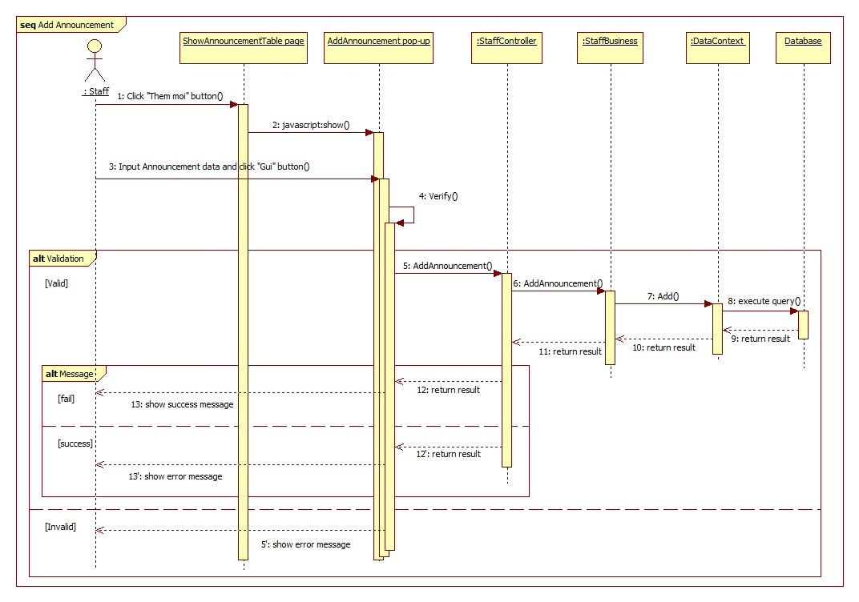

Figure 46: Sequence Diagram <Staff> Add Announcement

#### <Staff> Add Schedule

**Summary:** This diagram shows how staff add schedule into system.

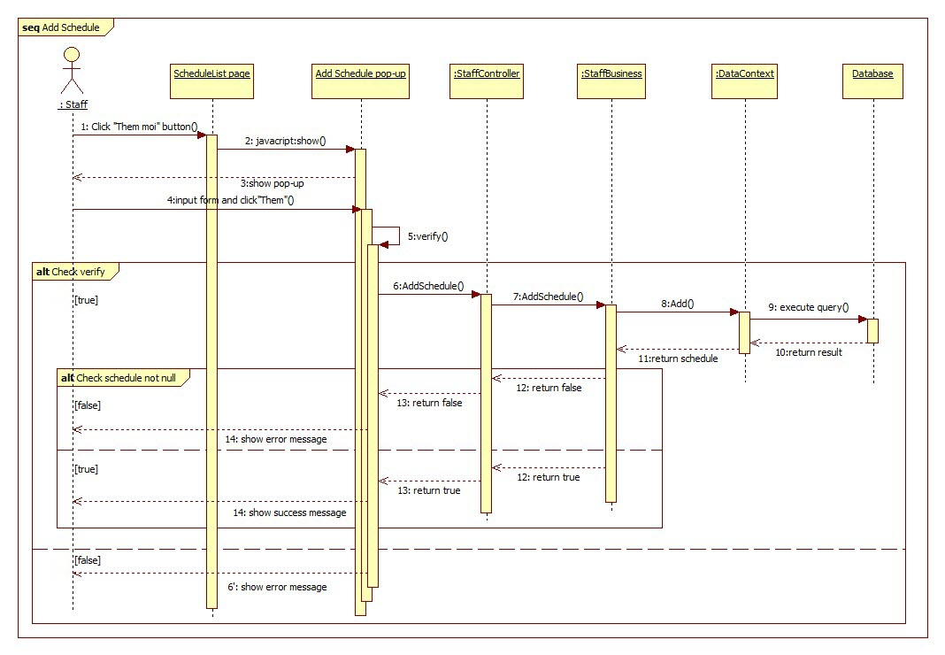

Figure 47: Sequence Diagram <Staff> Add Schedule

#### <Staff> Update Schedule Detail

**Summary:** This diagram shows how staff shows detail of schedule from system.

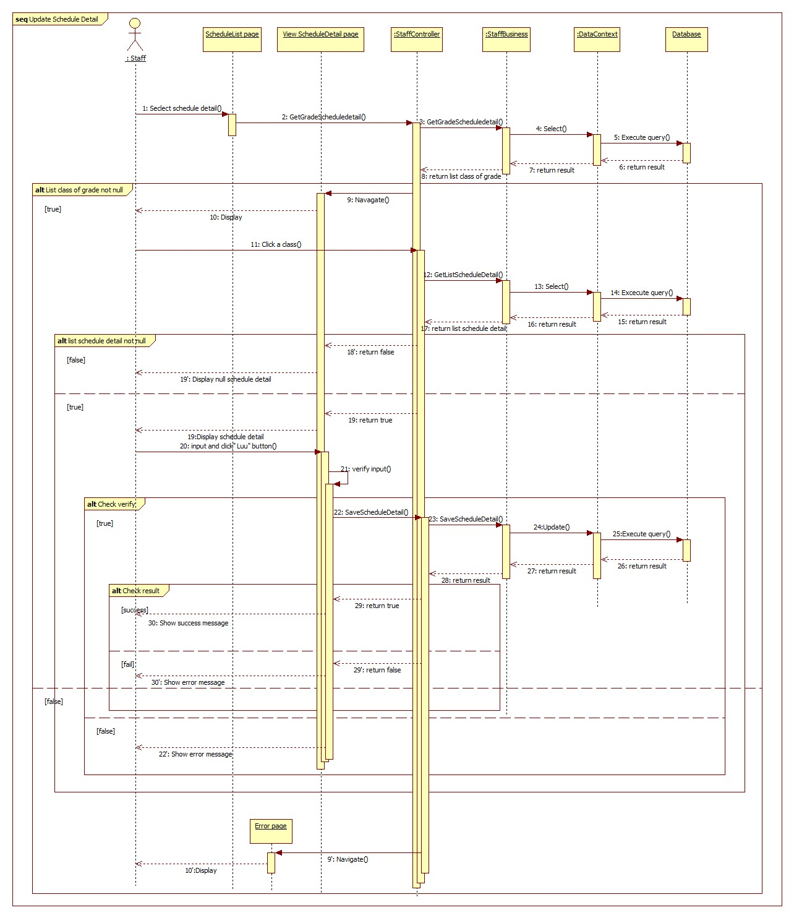

Figure 48: Sequence Diagram <Staff> Update Schedule Detail

#### <Staff> Delete Schedule

**Summary:** This diagram shows how staff delete schedule from system.

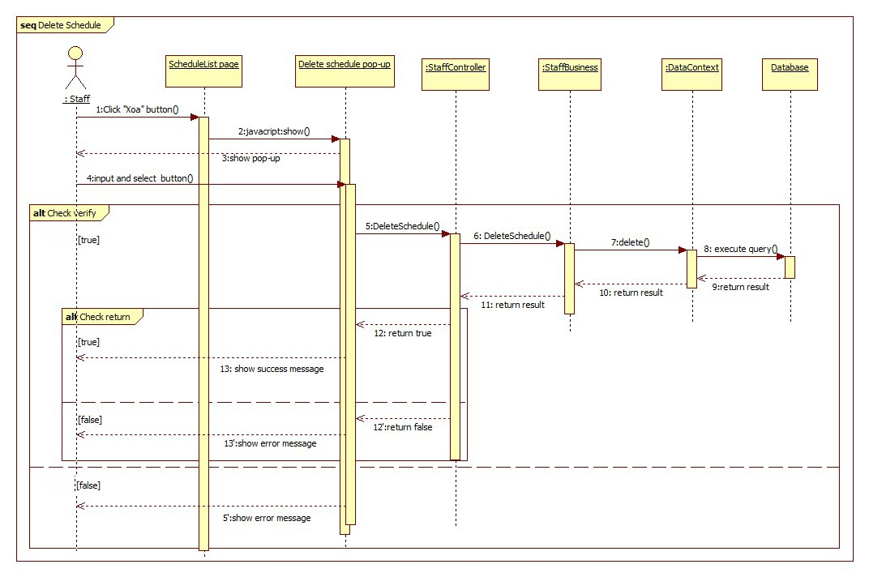

Figure 49: Sequence Diagram <Staff> Delete Schedule

#### <Head Teacher> View Statistic of Grade

**Summary:** This diagram shows how head teacher view statistic of grade.

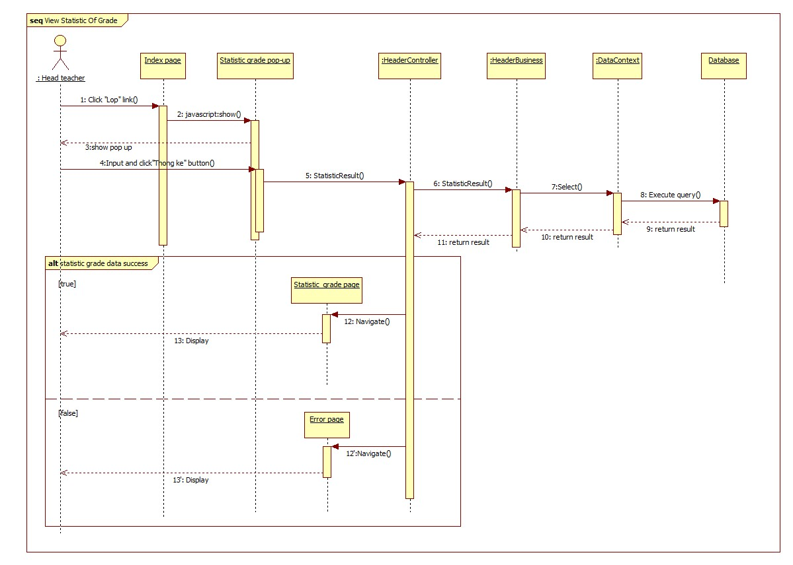

Figure 50: Sequence Diagram <Head Teacher> View Statistic of Grade

#### < Subject Teacher > Edit Gradebook

**Summary:** This diagram shows how subject teacher edit gradebook.

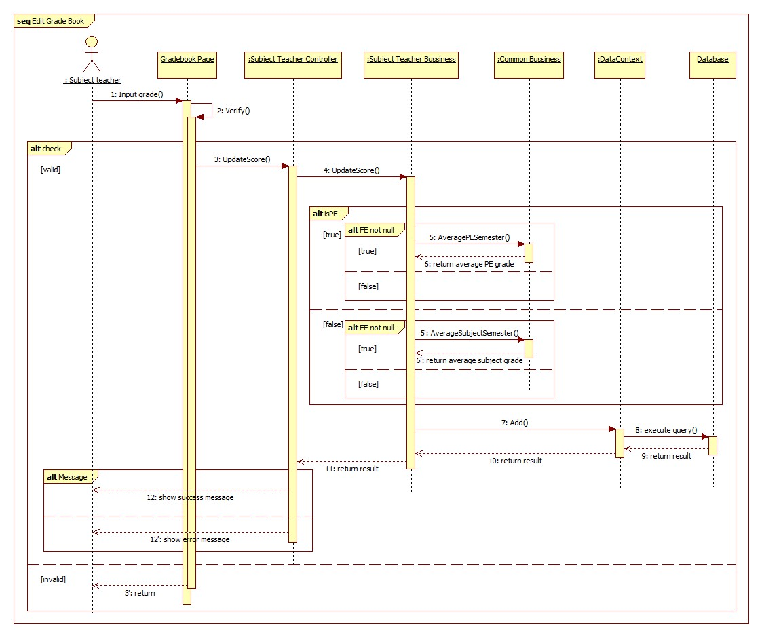

Figure 51: Sequence Diagram <Subject Teacher> Edit Gradebook

#### <Homeroom Teacher> Approve Absence Request

**Summary:** This diagram shows how homeroom teacher approve absence request form.



Figure 52: Sequence Diagram <Homeroom Teacher> Approve Absence Request

#### <Homeroom Teacher> Disapprove Absence Request

**Summary:** This diagram shows how homeroom teacher disapprove absence request.



Figure 53: Sequence Diagram <Homeroom Teacher> Disapprove Absence Request

#### <Homeroom Teacher> Evaluate Behavior

**Summary:** This diagram shows how homeroom teacher evaluate behavior.

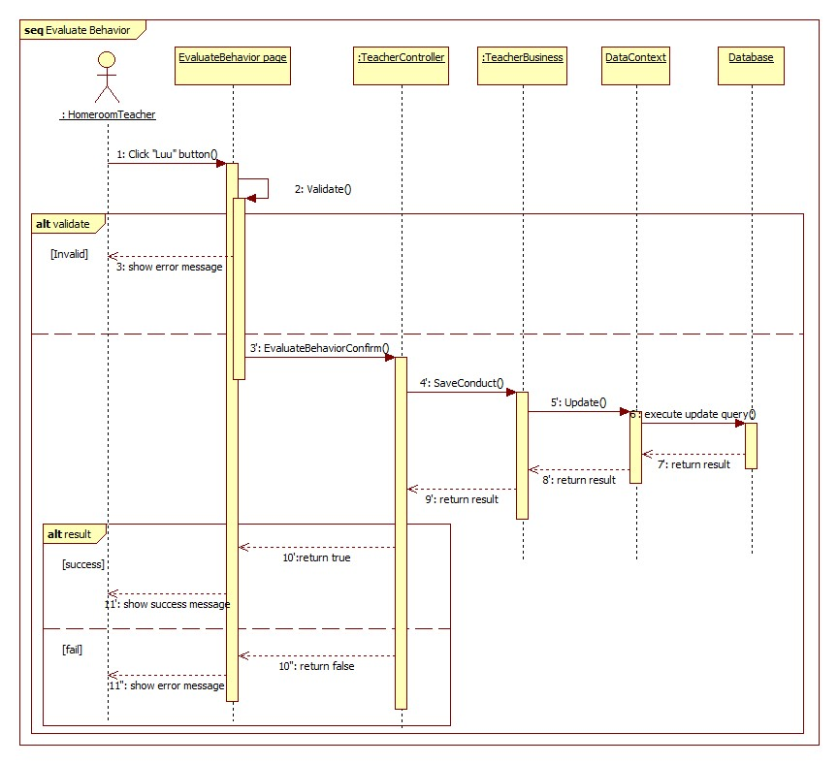

Figure 54: Sequence Diagram <Homeroom Teacher> Evaluate Behavior

#### <Student’s Parent> Send Absence Request

**Summary:** This diagram shows how student’s parent sent absence request.

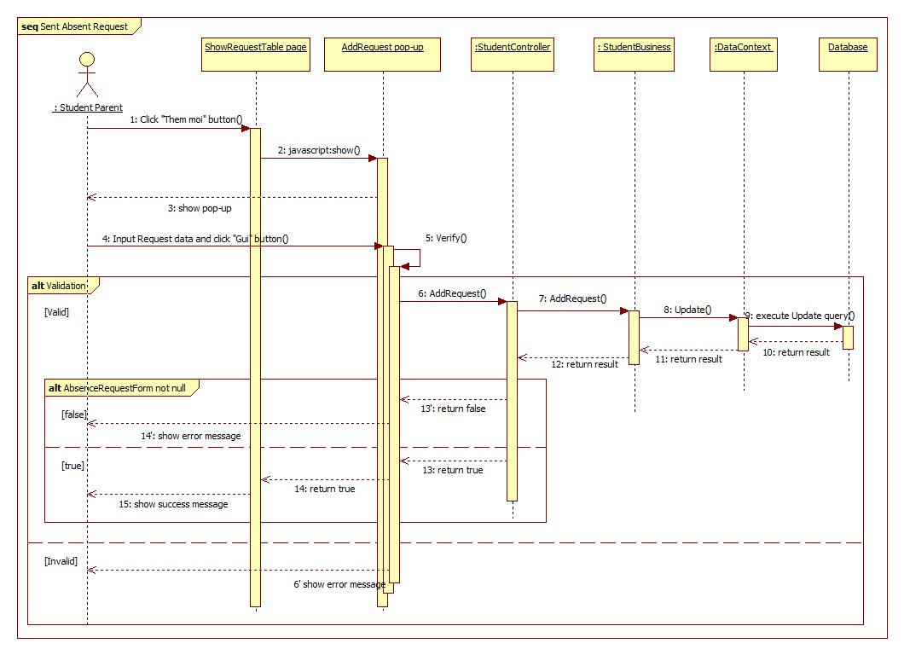

Figure 55: Sequence Diagram <Student’s Parent> Send Absence Request

## User Interface Design

### Guest Interface Design

#### Login

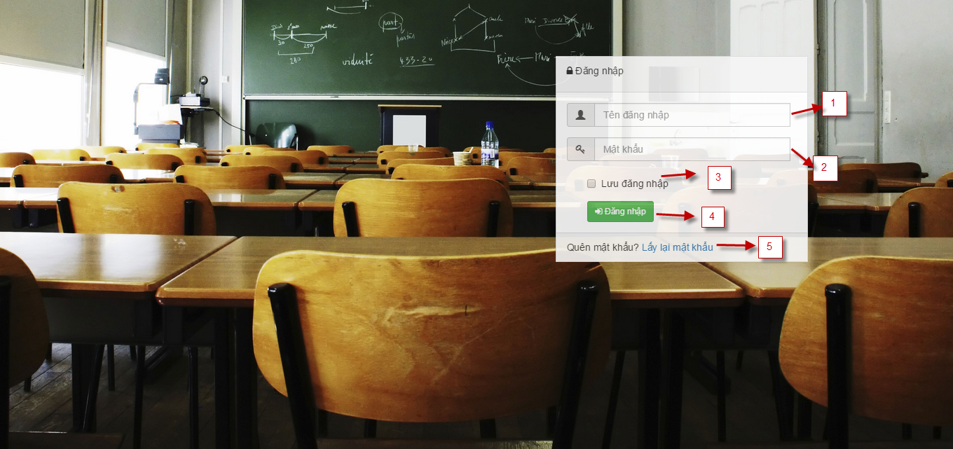

Figure 56: Login Page

**Fields**

|  |  |  |  |  |  |  |  |
| --- | --- | --- | --- | --- | --- | --- | --- |
| No | Field  Name | Description | Read  only | Mandatory | Control  Type | Data  Type | Length |
| 1 | Username | Fill username | No | Yes | Textbox | String | N/A |
| 2 | Password | Fill password | No | Yes | Password | String | N/A |
| 3 | Remember account | Check to remember username and password | No | No | Checkbox | Boolean | N/A |

**Buttons/Hyperlinks**

|  |  |  |  |  |
| --- | --- | --- | --- | --- |
| **No** | **Function** | **Description** | **Validation** | **Outcome** |
| 4 | Forgot password | Click when user forgot password | No | Show pop-up forgot password page |
| 5 | Login | Click to login into system | Yes | Navigate to appropriate page |

#### Admin Home Page

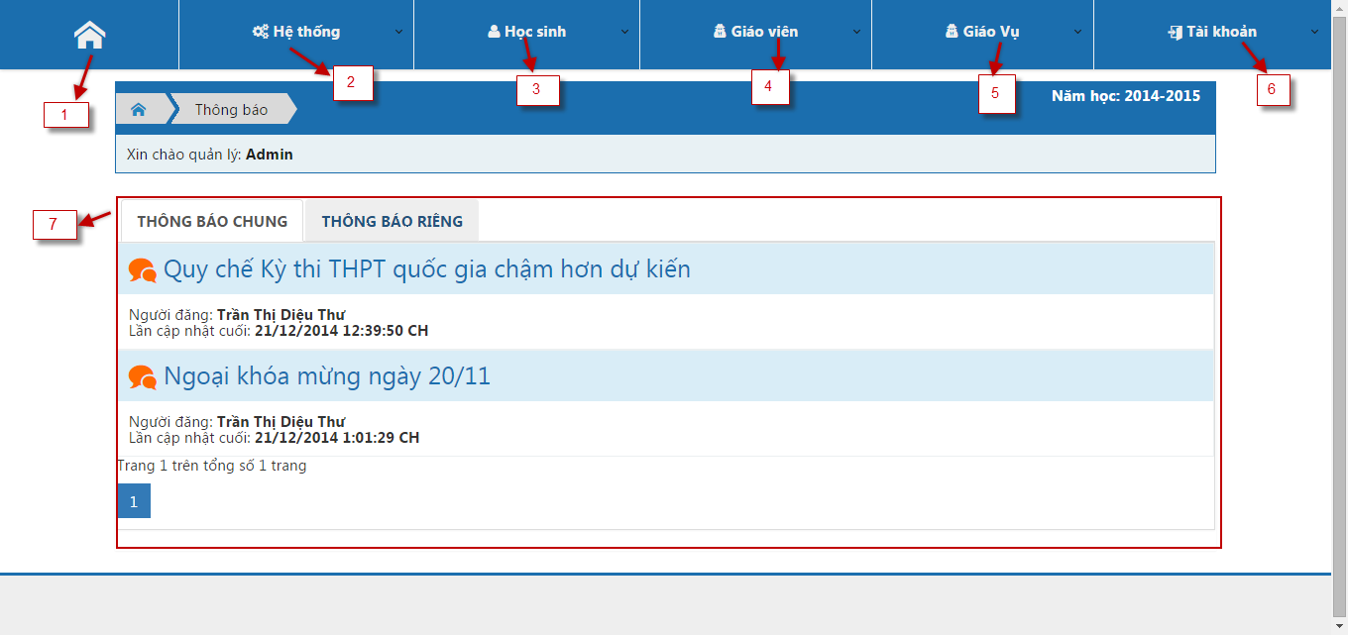

Figure 57: Admin Home Page

**Fields**

|  |  |  |  |  |  |  |  |
| --- | --- | --- | --- | --- | --- | --- | --- |
| No | Field  Name | Description | Read  only | Mandatory | Control  Type | Data  Type | Length |
| 2 | System | Click to show drop down list system function | No | No | Drop down | N/A | N/A |
| 3 | Student | Click to show drop down list student function | No | No | Drop down | N/A | N/A |
| 4 | Teacher | Click to show drop down list teacher function | No | No | Drop down | N/A | N/A |
| 5 | Staff | Click to show drop down list staff function | No | No | Drop down | N/A | N/A |
| 6 | Account | Click to show drop down list system function | No | No | Drop down | N/A | N/A |
| 7 | Announcement | Click show public and private announcement | Yes | No | Tab | N/A | N/A |

**Buttons/Hyperlinks**

|  |  |  |  |  |
| --- | --- | --- | --- | --- |
| **No** | **Function** | **Description** | **Validation** | **Outcome** |
| 1 | Home | Show home page | No | Show index home page of admin |

#### School Year List

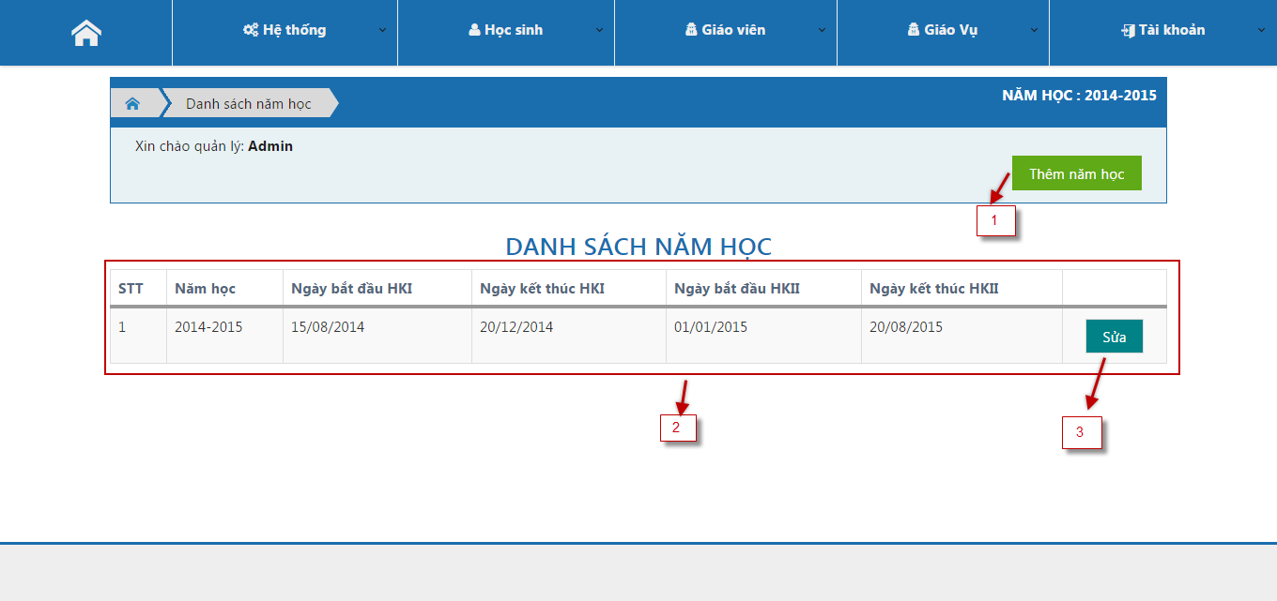

Figure 58: School Year List Page

**Fields**

|  |  |  |  |  |  |  |  |
| --- | --- | --- | --- | --- | --- | --- | --- |
| No | Field  Name | Description | Read  only | Mandatory | Control  Type | Data  Type | Length |
| 2 | School year table | Show all school year | Yes | Yes | Table | String | N/A |

**Buttons/Hyperlinks**

|  |  |  |  |  |
| --- | --- | --- | --- | --- |
| **No** | **Function** | **Description** | **Validation** | **Outcome** |
| 1 | Create new | Click create new school year | No | Show pop-up create new school year |
| 3 | Edit | Click edit school year | No | Show pop-up edit school year |

#### Add New School Year

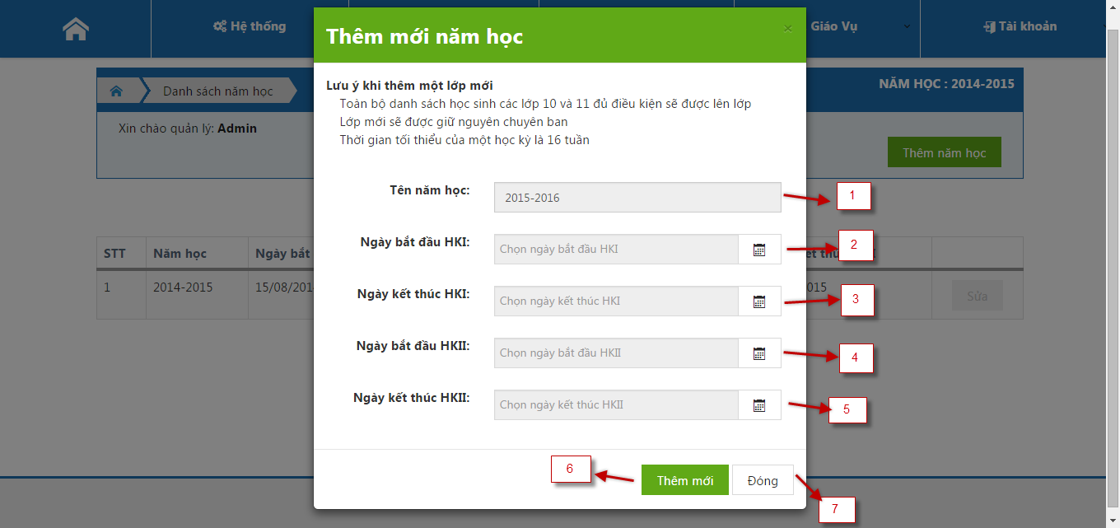

Figure 59: Add New School Year Page

**Fields**

|  |  |  |  |  |  |  |  |
| --- | --- | --- | --- | --- | --- | --- | --- |
| No | Field  Name | Description | Read  only | Mandatory | Control  Type | Data  Type | Length |
| 1 | School year name | Fill name of school year | No | Yes | Text box | String | N/A |
| 2 | Start date 1st semester | Select date time of start date 1st semester | No | Yes | Date picker | Date | N/A |
| 3 | End date 1st semester | Select date time of end date 1st semester | No | Yes | Date picker | Date | N/A |
| 4 | Start date 2nd semester | Select date time of start date 2nd semester | No | Yes | Date picker | Date | N/A |
| 5 | End date 1st semester | Select date time of end date 2nd semester | No | Yes | Date picker | Date | N/A |

**Buttons/Hyperlinks**

|  |  |  |  |  |
| --- | --- | --- | --- | --- |
| **No** | **Function** | **Description** | **Validation** | **Outcome** |
| 6 | Create new | Click create new school year | Yes | Add new school year and close pop-up |
| 7 | Close | Click cancel add school year | No | Close pop-up |

#### Teacher List

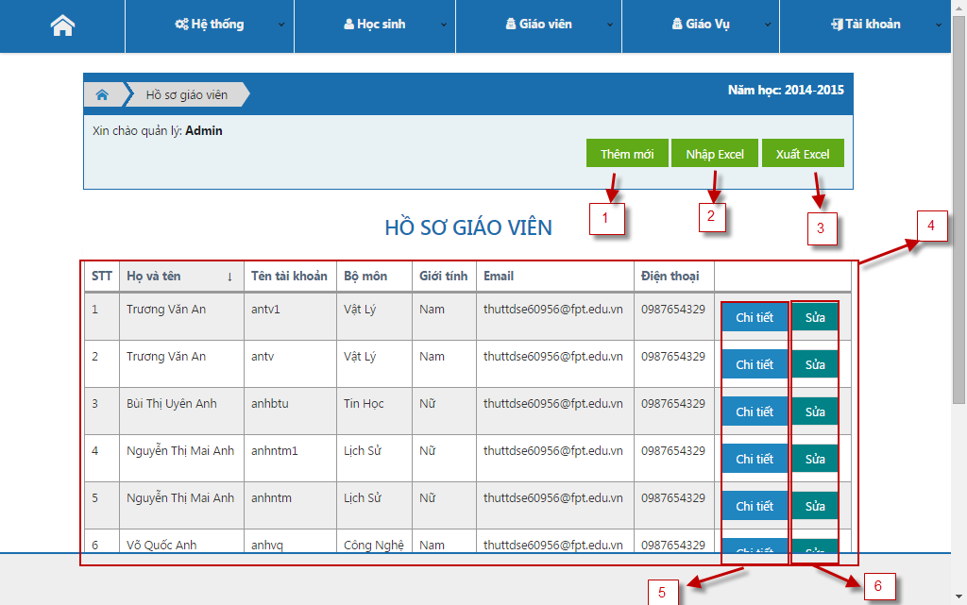

Figure 60: Teacher List Page

**Fields**

|  |  |  |  |  |  |  |  |
| --- | --- | --- | --- | --- | --- | --- | --- |
| No | Field  Name | Description | Read  only | Mandatory | Control  Type | Data  Type | Length |
| 4 | Teacher table | Show teacher in a school | Yes | Yes | Table | String | N/A |

**Buttons/Hyperlinks**

|  |  |  |  |  |
| --- | --- | --- | --- | --- |
| **No** | **Function** | **Description** | **Validation** | **Outcome** |
| 1 | Create new teacher | Click create new teacher | No | Show pop-up create new teacher |
| 2 | Import Excel | Click to up excel file into system | No | Navigate to import teacher page |
| 3 | Export Excel | Click to download data of system | No | Download file excel |
| 5 | View detail | Click to view detail a teacher | No | Show pop-up information of teacher page |
| 6 | Edit | Click to edit a teacher | No | Show pop-up edit teacher page |

#### Class List

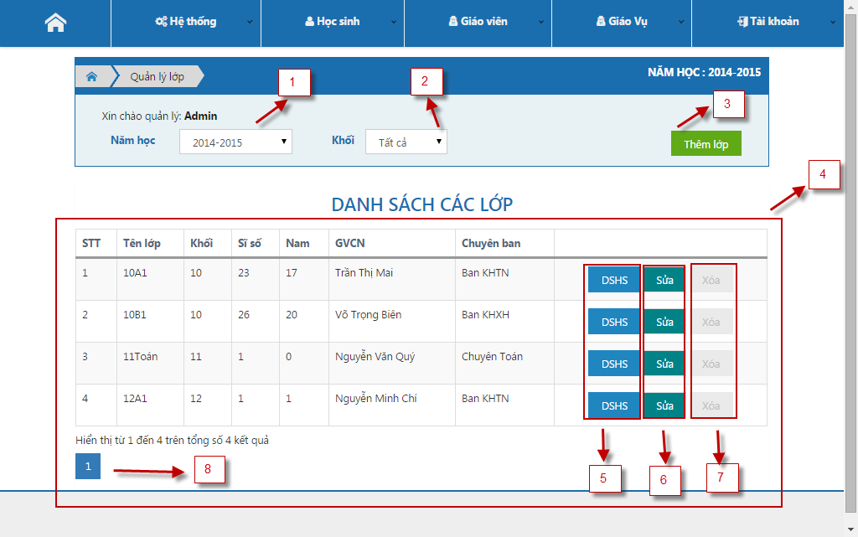

Figure 61: Class List Page

**Fields**

|  |  |  |  |  |  |  |  |
| --- | --- | --- | --- | --- | --- | --- | --- |
| No | Field  Name | Description | Read  only | Mandatory | Control  Type | Data  Type | Length |
| 4 | Class in school year table | Show all classes in current school year | Yes | Yes | Table | String | N/A |

**Buttons/Hyperlinks**

|  |  |  |  |  |
| --- | --- | --- | --- | --- |
| **No** | **Function** | **Description** | **Validation** | **Outcome** |
| 1 | Get class table by year | Select school year name | No | Refresh table with appropriate data |
| 2 | Get table by grade | Select grade school year | No | Refresh table with appropriate data |
| 3 | Create new class | Click create new class | No | Show pop-up create class page |
| 5 | View detail class | Click to view detail a class | No | Show pop-up view detail class page |
| 6 | Edit class | Click to edit class | No | Show pop-up edit class page |
| 7 | Delete class | Click to remove a class | No | Show pop-up remove class page |
| 8 | Pagination | Click to show next data table | No | Next data table is showed |

#### Student List of Class

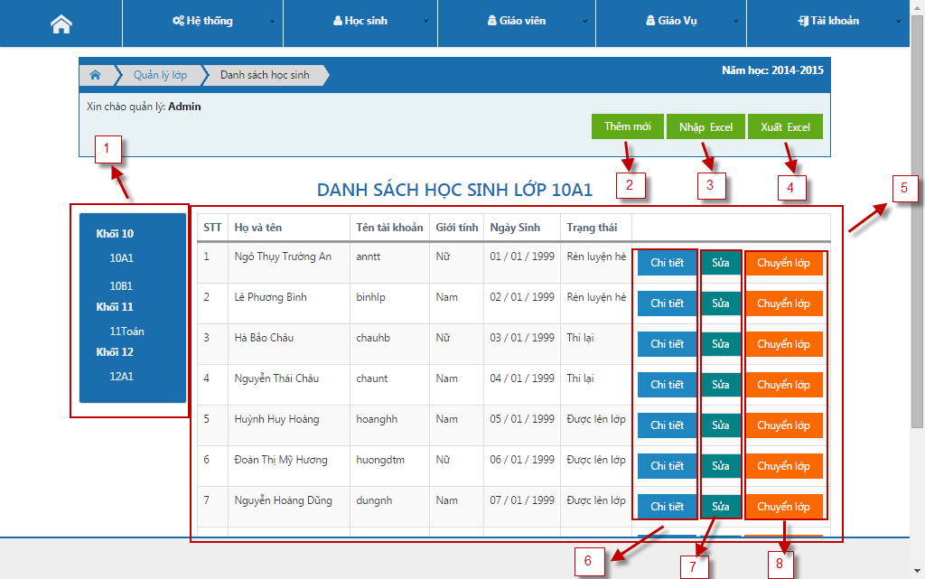

Figure 62: Student List of Class Page

**Fields**

|  |  |  |  |  |  |  |  |
| --- | --- | --- | --- | --- | --- | --- | --- |
| No | Field  Name | Description | Read  only | Mandatory | Control  Type | Data  Type | Length |
| 5 | Student in a class table | View all students in a year | Yes | Yes | Table | String | N/A |

**Buttons/Hyperlinks**

|  |  |  |  |  |
| --- | --- | --- | --- | --- |
| **No** | **Function** | **Description** | **Validation** | **Outcome** |
| 1 | Get class in grade school | Click a class is a grade | No | Show Student in a class table |
| 2 | Create new | Click edit school year | No | Show pop-up edit school year |
| 3 | Import Excel | Click to up excel file | No | Navigate to import student page |
| 4 | Export Excel | Click to download data of system | No | Download file excel |
| 6 | View Detail | Click to view detail a student | No | Show pop-up detail student page |
| 7 | Edit | Click to edit a student | No | Show pop-up edit student page |
| 8 | Transfer class | Click to change current class to another class | No | Show pop-up transfer class page |

#### Assign Teaching

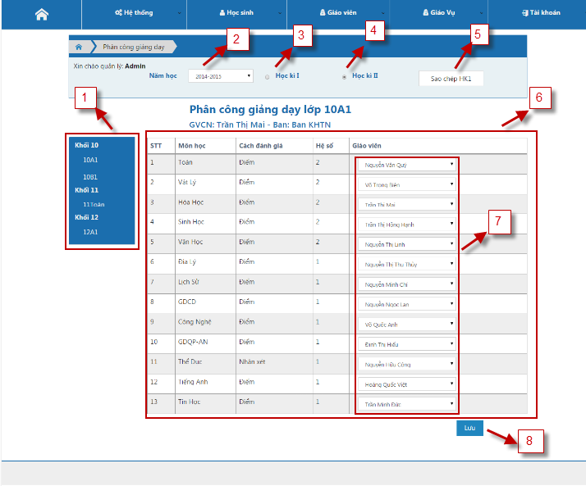

Figure 63: Assign Teaching Page

**Fields**

|  |  |  |  |  |  |  |  |
| --- | --- | --- | --- | --- | --- | --- | --- |
| No | Field  Name | Description | Read  only | Mandatory | Control  Type | Data  Type | Length |
| 6 | Assign teacher table | Show list assign teacher | Yes | Yes | Table | String | N/A |
| 7 | Teacher list | Select a teacher for a subject of class | No | Yes | Drop down list | String | N/A |

**Buttons/Hyperlinks**

|  |  |  |  |  |
| --- | --- | --- | --- | --- |
| **No** | **Function** | **Description** | **Validation** | **Outcome** |
| 1 | Get class in grade school | Click a class of grade | No | Show assign teacher table |
| 2 | Get assign teacher table by school year | Select a year name | No | Refresh and get new data |
| 3 | Get assign teacher table by 1st semester | Check 1st semester | No | Refresh and get new data |
| 4 | Get assign teacher table by 2nd semester | Check 2nd semester | No | Refresh and get new data |
| 5 | Copy data | Click copy assign teacher of semester | Yes | Copy assign teacher of 1st semester |
| 8 | Save | Click to save assign teacher | Yes | Save data and show success message |

#### Manage Account

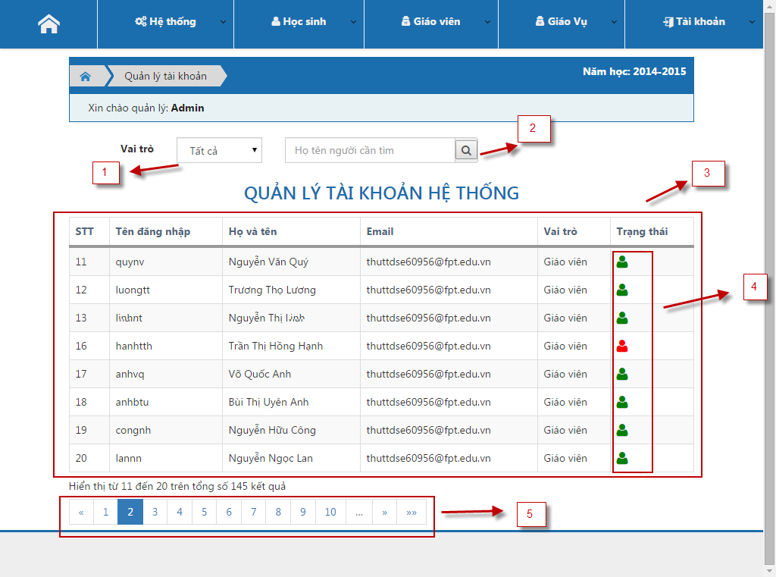

Figure 64: Manage Account Page

**Fields**

|  |  |  |  |  |  |  |  |
| --- | --- | --- | --- | --- | --- | --- | --- |
| No | Field  Name | Description | Read  only | Mandatory | Control  Type | Data  Type | Length |
| 3 | Manage account table | Show all account in system | Yes | Yes | Table | String | N/A |

**Buttons/Hyperlinks**

|  |  |  |  |  |
| --- | --- | --- | --- | --- |
| **No** | **Function** | **Description** | **Validation** | **Outcome** |
| 1 | Get list accounts by role | Select a role in system | No | Refresh and show new data by role |
| 2 | Search an account | Fill and click to search an account | No | Refresh and show result of search |
| 4 | Status | Click to change status | No | Save status and change color of account |
| 5 | Pagination | Click to view next data | No | Refresh and show new data |

#### Manage Announcement

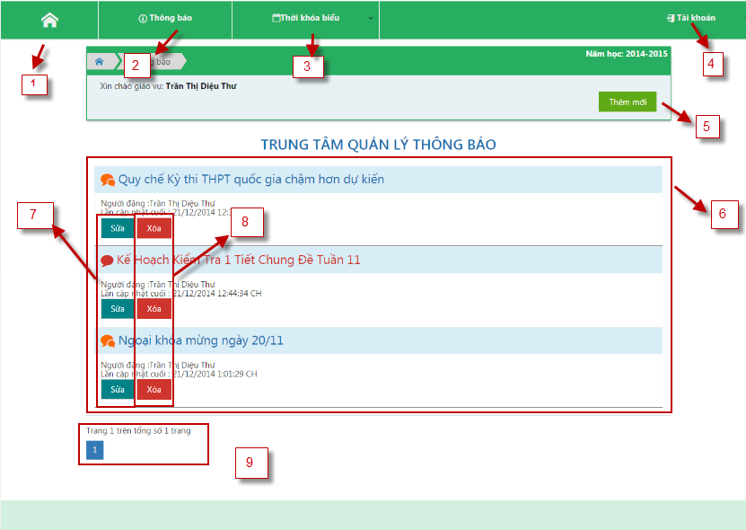

Figure 65: Manage Announcement Page

**Fields**

|  |  |  |  |  |  |  |  |
| --- | --- | --- | --- | --- | --- | --- | --- |
| No | Field  Name | Description | Read  only | Mandatory | Control  Type | Data  Type | Length |
| 2 | Manage announcement | Click to select announcement function | No | No | Drop down list | N/A | N/A |
| 3 | Schedule | Click to select schedule function | No | No | Drop down list | N/A | N/A |
| 4 | Account | Click to select account function | No | No | Drop down list | N/A | N/A |
| 6 | Announcement table | Show public and private announcement | No | No | Accordion | N/A | N/A |

**Buttons/Hyperlinks**

|  |  |  |  |  |
| --- | --- | --- | --- | --- |
| **No** | **Function** | **Description** | **Validation** | **Outcome** |
| 1 | Home | Show home page | No | Show index home page of Staff |
| 5 | Create new | Click to create new announcement | No | Show pop-up create new announcement page |
| 7 | Edit | Click to edit an announcement | No | Show pop-up edit announcement page |
| 8 | Delete | Click to delete an announcement | No | Show pop-up delete announcement page |
| 9 | Pagination | Click to view next data | No | Refresh and show new data |

#### Manage Schedule

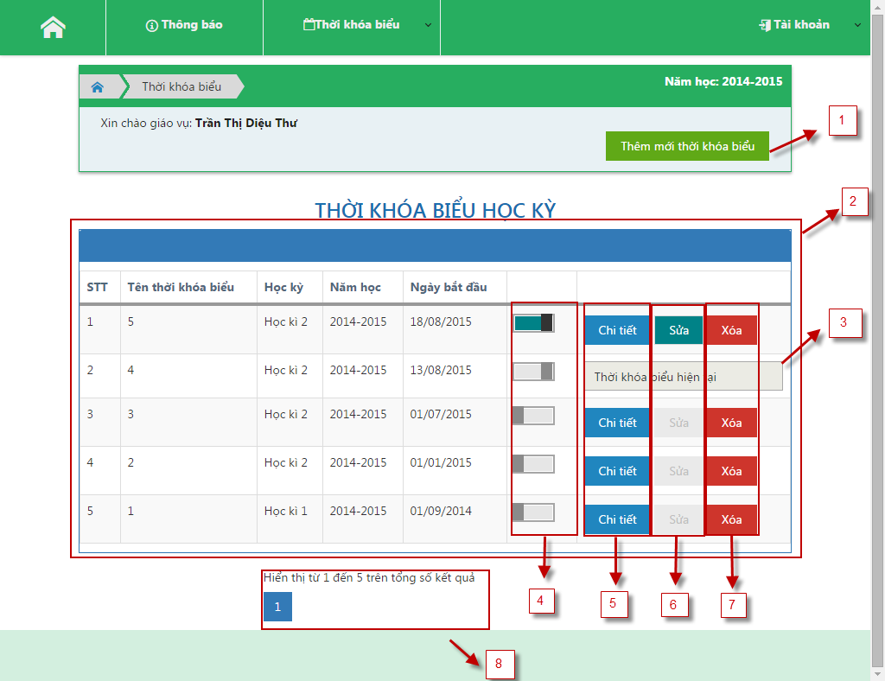

Figure 66: Manage Schedule Page

**Fields**

|  |  |  |  |  |  |  |  |
| --- | --- | --- | --- | --- | --- | --- | --- |
| No | Field  Name | Description | Read  only | Mandatory | Control  Type | Data  Type | Length |
| 2 | Schedule list table | View all schedule in a year | Yes | Yes | Table | String | N/A |
| 3 | Schedule current | Schedule is used for all class at the present | Yes | Yes | Text | String | N/A |

**Buttons/Hyperlinks**

|  |  |  |  |  |
| --- | --- | --- | --- | --- |
| **No** | **Function** | **Description** | **Validation** | **Outcome** |
| 1 | Create new | Click to add new schedule | No | Show pop-up create schedule page |
| 4 | Change status | Scroll to change status of schedule | No | Save status into data and change color in user interface |
| 5 | View detail schedule | Click to view detail of schedule | No | Show pop-up detail schedule page |
| 6 | Edit | Click to edit a schedule | No | Show pop-up edit schedule page |
| 7 | Delete | Click to delete a schedule | No | Show pop-up Delete schedule page |
| 8 | Pagination | Click to view next data | No | Refresh and show new data |

#### Statistic of Grade

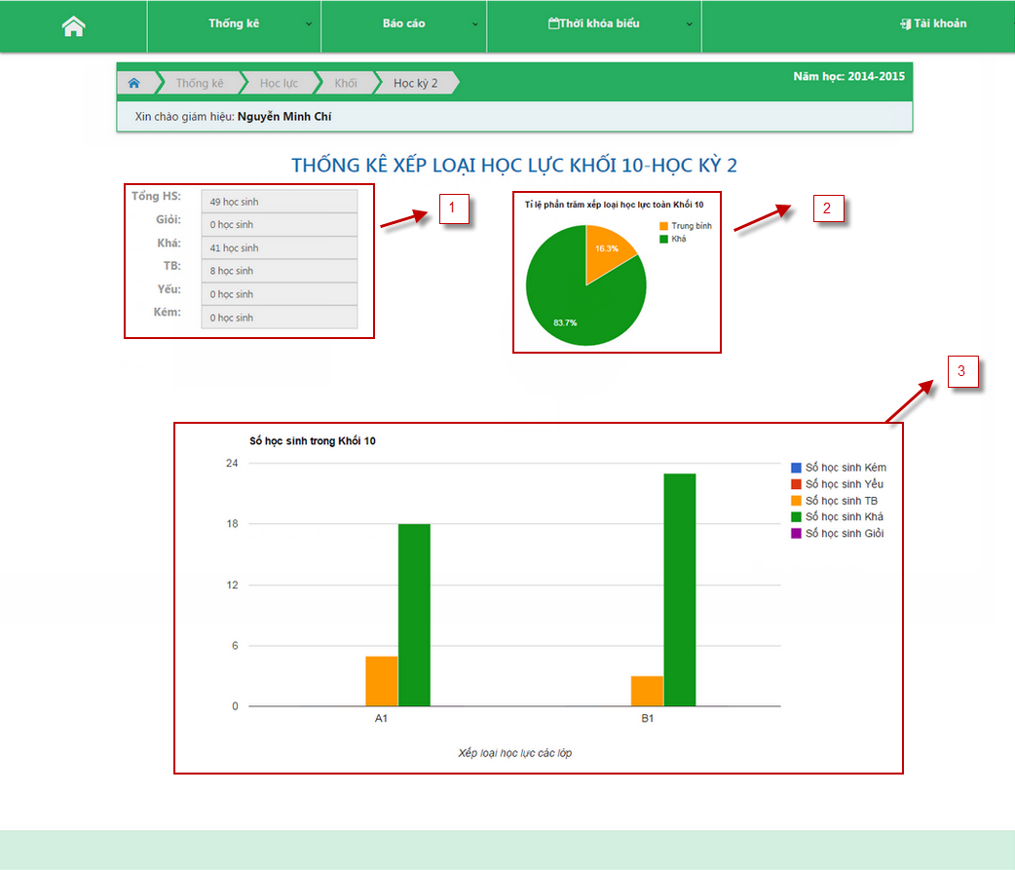

Figure 67: Statistic of Grade Page

**Fields**

|  |  |  |  |  |  |  |  |
| --- | --- | --- | --- | --- | --- | --- | --- |
| No | Field  Name | Description | Read  only | Mandatory | Control  Type | Data  Type | Length |
| 1 | Summary of class | View all result of student | Yes | Yes | N/A | N/A | N/A |
| 2 | Pie chart | View present result of student | Yes | Yes | N/A | N/A | N/A |
| 3 | Bar chart | View all result of student | Yes | Yes | N/A | N/A | N/A |

**Buttons/Hyperlinks:** N/A

## Database Design

### Logical Diagram

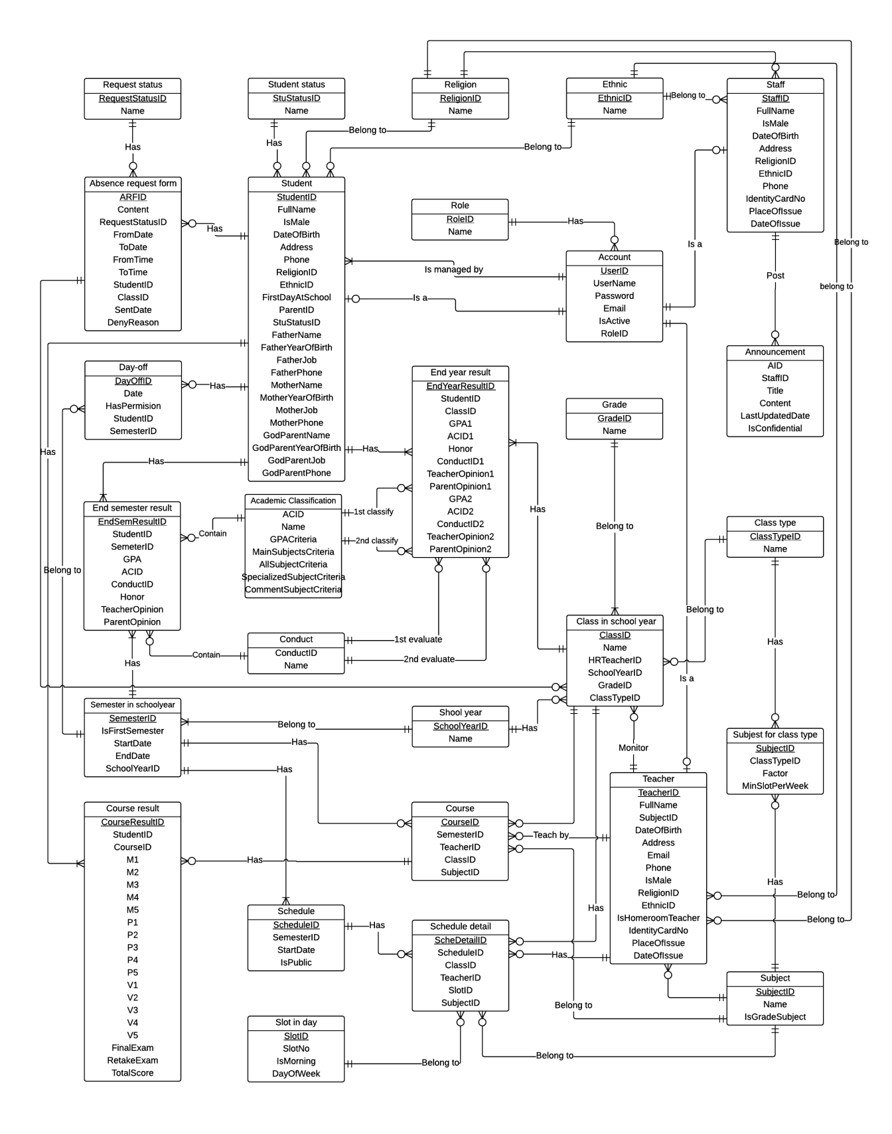

Figure 68: Logical Diagram

### Data Dictionary

Please refer full document in CD.

## Algorithms

Academic classification, considering honor and upgrading methods are based on the circular “58/2011/TT-BGDĐT” of the Ministry of Education and Training.

### Academic classification

There are 5 type of academic classification: “Giỏi” (very good), “Khá” (good), “TB” (mean), “Yếu” (bad), “Kém” (very bad). Classification method for each type is based on 5 criteria:

* GPA
* Math’s total score or Literature’s total score
* All grade subject total score
* Specialized subject’s total score (in case of specialized class)
* Comment subject

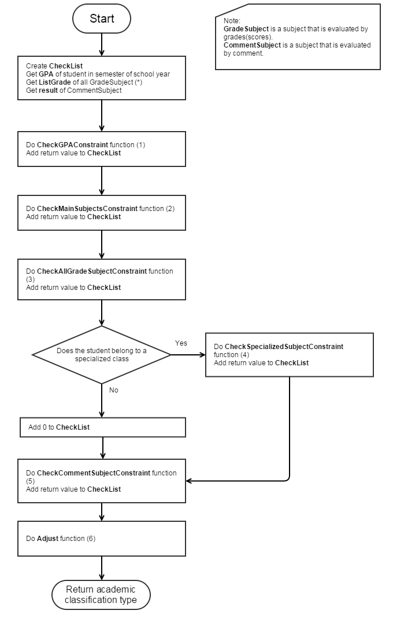

Figure 69: Academic classification main flow

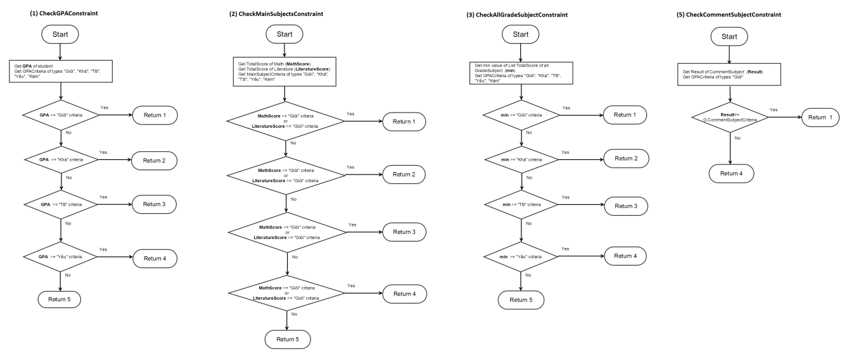

Figure 70: Academic classification sub-flow 1, 2, 3, 5

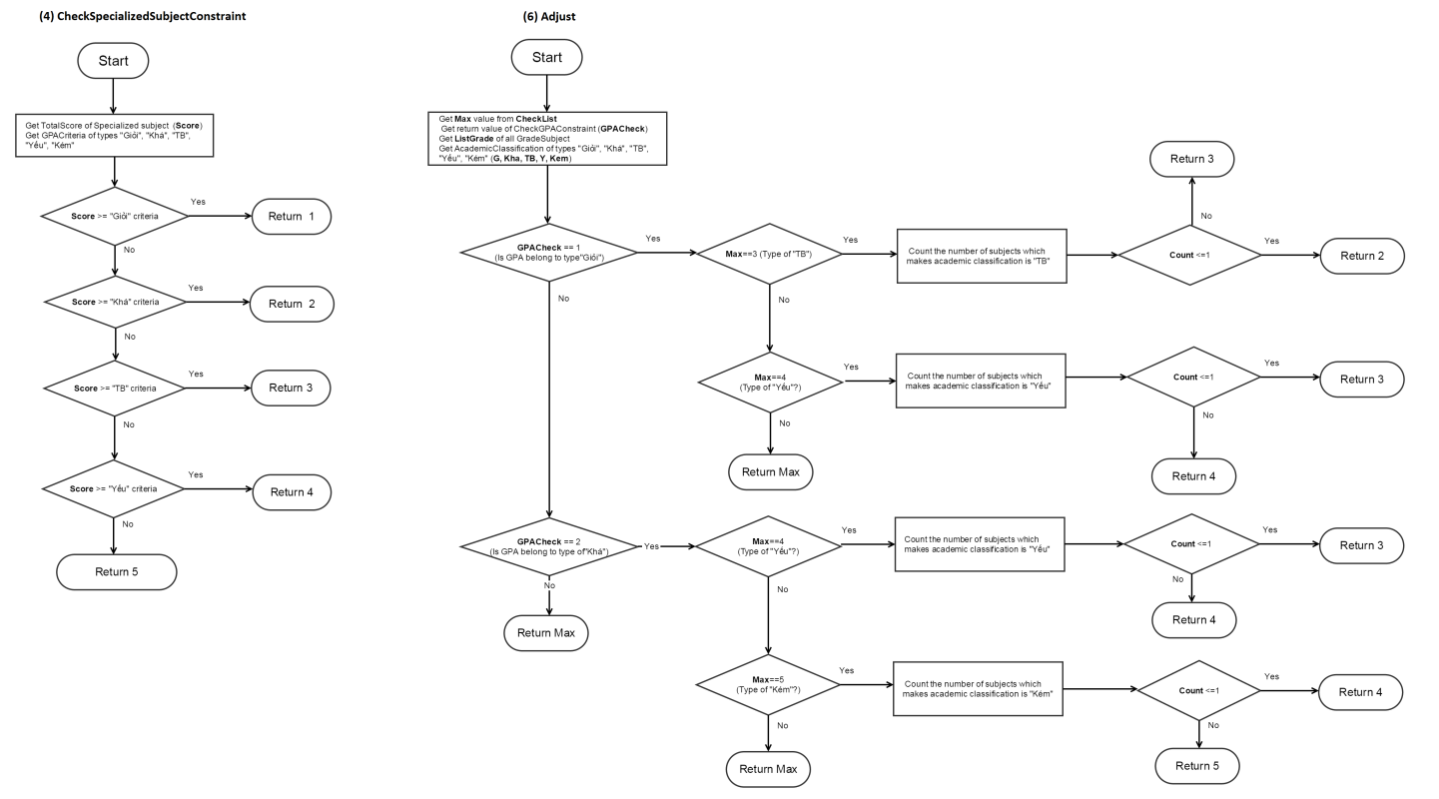

Figure 71: Academic classification sub-flow 4, 6

### Consider of honor

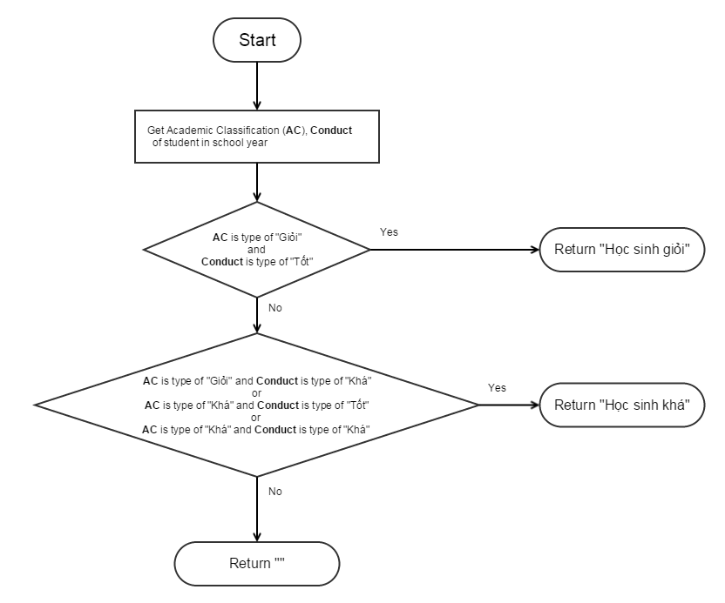

Figure 72: Consider Honor

### Consider of upgrading

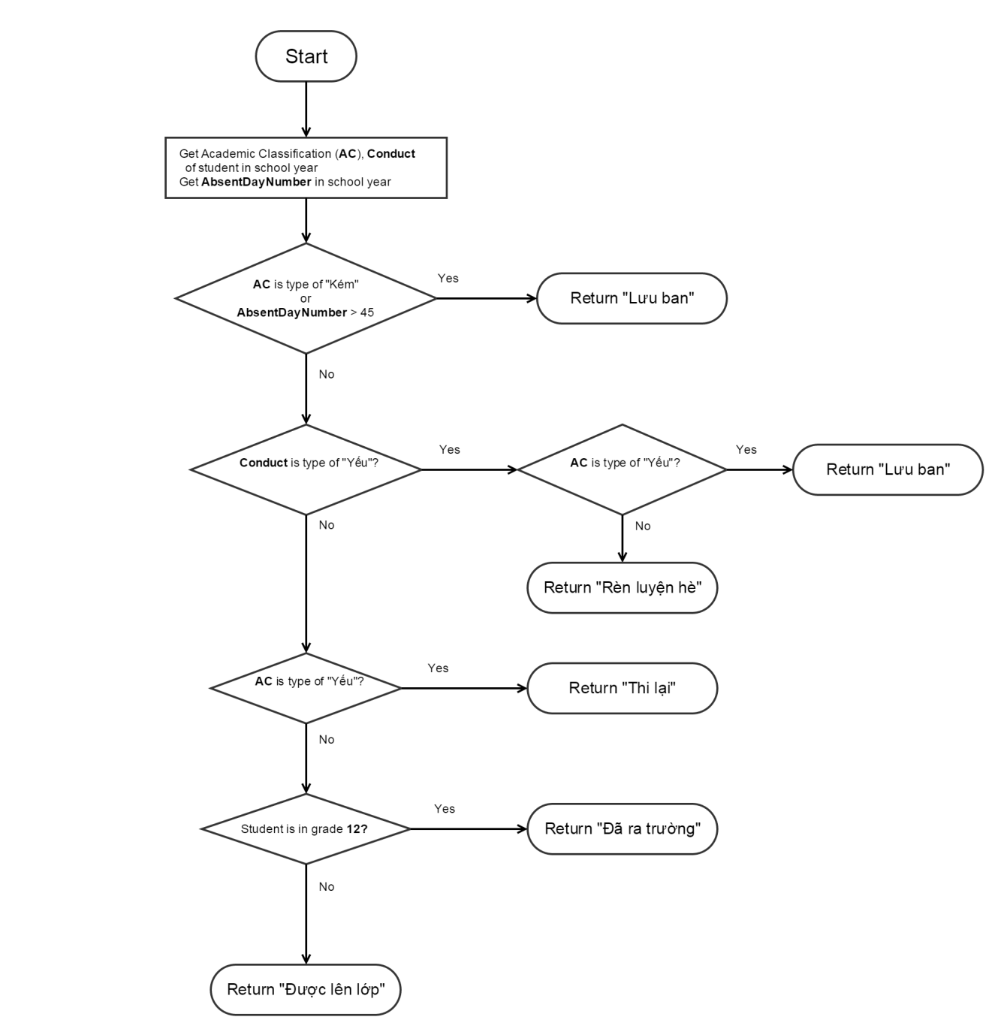

Figure 73: Consider Upgrading

### State Machine Diagram for Student Status

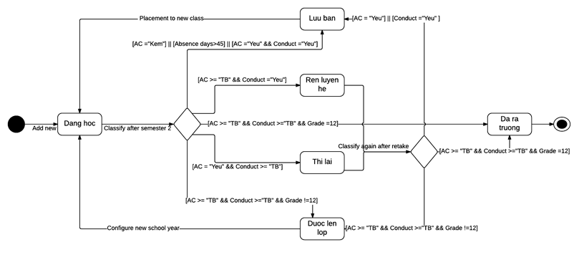

Figure 74: State Machine Diagram for Student Status

### State Machine Diagram for Request Status

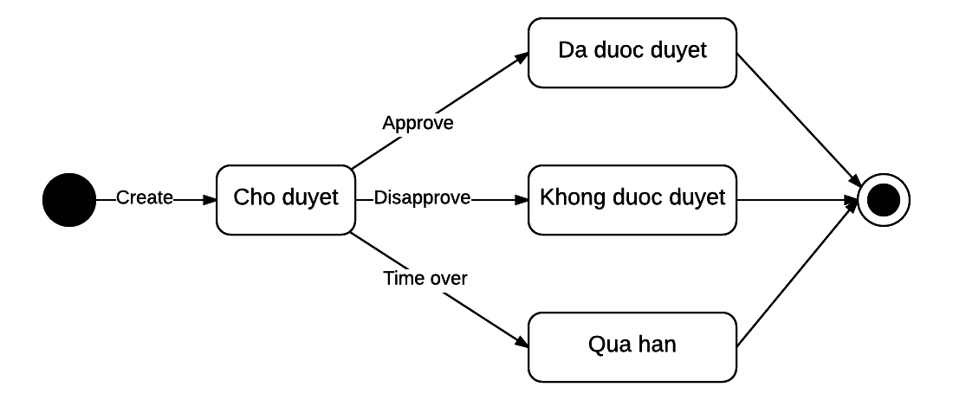

Figure 75: State Machine Diagram for Request Status

# System Implementation & Test

## Introduction

### Overview

This section provides in detail all necessary information about test plans, test cases, test result, test environments, pass/fail criteria and risks estimations as well as a checklist to cover all possible cases of this project.

### Test Approach

* Goal: To test the whole system based on the core workflow.
* Method: System Testing, Black – box Testing.

## Database Relationship Diagram

### Physical Diagram



Figure 76: Database Relationship Diagram

### Data Dictionary

#### Data Dictionary

|  |  |
| --- | --- |
| **Relation dictionary** | |
| **Relation Name** | **Description** |
| AbsenceRequestForm | Describe the absent forms of students. |
| AcademicClassification | Describe all kind of academic classification base on 5 criteria. It includes: “Giỏi”, “Khá”, “Trung bình”, “Yếu” and “Kém”. |
| Account | Describe all users of the system. Each user has only one account. |
| Announcement | Describe all announcements. An announcement can be general or confidential one. |
| ClassInSchoolYear | Describe the specific classes in specific years. Each class has maximum 50 students. |
| ClassType | Describe group of classes which have same courses. |
| Conduct | Describe all kind of conduct. It includes: “Tốt”, “Khá”, “Trung bình” and “Yếu”. |
| Course | Weak entity describes all courses. A course should be answer for these questions: In a specific semester, which class has to study which subject? Who teach? |
| CourseResult | Describe the study result of a student in a course. |
| Day-Off | Describe all absent day which had permitted or not of student in specified semester. |
| EndSemesterResult | Weak entity describes the summary result of student in the end of semester. |
| EndYearResult | Weak entity describes the summary result of student in the end of school year. |
| Ethnic | Describe 54 ethnics in Viet Nam. |
| Grade | Describe all grades of a high school, includes: 10, 11, 12 |
| Religion | Describe some religions. |
| RequestStatus | Describe status of request which includes: “Chờ duyệt”, “Đã được duyệt”, “Không được duyệt”, “Quá hạn”. |
| Role | Describe all roles in the system. |
| Schedule | Describe all versions of schedule. |
| ScheduleDetail | Weak entity. A schedule detail should be answer for these questions: In a specific schedule, which class has to study which subject? Who teach? Which slot? |
| SchoolYear | Describe school year. A school year lasts for 9 months, it starts from August and finish at May of the next year. |
| SemesterInSchoolYear | Describe the specific semester in a school year. Each school year has exactly 2 semesters. |
| SlotInDay | Describe all study slots in weekdays. Each slot is 45 minutes. |
| Staff | Describe all staff profiles in the system. |
| Student | Describe all students in the system. |
| StudentStatus | Describe status of student which includes: “Đang học”, ” Được lên lớp”, ”Lưu ban”, ”Đã ra trường”, ”Rèn luyện hè”, “Thi lại”. |
| Subject | Describe all available subjects being taught in high school. |
| SubjectForClassType | Describe detail subjects for each type of class. |
| Teacher | Describe all teacher profiles in the system. Each teacher has only one account and teaches only one subject. |

Table 39: Data Dictionary

#### Attribute Data Dictionary

|  |  |  |  |  |
| --- | --- | --- | --- | --- |
| **Table name** | **Attributes** | **Description** | **Domain** | **Null** |
| AbsenceRequestForm | ARFID(PK) | Unique identifier of absence request form, auto increment. | int | No |
| Content | Content of absence request form. | nvarchar(max) | No |
| RequestStatus{FK} | Identity of request status. | int | No |
| FromDate | Start date of student absence | date | No |
| ToDate | End date of student absence | date | Yes |
| FromTime | Morning/Afternoon/All | int | No |
| ToTime | Morning/Afternoon/All | int | Yes |
| StudentID {FK} | Identity of student. | int | No |
| ClassID{FK} | Identity of class. | int | No |
| SentDate | Sent date of absence request form | datetime | No |
| DeniedReason | Reason of case teacher denies an absence request. | nvarchar(500) | Yes |
| AcademicClassification | ACID{PK} | Unique identifier of Academic classification, auto increment. | int | No |
| Name | Name of academic classification. | nvarchar(20) | No |
| Account | UserID{PK} | Unique identifier, auto increment. | int | No |
| UserName | User name | nvarchar(20) | No |
| Password | password | nvarchar(20) | No |
| Email | Student's email | nvarchar (50) | No |
| RoleID{PK} | Identity of role. | int | No |
| IsActive | Account status | bit | No |
| Announcement | AID{PK} | Unique identifier, auto increment. | int | No |
| StaffID{FK} | Identity of a staff who posts this announcement. | int | No |
| Title | Title of announcement. | nvarchar(50) | No |
| Content | Content of announcement. | nvarchar(max) | No |
| LastUpdatedDate | Last updated date. | date | No |
| IsConfidential | The announcement is confidential or not. | bit | No |
| ClassInSchoolYear | ClassID {PK} | Unique identifier of class, auto increment | int | No |
| GradeID(FK) | Identity of grade | int | No |
| Name | Name of Class | nvarchar(10) | No |
| HRTeacherID {FK} | Identity of a teacher who monitor this class. | int | No |
| SchoolYearID {FK} | Identity of a school year. | int | No |
| ClassTypeID{FK} | Identity of a class type. | int | No |
| ClassType | ClassTypeID{PK} | Unique identifier, auto increment | int | No |
| Name | Class type name. | nvarchar(20) | No |
| SpecializedSubjectID{FK} | Identity of a subject. | int | Yes |
| Conduct | ConductID{PK} | Unique identifier of student conduct, auto increment. | int | No |
| Name | Name of conduct kind. | nvarchar(20) | No |
| Course | CourseID {PK} | Unique identifier of course, auto increment. | int | No |
| SemesterID {FK} | Identity c semester. | int | No |
| TeacherID {FK} | Identity of a teacher. | int | Yes |
| ClassID {FK} | Identity of a class. | int | No |
| SubjectID{FK} | Identity of a subject. | int | No |
| CourseResult | CourseResultID {PK} | Unique identifier of course result, auto increment. | int | No |
| StudentID {FK} | Identity of student. | int | No |
| CourseID {FK} | Identity of course. | int | No |
| M1 | Oral Test 1 | float | Yes |
| M2 | Oral Test 2 | float | Yes |
| M3 | Oral Test 3 | float | Yes |
| M4 | Oral Test 4 | float | Yes |
| M5 | Oral Test 5 | float | Yes |
| P1 | 15 minutes Test 1 | float | Yes |
| P2 | 15 minutes Test 2 | float | Yes |
| P3 | 15 minutes Test 3 | float | Yes |
| P4 | 15 minutes Test 4 | float | Yes |
| P5 | 15 minutes Test 5 | float | Yes |
| V1 | 45 minutes Test 1 | float | Yes |
| V2 | 45 minutes Test 2 | float | Yes |
| V3 | 45 minutes Test 3 | float | Yes |
| V4 | 45 minutes Test 4 | float | Yes |
| V5 | 45 minutes Test 5 | float | Yes |
| FinalExam | Final exam score | float | Yes |
| RetakeExam | Retake exam score | float | Yes |
| TotalScore | Total score | float | Yes |
| DayOff | DayOffID(PK) | Unique identifier of day off, auto increment. | int | No |
| Date | Student's day-off date. | date | No |
| HasPermission | Has/hasn’t permission of teacher. | bit | No |
| StudentID(FK) | Identity of student. | int | No |
| SemesterID(FK) | Identity of semester. | int | No |
| IsMorning | Morning/Afternoon | bit | No |
| EndSemesterResult | EndSemesterResultID {PK} | Unique identifier of a study result of student in a semester, auto increment. | int | No |
| StudentID{FK} | Identity of a student. | int | No |
| SemesterID{FK} | Identity of a semester. | int | No |
| GPA | Grade Point Average of a semester. | float | Yes |
| ACID {FK} | Identity of academic classification. | int | Yes |
| ConductID {FK} | Identity of conduct. | int | Yes |
| Honor | Student's honor | nvarchar(50) | Yes |
| TeacherOpinion | Teacher’s opinion | nvarchar(500) | Yes |
| ParentOpinion | Parent’s opinion | nvarchar(500) | Yes |
| EndYearResult | EndYearResultID {PK} | Unique identifier of a study result of student in a school year, auto increment. | int | No |
| StudentID{FK} | Identity of a student. | int | No |
| ClassID {FK} | Identity of a class in school year. | int | No |
| GPA | Grade Point Average of a semester. | float | Yes |
| ACID {FK} | Identity of academic classification. | int | Yes |
| ConductID {FK} | Identity of conduct. | int | Yes |
| Honor | Student's honor | nvarchar(20) | Yes |
| TeacherOpinion | Teacher’s opinion. | nvarchar(500) | Yes |
| ParentOpinion | Parent’s opinion. | nvarchar(500) | Yes |
| GPA2 | Grade Point Average of a semester. | float | Yes |
| ACID2 {FK} | Identity of academic classification. | int | Yes |
| ConductID2 {FK} | Identity of conduct. | int | Yes |
| TeacherOpinion2 | Teacher’s opinion. | nvarchar(500) | Yes |
| ParentOpinion2 | Parent’s opinion. | nvarchar(500) | Yes |
| Ethnic | EthnicID(PK) | Unique identifier, auto increment. | int | No |
| Name | Name of ethnic. | nvarchar(20) | No |
| Grade | GradeID(PK) | Unique identifier of grade, auto increment. | int | No |
| Name | Name of grade. | nvarchar(20) | No |
| Religion | ReligionID(PK) | Unique identifier of religion, auto increment. | int | No |
| Name | Name of religion. | nvarchar(20) | No |
| RequestStatus | RequestStatusID(PK) | Unique identifier of request status, auto increment. | int | No |
| Name | Name of student request status. | nvarchar(20) | No |
| Role | RoleID{PK} | Unique identifier or role, auto increment. | int | No |
| RoleName | The role name. | nvarchar(20) | No |
| Schedule | ScheduleID {PK} | Unique identifier of schedule, auto increment. | int | No |
| SchoolYearID {FK} | Identity of a school year. | int | No |
| StartDate | starting schedule date | date | No |
| IsPublic | Schedule is in public or not | bit | No |
| ScheduleDetail | ScheduleDetailID {PK} | Unique identifier of schedule detail, auto increment. | int | No |
| ScheduleID {FK} | Identity of a schedule. | int | No |
| ClassID {FK} | Identity of a class. | int | No |
| SubjectID{FK} | Identity of a subject. | int | No |
| TeacherID {FK} | Identity of a teacher. | int | No |
| SlotID {FK} | Identity of a slot. | int | No |
| SchoolYear | SchoolYearID {PK} | Unique identifier of school year, auto increment. | int | No |
| Name | Name of the school year | nvarchar(20) |  |
| SemesterInSchoolYear | SemesterID {PK} | Unique identifier of semester, auto increment | int | No |
| SchoolYearID {FK} | Identity of a school year. | int | No |
| IsFirstSemester | Identity the semester is the first or the second. | bit | No |
| StartDate | The start date of semester | date | No |
| EndDate | The end date of semester | date | No |
| SlotInDay | SlotID {PK} | Unique identifier of slot, auto increment | int | No |
| SlotNo | Number of slot | int | No |
| isMorning | the slots are placed in the morning or in the evening | bit | No |
| DayOfWeek | Day of the week | smallInt | No |
| Staff | StaffID {PK}{FK} | Unique identifier of a staff. Foreign key, user identifier. | int | No |
| FullName | Staff’s full name | nvarchar(50) | No |
| DateOfBirth | Staff’s date of birth. | Date | No |
| IsMale | Staff Is a male or female. | bit | No |
| Address | Staff's Address | nvarchar(200) | No |
| Phone | Staff's Phone number | nvarchar(20) | Yes |
| IdentityCardNo | Staff’s Identity card number | varchar(9) | No |
| PlaceOfIssue | Place of issue the identity card | nvarchar(50) | No |
| DateOfIssue | Date of issue the identity card | date | No |
| Student | StudentID(PK) {FK} | Unique identifier of a student. Foreign key, user identifier. | int | No |
| Username | Student's username | nvarchar(50) | No |
| FullName | Student's full name | nvarchar(50) | No |
| DateOfBirth | Student’s date of birth. | date | No |
| Address | Student's address | nvarchar(200) | No |
| Phone | Student's phone number | varchar(20) | Yes |
| ReligionID(FK) | Identity of religion. | int | No |
| EthinicID(FK) | Identity of ethnic. | int | No |
| FirstDayAtSchool | First day at school of student. | Date | No |
| ParentID(FK) | Identity of parent. | int | No |
| StudentStatusID (FK) | Identity of student status. | int | No |
| FatherName | Student’s father name. | nvarchar(50) | Yes |
| FatherYearOfBirth | Student’s father year of birth. | Date | Yes |
| FatherJob | Student’s father job. | nvarchar(50) | Yes |
| FatherPhone | Student’s father phone number. | varchar(20) | Yes |
| MotherName | Student’s mother name. | nvarchar(50) | Yes |
| MotherYearOfBirth | Student’s mother year of birth. | Date | Yes |
| MotherJob | Student’s mother job. | nvarchar(50) | Yes |
| MotherPhone | Student’s mother phone number. | varchar(20) | Yes |
| GodParentName | Student’s god parent name. | nvarchar(50) | Yes |
| GodParentYearOfBirth | Student’s god parent year of birth. | Date | Yes |
| GodParentJob | Student’s god parent job. | nvarchar(50) | Yes |
| GodParentPhone | Student’s god parent phone number. | varchar(20) | Yes |
| StudentStatus | StudentStatusID (PK) | Unique identifier of student status, auto increment. | int | No |
| Name | Name of student status. | nvarchar(10) | No |
| Subject | SubjectID {PK} | Unique identifier of subject, auto increment. | int | No |
| SemesterID {FK} | Identity of a semester. | int | No |
| Name | Name of Subject in Vietnamese | nvarchar(100) | No |
| isGradeSubject | The subject is evaluate by grade or comment | bit | No |
| SubjectForClassType | SubjectID {FK} | Identity of a subject | int | No |
| ClassTypeID {FK} | Class Type Identity | int | No |
| Factor | Factor of subject. | nvarchar(50) | No |
| MinSlotPerWeek | Minimum number of slot per week (float number). | float | No |
| Teacher | TeacherID {PK}{FK} | Unique identifier of teacher, Foreign key , user identifier | int | No |
| UserName | Teacher’s username | nvarchar(50) | No |
| FullName | Teacher’s full name | nvarchar(50) | No |
| SubjectID {FK} | Identity of Subject | nvarchar(50) | No |
| DateOfBirth | Teacher’s date of birth | date | No |
| Phone | Teacher’s Telephone number | nvarchar(20) | No |
| isMale | Teacher is a male or female | bit | No |
| ReligionID {FK} | Teacher’s religion | int | No |
| EthnicID {FK} | Teacher’s ethnic | int | No |
| isHomeroom Teacher | A teacher can become a homeroom teacher, there can be only one Homeroom Teacher for one class | bit | No |
| IdentityCardNo | Teacher’s Identify card Number | Nvarchar(9) | No |
| PlaceOfIssue | Place receive the Identity Card | Nvarchar (200) | No |
| DateOfIssue | Date receive the Identity Card | date | No |

Table 40: Attribute Data Dictionary

## Performance Measures

### Send mail performance

The total time for creating and sending each mail is less than 7 seconds per mail.

### Calculate semester/ school year result performance

The speed of calculate semester or school year result is less than 10 seconds per 100 students.

## Test Plan

The purpose of this section is to verify and ensure that TMST meets its design specification and other requirements from user. The following part will describe which features to be tested and which will not.

### Features to be tested

We will test the entire system based on the following core workflow (Reference: Figure 2, 3: Core Workflow).

Based on the workflow, all following features will be tested, which can include one or more functions. These features will be focused and tested thoroughly during the test phase.

Staff:

* Import Plan Semester.
* Import Classes List.
* View Temporary Timetable.
* Edit Temporary Timetable.
* Check Conflict Temporary Timetable.
* Export Temporary Timetable.
* Import Instructor List.
* View Complete Timetable.
* Edit Complete Timetable.
* Check Conflict Complete Timetable.
* Import Project Group List.
* Edit Guide Project Schedule.
* View Guide Project Schedule
* View Timekeeping
* View Room Usage Schedule
* Suggest Room Usage Schedule
* Edit Room Usage Schedule

System:

* Suggest Temporary Timetable.
* Suggest Complete Timetable.
* Suggest Room Usage.
* Suggest Guide Project Schedule.
* Calculate Timekeeping.

### Features not to be tested

* Login, Logout.
* Create New Semester.
* Open Semester.
* Manage Plan Semester.
* Manage Subject.
* Manage Class.
* Export Complete Timetable.
* Export Room Usage Schedule.
* Manage Group.
* Manage Instructor.
* Send Mail.
* Email Configure
* Synchronize Configure.

## System Testing Test Case

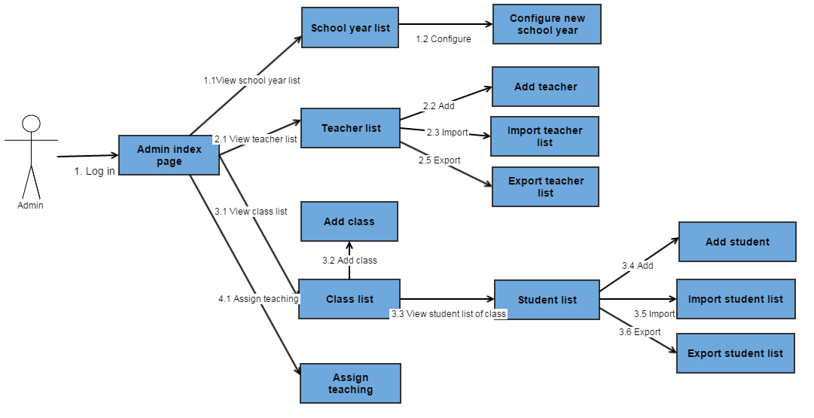

Figure 77: Core Flow 1

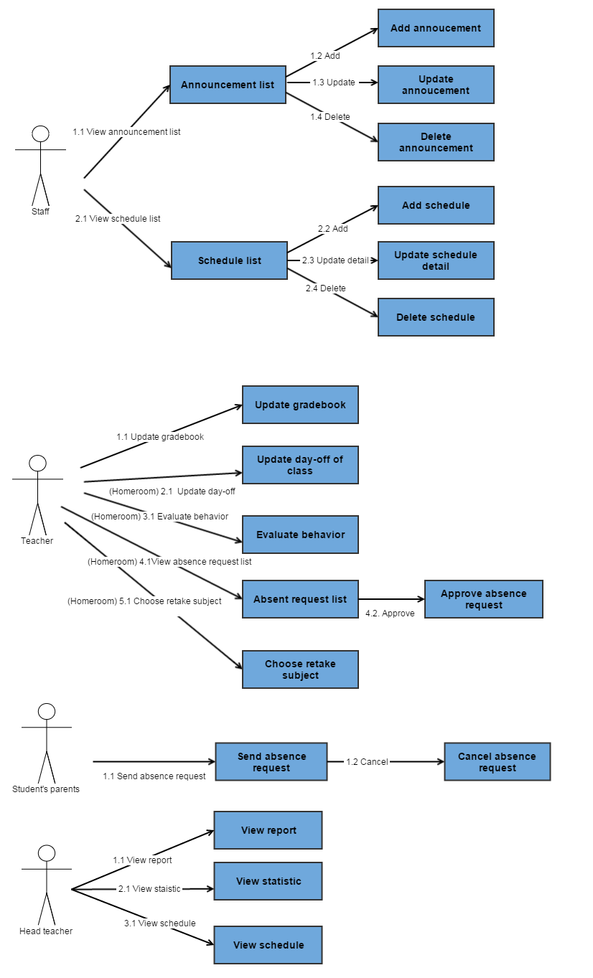

Figure 78: Core Flow 2

### Core Flow 1

#### Configure New School Year

|  |  |  |  |  |  |  |  |
| --- | --- | --- | --- | --- | --- | --- | --- |
| **ID** | **Test Case Description** | **Test Case Procedure** | **Expected output** | **Inter-test Case Dependence** | **Result** | **Test Date** | **Note** |
| CNSY01 | Admin can view "Thêm mới năm học" pop-up | 1. Login as Admin 2. On index page, clicks “Cấu hình năm học mới” link on “Hệ thống” menu navigation bar. 3. On “Cấu hình năm học mới” page, click “Thêm mới”. | * After step 3, show " Thêm mới năm học " popup |  | Passed | 20/7/2015 |  |
| CNSY02 | Admin Add New School Year | 1. On “Thêm mới năm học” popup , Admin input valid data and click “Thêm” button | * close " Thêm mới năm học " popup * display success message “Đã lưu” * Data is saved to database | CNSY01 | Passed | 20/7/2015 |  |
| CNSY03 | Admin create another school year with duplicate name | 1. On “Thêm mới năm học” popup, Admin input duplicate school year name 2. Admin click “Thêm” button | * After step 2, show " Tên lớp đã tồn tại " error message on popup | CNSY01 | Passed | 20/7/2015 |  |
| CNSY04 | Admin input start date of 1st semester bigger than end date of 2nd semester | 1. On “Thêm mới năm học” popup, Admin pick 1st Semester start date bigger than 2nd Semester end date 2. Admin click “Thêm” button | * After step 2, show " Ngày bắt đầu HKI không hợp lệ " error message | CNSY01 | Passed | 20/7/2015 |  |
| CNSY05 | Admin input Begin date of 1st semester and the end of 1st semester less than 16 weeks | 1. On “Thêm mới năm học” popup, Admin pick 1st Semester start date and 1st Semester end date sum up less than 16 weeks 2. Admin click “Thêm” button | * After step 2, show " Thời gian của HKI tối thiểu là 16 tuần " error message | CNSY01 | Passed | 20/7/2015 |  |
| CNSY06 | Admin input Begin date of 2nd semester and the end of 2nd semester less than 16 weeks | 1. On “Thêm mới năm học” popup, Admin pick 2nd Semester start date and 2nd Semester end date sum up less than 16 weeks 2. Admin click “Thêm” button | * After step 2, show " Thời gian của HKII tối thiểu là 16 tuần " error message | CNSY01 | Passed | 20/7/2015 |  |

Table 41: Configure New School Year

#### Import Teacher List

|  |  |  |  |  |  |  |  |
| --- | --- | --- | --- | --- | --- | --- | --- |
| **ID** | **Test Case Description** | **Test Case Procedure** | **Expected output** | **Inter-test Case Dependence** | **Result** | **Test Date** | **Note** |
| ITL01 | Admin navigate Import Teacher List page | 1. Login as Admin 2. On index page, clicks “Danh sách giáo viên” link on “Giáo viên” menu navigation bar. 3. On “Danh sách giáo viên” page, click “Nhập excel”. | * After step 3, show "Nhập excel " page |  | Passed | 20/7/2015 |  |
| ITL02 | Admin import teacher list | 1. On “Nhập excel” page , Admin chooses the right excel file and clicks “Nhập excel” button | * Redirect to “Danh sách giáo viên” page * Import data is displayed * Data is saved to database | ITL01 | Passed | 20/7/2015 |  |
| ITL03 | Admin choose excel file with wrong format | 1. On “Nhập excel” page, Admin chooses the excel file with wrong format and clicks “Nhập excel” button | * Show error message “File không đúng định dạng. Xin vui lòng nhập thông tin theo file mẫu và thử lại”. | ITL01 | Passed | 20/7/2015 |  |
| ITL04 | Admin does not choose file before import | 1. On “Nhập excel” page, Admin clicks “Nhập excel” button | * Show error message “Bạn chưa chọn file!” | ITL01 | Passed | 20/7/2015 |  |
| ITL05 | Admin choose invalid excel file | 1. On “Nhập excel” page, Admin chooses wrong excel file and clicks “Nhập excel” button | * Show error message “File vừa chọn không phải là file excel!” | ITL01 | Passed | 20/7/2015 |  |

Table 42: Import Teacher List.

#### Export Teacher List

|  |  |  |  |  |  |  |  |
| --- | --- | --- | --- | --- | --- | --- | --- |
| **ID** | **Test Case Description** | **Test Case Procedure** | **Expected output** | **Inter-test Case Dependence** | **Result** | **Test Date** | **Note** |
| ETL01 | Admin export teacher list | 1. Login as Admin 2. On index page, clicks “Danh sách giáo viên” link on “Giáo viên” menu navigation bar. 3. On “Danh sách giáo viên” page, click “Xuất excel”. | * System creates excel file and sends it to browser. |  | Passed | 20/7/2015 |  |

Table 43: Export Teacher List

#### Add Teacher Profile

|  |  |  |  |  |  |  |  |
| --- | --- | --- | --- | --- | --- | --- | --- |
| **ID** | **Test Case Description** | **Test Case Procedure** | **Expected output** | **Inter-test Case Dependence** | **Result** | **Test Date** | **Note** |
| AT01 | Admin navigate " Thêm mới Giáo viên " pop-up | 1. Login as Admin 2. On Index page, click “Hồ sơ giáo viên” on “Giáo viên” menu navigation bar. 3. On “Hồ sơ giáo viên” page, click “Thêm mới”. | * After step 3, show " Thêm mới Giáo viên" popup |  | Passed | 20/7/2015 |  |
| AT02 | Admin add new teacher | 1. On " Thêm mới Giáo viên " popup, Admin input valid data 2. click “Thêm mới”. | * After step 2, " Thêm mới Giáo viên " popup will close then System show success message * Teacher account will be created in database with random password * Information about account and password will be sent via Teacher Email | AT01 | Passed | 20/7/2015 |  |
| AT03 | Admin leave required fields empty | 1. On " Thêm mới Giáo viên " popup, Admin only click “Thêm mới” without input any information | Error messages show below required textbox fields | AT01 | Passed | 20/7/2015 |  |

Table 44: Add Teacher Profile

#### Assign Teaching

|  |  |  |  |  |  |  |  |
| --- | --- | --- | --- | --- | --- | --- | --- |
| **ID** | **Test Case Description** | **Test Case Procedure** | **Expected output** | **Inter-test Case Dependence** | **Result** | **Test Date** | **Note** |
| AT01 | Admin assign teacher | 1. Login as Admin 2. On Index page, click “Phân công giảng dạy” on “Giáo viên” menu navigation bar. 3. On “Phân công giảng dạy” page, Admin select all dropdown list value 4. Admin click “Lưu” | * After step 4, System shows “Đã lưu” message. * Teacher Assign data in Semester I should be display and saved into database * Teacher Assign data in Semester II should be empty |  | Passed | 20/7/2015 |  |
| AT02 | Admin copy data from Semester I | 1. Login as Admin 2. On Index page, click “Phân công giảng dạy” on “Giáo viên” menu navigation bar. 3. On “Phân công giảng dạy” page, Admin select all dropdown list value and click on “Sao chép HK1” button 4. Admin click “Lưu” | * After step 4, System shows “Đã lưu” message. * Teacher Assign data in Semester I should be display and saved into database * Teacher Assign data in Semester II should be the same as Semester I |  | Passed | 20/7/2015 |  |

Table 45: Assign Teaching

#### Add Class

|  |  |  |  |  |  |  |  |
| --- | --- | --- | --- | --- | --- | --- | --- |
| **ID** | **Test Case Description** | **Test Case Procedure** | **Expected output** | **Inter-test Case Dependence** | **Result** | **Test Date** | **Note** |
| AC01 | Admin navigate " Thêm lớp " pop-up | 1. Login as Admin 2. On Index page, click “Quản lí lớp” on “Học Sinh” menu navigation bar. 3. On “Danh sách lớp” page, click “Thêm lớp”. | * After step 2, show " Danh sách lớp " page * After step 3, show " Thêm lớp " popup |  | Passed | 20/7/2015 |  |
| AC02 | Admin add new class | 1. On “Thêm lớp” popup, Admin input all required data 2. Click “Thêm” button | * After step 2, “Thêm lớp” popup will be closed then System show success message * A new class should be created and saved into database | AC01 | Passed | 20/7/2015 |  |
| AC03 | Admin leave required field empty | 1. On “Thêm lớp” popup, Admin only Click “Thêm” button | * Show error messages below required textbox | AC01 | Passed | 20/7/2015 |  |
| AC04 | Admin already created a class with the same name | 1. On “Thêm lớp” popup, Admin input all required data but the name of the new class is the same as the old one 2. Click “Thêm” button | * After step 2, “Thêm lớp” System show error message   “Tên lớp đã tồn tại”. |  | Passed | 20/7/2015 |  |

Table 46: Add Class

#### Add Student Profile

|  |  |  |  |  |  |  |  |
| --- | --- | --- | --- | --- | --- | --- | --- |
| **ID** | **Test Case Description** | **Test Case Procedure** | **Expected output** | **Inter-test Case Dependence** | **Result** | **Test Date** | **Note** |
| AS01 | Admin navigate " Thêm mới Học Sinh" pop-up | 1. Login as Admin 2. On Index page, click “Quản lí lớp” on “Học Sinh” menu navigation bar. 3. On “Danh sách lớp” page, click “DSHS”. ( At least a class must be created ) 4. On “Danh sách học sinh” page, click “Thêm mới”. | * After step 4, show " Thêm mới Học Sinh" popup |  | Passed | 20/7/2015 |  |
| AS02 | Admin add new student with new parent | 1. On " Thêm mới Học Sinh" popup, Admin input valid data, excluding “Account Phụ Huynh” 2. Click “Thêm mới”. | * After step 2, " Thêm mới Học Sinh" popup will close then show success message “Thêm mới học sinh thành công”. * 2 account will be created in database : Student and Student’s Parent account with random password * Information about account and password will be sent via Student Email and Student’s Parent Email | AS01 | Passed | 20/7/2015 |  |
| AS03 | Admin add new student with existed parent | 1. On " Thêm mới Học Sinh" popup, Admin input valid data, including “Account Phụ Huynh” that contained in database, “Email Phụ Huynh” belong to the provide account 2. click “Thêm mới”. | * After step 2, " Thêm mới Học Sinh” popup will close then show success message “Thêm mới học sinh thành công”. * Only student account will be created in database * Information about account and password will be sent via Student Email and Student’s Parent Email |  | Passed | 20/7/2015 |  |
| AS04 | Admin leave required field empty | 1. On " Thêm mới Học Sinh" only click “Thêm mới” without input any information | Error messages show below required textbox fields | AS01 | Passed | 20/7/2015 |  |
| AS05 | Admin input invalid Parent Account | 1. On " Thêm mới Học Sinh", filled all required field with valid data but the “Account Phụ Huynh”data doesn’t contain in database 2. click “Thêm mới” | After Step 2 ,Error message show below “Account Phụ Huynh” field “Sai Account Phụ Huynh” | AS01 | Passed | 20/7/2015 |  |
| AS06 | Admin input valid Parent Account but invalid Parent Email | 1. On " Thêm mới Học Sinh", filled all required field with valid data but the “Email Phụ Huynh”data doesn’t contain in database 2. click “Thêm mới” | After Step 2 ,Error message show below “Email Phụ Huynh” field “Sai Email Phụ Huynh” | AS01 | Passed | 20/7/2015 |  |

Table 47: Add Student Profile

#### Import Student List

|  |  |  |  |  |  |  |  |
| --- | --- | --- | --- | --- | --- | --- | --- |
| **ID** | **Test Case Description** | **Test Case Procedure** | **Expected output** | **Inter-test Case Dependence** | **Result** | **Test Date** | **Note** |
| ISL01 | Admin navigate Import Student List page | 1. Login as Admin 2. On index page, clicks “Quản lí lớp” link on “Học sinh” menu navigation bar. 3. On “Quản lí lớp” page, click “Nhập excel”. | * After step 3, show "Nhập excel " page |  | Passed | 20/7/2015 |  |
| ISL02 | Admin import Student List | 1. On “Nhập excel” page, Admin chooses the right excel file and clicks “Nhập excel” button | * Redirect to “Quản lí lớp” page * Import data is displayed * Data is saved to database | ISL01 | Passed | 20/7/2015 |  |
| ISL03 | Admin choose excel file with wrong format | 1. On “Nhập excel” page, Admin chooses the excel file with wrong format and clicks “Nhập excel” button | * Show error message “File không đúng định dạng. Xin vui lòng nhập thông tin theo file mẫu và thử lại”. | ISL01 | Passed | 20/7/2015 |  |
| ISL04 | Admin does not choose file before import | 1. On “Nhập excel” page, Admin clicks “Nhập excel” button | * Show error message “Bạn chưa chọn file!” | ISL01 | Passed | 20/7/2015 |  |
| ISL05 | Admin choose invalid excel file | 1. On “Nhập excel” page, Admin chooses wrong excel file and clicks “Nhập excel” button | * Show error message “File vừa chọn không phải là file excel!” | ISL01 | Passed | 20/7/2015 |  |

Table 48: Import Student List.

#### Export Student List

|  |  |  |  |  |  |  |  |
| --- | --- | --- | --- | --- | --- | --- | --- |
| **ID** | **Test Case Description** | **Test Case Procedure** | **Expected output** | **Inter-test Case Dependence** | **Result** | **Test Date** | **Note** |
| ESL01 | Admin export student list | 1. Login as Admin 2. On index page, clicks “Danh sách giáo viên” link on “Giáo viên” menu navigation bar. 3. On “Danh sách giáo viên” page, click “Xuất excel”. | * System creates excel file and sends it to browser. |  | Passed | 20/7/2015 |  |

Table 49: Export Student List

#### Add Schedule

|  |  |  |  |  |  |  |  |
| --- | --- | --- | --- | --- | --- | --- | --- |
| **ID** | **Test Case Description** | **Test Case Procedure** | **Expected output** | **Inter-test Case Dependence** | **Result** | **Test Date** | **Note** |
| AS01 | Staff navigate “Thêm mới thời khóa biểu” popup | 1. Login as Staff 2. On index page, clicks “Thời khóa biểu” link on menu navigation bar. 3. On “Thời khóa biểu” page, click “Thêm mới”. | * After step 3, Show “Thêm mới thời khóa biểu” popup |  | Passed | 20/7/2015 |  |
| AS02 | Staff add new Schedule | 1. On "Thêm mới thời khóa biểu" popup, Staff clicks “Học kỳ I”/”Học kỳ II” radio button and choose valid “Ngày bắt đầu” start date by datepicker. 2. Staff clicks “Thêm lịch mới”. | * After step 2, “Thêm mới thời khóa biểu” popup will be closed * Schedule data is saved into database | AS01 | Passed | 20/7/2015 |  |
| AS03 | Staff choose schedule date in the past | 1. On "Thêm mới thời khóa biểu" popup, Staff clicks “Học kỳ I”/”Học kỳ II” radio button and choose “Ngày bắt đầu” start date later than today. 2. Staff clicks “Thêm lịch mới”. | * Show error message “Thời khóa biểu đã qua”. | AS01 | Passed | 20/7/2015 |  |
| AS04 | Staff choose schedule date not in the semester I range | 1. On "Thêm mới thời khóa biểu" popup, Staff clicks “Học kỳ I” radio button and choose “Ngày bắt đầu” start date not in the semester range. 2. Staff clicks “Thêm lịch mới”. | * Show error message “Bạn đã chọn ngày không nằm trong học kỳ!”. | AS01 | Passed | 20/7/2015 |  |
| AS05 | Staff choose schedule date not in the semester II range | 1. On "Thêm mới thời khóa biểu” popup, Staff clicks “Học kỳ II” radio button and choose “Ngày bắt đầu” start date not in the semester range. 2. Staff clicks “Thêm lịch mới”. | * Show error message “Bạn đã chọn ngày không nằm trong học kỳ!”. | AS01 | Passed | 20/7/2015 |  |

Table 50: Add Schedule

#### Update Schedule Detail

|  |  |  |  |  |  |  |  |
| --- | --- | --- | --- | --- | --- | --- | --- |
| **ID** | **Test Case Description** | **Test Case Procedure** | **Expected output** | **Inter-test Case Dependence** | **Result** | **Test Date** | **Note** |
| USD01 | Staff navigate “Thay đổi thời khóa biểu” popup | 1. Login as Staff 2. On index page, clicks “Thời khóa biểu” link on menu navigation bar. 3. On “Thời khóa biểu” page, click “Sửa”. ( At least 1 schedule is created ) | After step 3, Show “Thay đổi thời khóa biểu” popup | AS02 | Passed | 20/7/2015 |  |
| USD02 | Staff update Schedule | 1. On "Sửa thời khóa biểu “popup, Staff clicks “Học kỳ I”/”Học kỳ II” radio button and choose valid “Ngày bắt đầu” start date by datepicker. 2. Staff clicks “Thay đổi lịch”. | * After step 2, “Thay đổi thời khóa biểu” popup will be closed * Schedule data is modified into database | USD01 | Passed | 20/7/2015 |  |
| USD03 | Staff choose schedule date in the past | 1. On” Thay đổi thời khóa biểu" popup, Staff clicks “Học kỳ I”/”Học kỳ II” radio button and choose “Ngày bắt đầu” start date later than today. 2. Staff clicks “Thay đổi lịch. | * Show error message “Thời khóa biểu đã qua”. | USD01 | Passed | 20/7/2015 |  |
| USD04 | Staff choose schedule date not in the semester range | 1. On “Thay đổi thời khóa biểu” popup, Staff clicks “Học kỳ I” radio button and choose “Ngày bắt đầu” start date not in the semester range. 2. Staff clicks “Thay đổi lịch”. | * Show error message “Bạn đã chọn ngày không nằm trong học kỳ!”. | USD01 | Passed | 20/7/2015 |  |

Table 51: Update Schedule Detail

#### Delete Schedule

|  |  |  |  |  |  |  |  |
| --- | --- | --- | --- | --- | --- | --- | --- |
| **ID** | **Test Case Description** | **Test Case Procedure** | **Expected output** | **Inter-test Case Dependence** | **Result** | **Test Date** | **Note** |
| DS01 | Staff delete a schedule | 1. Login as Staff 2. On index page, clicks “Thời khóa biểu” link on menu navigation bar. 3. On “Thời khóa biểu” page, click “Xóa”. ( At least 1 schedule is created ) 4. Click “Xóa” button | * After step 3, Show “Bạn có chắc muốn xóa không” popup * After step 4, close popup * Selected schedule is deleted in database |  | Passed | 20/7/2015 |  |

Table 52: Delete Schedule

### Core Flow 2

#### Edit Gradebook

|  |  |  |  |  |  |  |  |
| --- | --- | --- | --- | --- | --- | --- | --- |
| **ID** | **Test Case Description** | **Test Case Procedure** | **Expected output** | **Inter-test Case Dependence** | **Result** | **Test Date** | **Note** |
| UGB01 | Subject Teacher update grade | 1. Login as Subject Teacher 2. On index page, clicks “Sổ điểm bộ môn” link on “Bộ môn” menu navigation bar. 3. Teacher input data and click “Cập nhật” | * After step 2, Show “Sổ điểm bộ môn” page * After step 3, System display “Đã lưu” message. * Student grade data is saved into database |  | Passed | 20/7/2015 |  |

Table 53: Edit Gradebook

#### Update Attendance

|  |  |  |  |  |  |  |  |
| --- | --- | --- | --- | --- | --- | --- | --- |
| **ID** | **Test Case Description** | **Test Case Procedure** | **Expected output** | **Inter-test Case Dependence** | **Result** | **Test Date** | **Note** |
| UA01 | Homeroom teacher update student attendance | 1. Login as Homeroom teacher 2. On index page, clicks “Sổ điểm danh” link on “Chủ nhiệm” menu navigation bar. 3. Homeroom teacher input data then click “Lưu” | * After step 2, Show “Sổ điểm danh” page * After step 3, System display “Đã lưu” success message. * All attendance data are saved into database |  | Passed | 20/7/2015 |  |

Table 54: Update Attendance

#### Evaluate Behaviour

|  |  |  |  |  |  |  |  |
| --- | --- | --- | --- | --- | --- | --- | --- |
| **ID** | **Test Case Description** | **Test Case Procedure** | **Expected output** | **Inter-test Case Dependence** | **Result** | **Test Date** | **Note** |
| EB01 | Homeroom teacher evaluate behavior (conduct) of all students of his/her class | 1. Login as Homeroom teacher 2. On index page, clicks “Xét hạnh kiểm” link on “Chủ nhiệm” menu navigation bar. 3. Teacher chooses value for dropdown list and fill “Nhận xét” field then clicks “Lưu” | * After step 2, Show “Xét hạnh kiểm” page * After step 3, System display “Đã lưu” success message. * All data are saved into database |  | Passed | 20/7/2015 |  |
| EB02 | Homeroom Teacher doesn’t input “Nhật xét” field | 1. Login as Homeroom teacher 2. On index page, clicks “Xét hạnh kiểm” link on “Chủ nhiệm” menu navigation bar. 3. Teacher chooses value for dropdown list but doesn’t fill “Nhận xét” field then clicks “Lưu” | * After step 3, System display “Phải nhập nhận xét kèm theo hạnh kiểm.” error message |  | Passed | 20/7/2015 |  |

Table 55: Evaluate Behavior

#### Approve Absence Request

|  |  |  |  |  |  |  |  |
| --- | --- | --- | --- | --- | --- | --- | --- |
| **ID** | **Test Case Description** | **Test Case Procedure** | **Expected output** | **Inter-test Case Dependence** | **Result** | **Test Date** | **Note** |
| AAR01 | Homeroom teacher approve Absence Request | 1. Login as Homeroom teacher 2. On index page, clicks “Đơn xin nghỉ” link on menu navigation bar. 3. click “Chấp nhận” button | * After step 2, Show “Danh sách đơn xin nghỉ” page * After step 3, System display “Đơn đã được duyệt” success message. * Absence request data is modified in database |  | Passed | 20/7/2015 |  |

Table 56: Approve Absence Request

#### DisApprove Absence Request

|  |  |  |  |  |  |  |  |
| --- | --- | --- | --- | --- | --- | --- | --- |
| **ID** | **Test Case Description** | **Test Case Procedure** | **Expected output** | **Inter-test Case Dependence** | **Result** | **Test Date** | **Note** |
| DAR01 | Homeroom teacher disapprove Absence Request | 1. Login as Homeroom teacher 2. On index page, clicks “Đơn xin nghỉ” link on menu navigation bar. 3. click “Không Chấp nhận” button 4. Teacher fill in “Lý do” field 5. Click “Gửi” button | * After step 2, show “Danh sách đơn xin nghỉ” page * After step 3, System display “Lý do” pop-up message. * After step 5, System closes “Lý do” popup * Absence request data is modified in database |  | Passed | 20/7/2015 |  |

Table 57: DisApprove Absence Request

#### Choose Retake Subject

|  |  |  |  |  |  |  |  |
| --- | --- | --- | --- | --- | --- | --- | --- |
| **ID** | **Test Case Description** | **Test Case Procedure** | **Expected output** | **Inter-test Case Dependence** | **Result** | **Test Date** | **Note** |
| CRS01 | Homeroom teacher choose retake subject for student | 1. Login as Homeroom teacher 2. On index page, clicks “Quản lý học sinh thi lại” link on “Chủ nhiệm” menu navigation bar. 3. Homeroom Teacher   tick on some subjects that student has to retake   1. Click “Cập nhật” button. | * After step 2, show “Danh sách đơn xin nghỉ” page * After step 3, system display “Đã lưu” success message. * All data are saved into database |  | Passed | 20/7/2015 |  |

Table 58: Choose Retake Subject

#### Send Absence Request

|  |  |  |  |  |  |  |  |
| --- | --- | --- | --- | --- | --- | --- | --- |
| **ID** | **Test Case Description** | **Test Case Procedure** | **Expected output** | **Inter-test Case Dependence** | **Result** | **Test Date** | **Note** |
| SAR01 | Student’s Parent navigate “Gửi đơn xin nghỉ” pop-up | 1. Login as Student’s Parent 2. On index page, clicks “Xin nghỉ học” link on menu navigation bar. 3. Student’s Parent click “Thêm mới” button | * After step 2, Show “Danh sách đơn xin nghỉ” page * After step 3, Show “Gửi đơn xin nghỉ” pop-up. |  | Passed | 20/7/2015 |  |
| SAR02 | Student’s Parent send an absence request | 1. On “Gửi đơn xin nghỉ” pop-up, Student’s Parent choose a date and time, fill “Nội dung” field then click “Gửi” button | * System closes “Gửi đơn xin nghỉ” popup * Absence request data is created in database | SAR01 | Passed | 20/7/2015 |  |
| SAR03 | Student’s Parent send an absence request with the same day as the old request | 1. On “Gửi đơn xin nghỉ” pop-up, Student’s Parent choose duplicate date and duplicate time, fill “Nội dung” field then click “Gửi” button | * System display “Đã có đơn xin nghỉ cho buổi này” error message | SAR02  SAR01 | Passed | 20/7/2015 |  |
| SAR04 | Student’s Parent send an absence request with date range bigger than limitation | 1. On “Gửi đơn xin nghỉ” pop-up, Student’s Parent check “Nghỉ nhiều buổi” checkbox, pick date range bigger than limitation, fill “Nội dung” field then click “Gửi” button | * System display “Đã nghỉ quá số buổi cho phép” error message | SAR01 | Passed | 20/7/2015 |  |
| SAR05 | Student’s Parent send an absence request without filling the “Nội dung” field | 1. On “Gửi đơn xin nghỉ” pop-up, Student’s Parent choose a date and time but doesn’t fill “Nội dung” field then click “Gửi” button | * System display “Không có nội dung” error message | SAR01 | Passed | 20/7/2015 |  |

Table 59: Send Absence Request

#### Cancel Absence Request

|  |  |  |  |  |  |  |  |
| --- | --- | --- | --- | --- | --- | --- | --- |
| **ID** | **Test Case Description** | **Test Case Procedure** | **Expected output** | **Inter-test Case Dependence** | **Result** | **Test Date** | **Note** |
| UDO01 | Student’s Parent delete an absence request | 1. Login as Student’s Parent 2. On index page, clicks “Xin nghỉ học” link on menu navigation bar. 3. On “Xin nghỉ học” page Click “Hủy” button 4. On Confirm pop-up, click “Hủy button” | * After step 2, show “Xin nghỉ học” page * After step 3, show “Bạn có muốn hủy đơn xin nghỉ ?” confirm pop-up. * After step 4, close confirm popup, the selected absence request is deleted in database |  | Passed | 20/7/2015 |  |

Table 60: Cancel Absence Request

# Software User’s Manual

## Installation Guide

### Setting up environment at server side

The web application must be installed into the server side:

#### Hardware requirements

Personal computers for developing with the minimum configuration:

* Processor: minimum Core 2 Duo 2.0 GHz.
* Memory: minimum 2GB RAM.
* Available Disk Space: minimum 30GB hard disk.
* Internet: minimum speed 10Mbps.

#### Software requirements

* Web Server:
* OS: Microsoft Windows Server 2008
* SQL Server 2008: used to create and manage the database for web application.

### Deployment at server side

#### Prepare deployment package

* 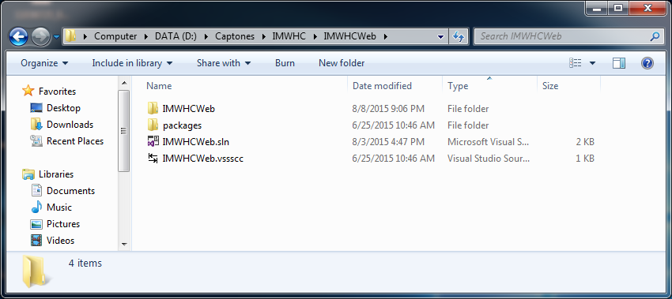Extract deployment package to a folder on sever.

Figure 79: Prepare deployment package

#### Configure Server before deploy

* Open Internet Information System Manager

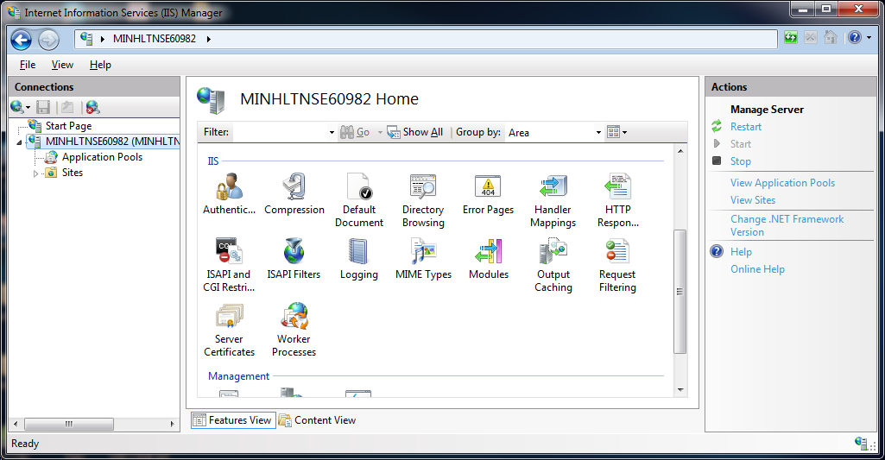

Figure 80: Internet Information System 1

* 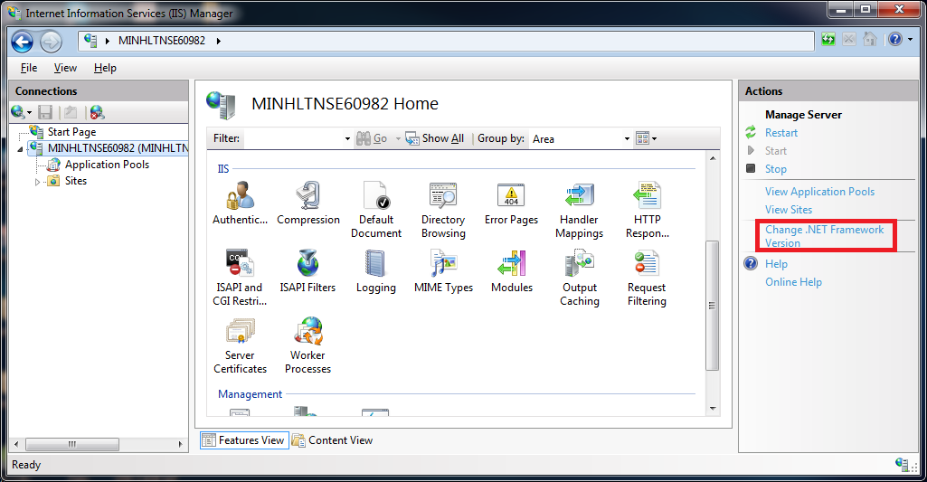Change the .NET Framework to 4.0 version

Figure 81: Internet Information System 2

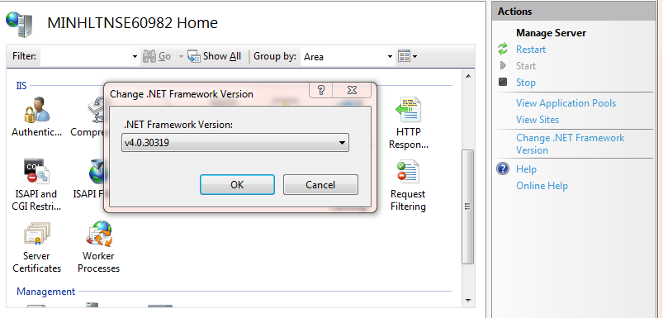

Select .NET Framework version to 4.0.30319

Figure 82: Internet Information System 3

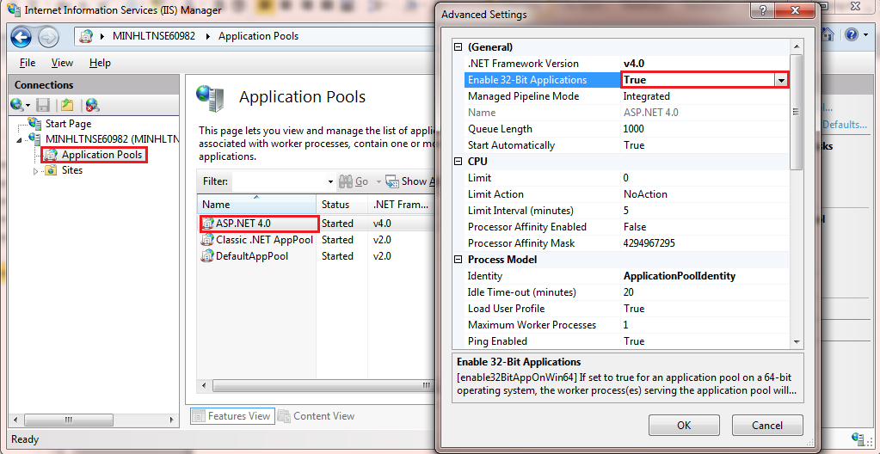Click Application Pools on the left screen.

Figure 83: Internet Information System 4

Right click the ASP.NET 4.0, select “Advance Settings”.

Set “Enable 32-bit Applications” to True.

#### Deploy web application on server

Change the connection string in Web.config.

Replace the “data source” with your own username and password.

Figure 84: Deploy web application on server

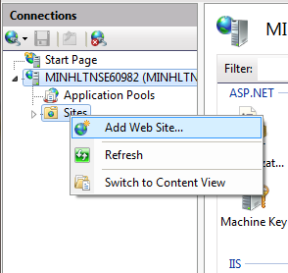Right click as Sites on Internet Information System Manager. Choose “Add Web Site”.

Figure 85: Add Website 1

* Enter site name. Choose Application Pool as ASP.NET 4.0
* Select the path as the folder in step 1. Enter port other than 80.

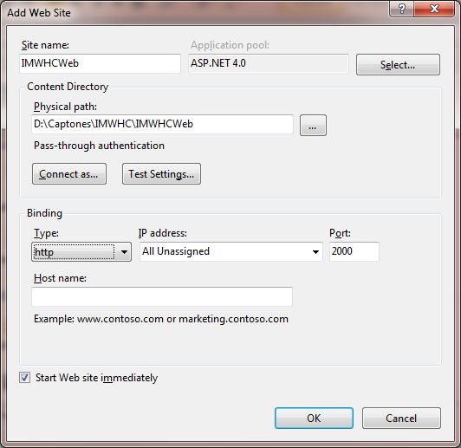Figure 86: Add Website 2

Press OK to finish the process.

## User Guide

### Configure New School Year



Figure 87: Configure New School Year

|  |  |
| --- | --- |
| **Step** | **Description** |
| 1 | Admin fills name school year. |
| 2 | Admin clicks to choose start date of 1st semester. |
| 3 | Admin clicks to choose end date of 1st semester. |
| 4 | Admin clicks to choose start date of 2nd semester. |
| 5 | Admin clicks to choose end date of 2nd semester. |
| 6 | Admin clicks “Thêm mới” button to add new school year. |
| 7 | Admin clicks “Đóng” button to cancel. |

### Add Class

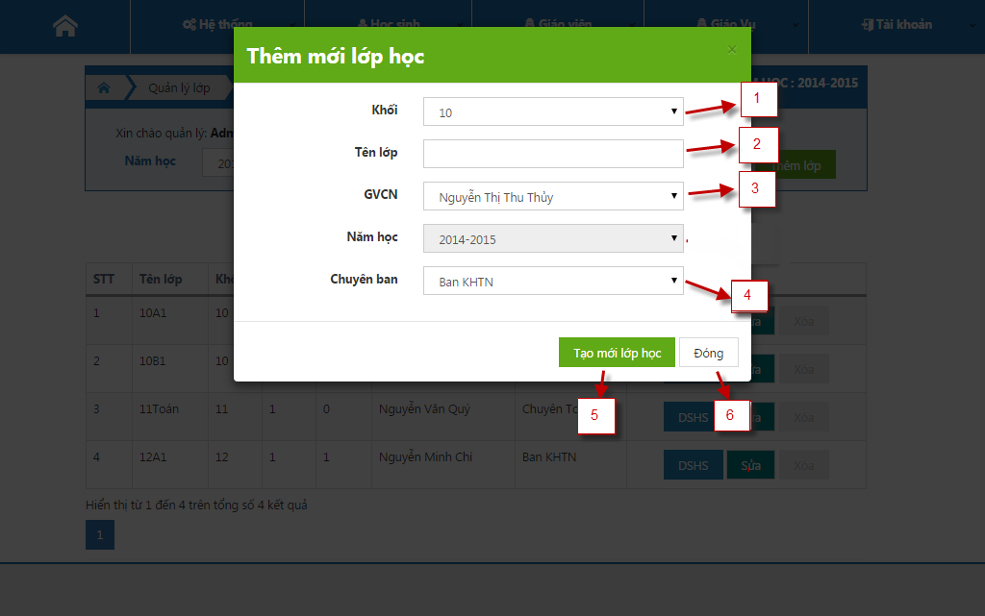

Figure 88: Add Class

|  |  |
| --- | --- |
| **Step** | **Description** |
| 1 | Admin selects a class grade. |
| 2 | Admin fills class name. |
| 3 | Admin selects a teacher. |
| 4 | Admin selects a class type. |
| 5 | Admin clicks “Tao mới lớp học” button to add new class. |
| 6 | Admin clicks “Đóng” button to cancel. |

### Import Student List

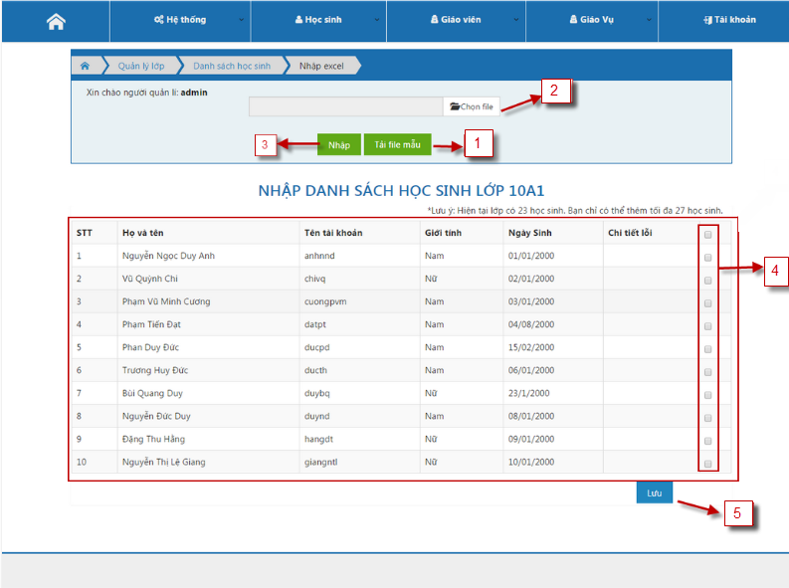

Figure 89: Import Student List

|  |  |
| --- | --- |
| **Step** | **Description** |
| 1 | Admin downloads an example excel. |
| 2 | Admin clicks “Chọn file” button to upload excel file. |
| 3 | Admin clicks “Nhập” button. |
| 4 | Admin check one or more check to select row student to add into system. |
| 5 | Admin clicks “Lưu” button to save into data base. |

### Edit Gradebook

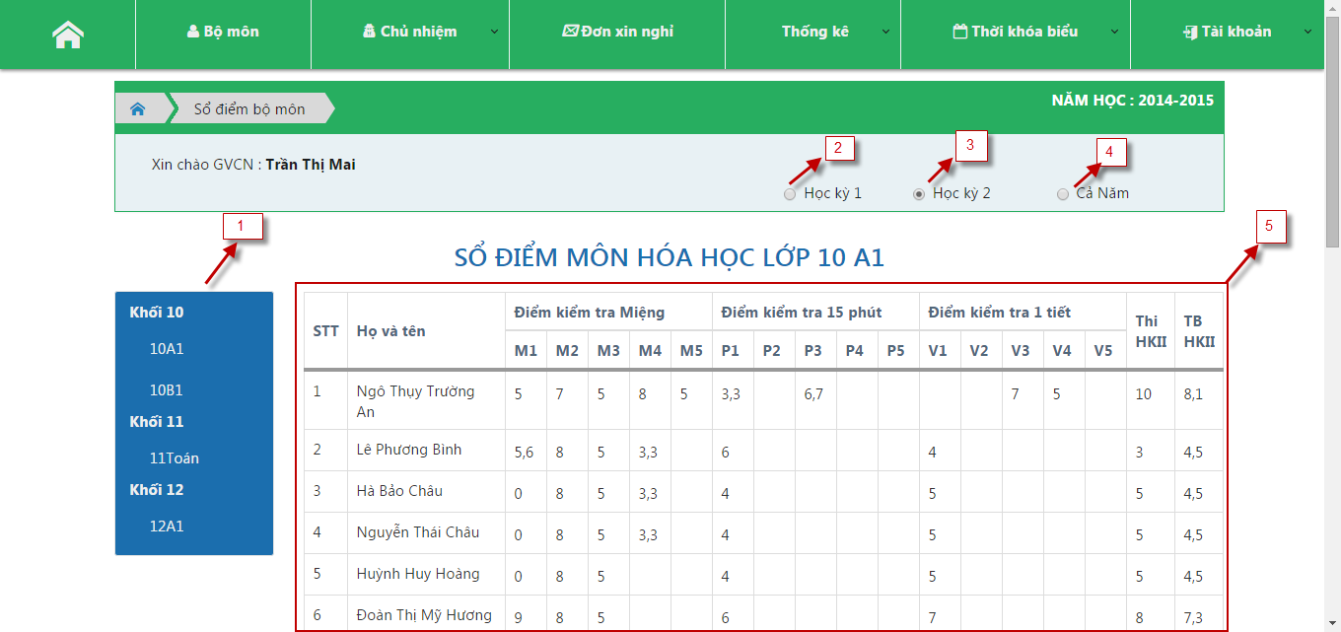

Figure 90: Edit GradeBook

|  |  |
| --- | --- |
| **Step** | **Description** |
| 1 | Teacher selects a class. |
| 2 | Teacher checks “Học kỳ 1”to show 1st semester. |
| 3 | Teacher checks “Học kỳ 2”to show 2nd semester. |
| 4 | Teacher checks “Cả Năm”to show end year. |
| 5 | Teacher fills data into table. |

### Evaluate Behavior

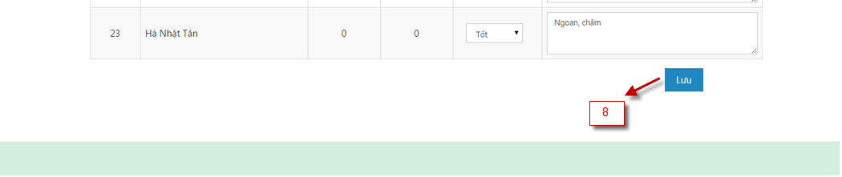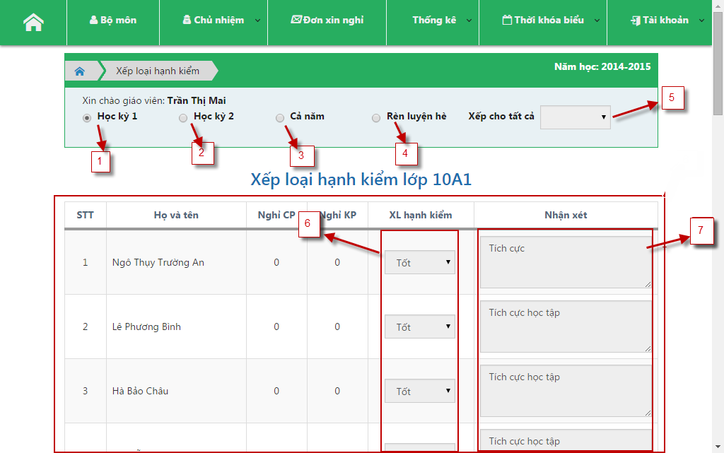

Figure 91: Evaluate Behavior

|  |  |
| --- | --- |
| **Step** | **Description** |
| 1 | Homeroom teacher ticks “Học kỳ 1” check box to view 1st semester. |
| 2 | Homeroom teacher ticks “Học kỳ 2” check box to view 2nd semester. |
| 3 | Homeroom teacher ticks “Rèn luyện hè” check box to view train summer. |
| 4 | Homeroom teacher ticks “Cả năm” check box to view end year. |
| 5 | Homeroom teacher selects “Xếp cho tất cả” drop down list to fill auto comment. |
| 6 | Homeroom teacher selects “XL hạnh kiểm” drop down list to evaluate behavior |
| 7 | Homeroom teacher ticks “Cả năm” check box to view end year. |
| 8 | Homeroom teacher clicks “Lưu” button to save into data base. |

### Add New Schedule

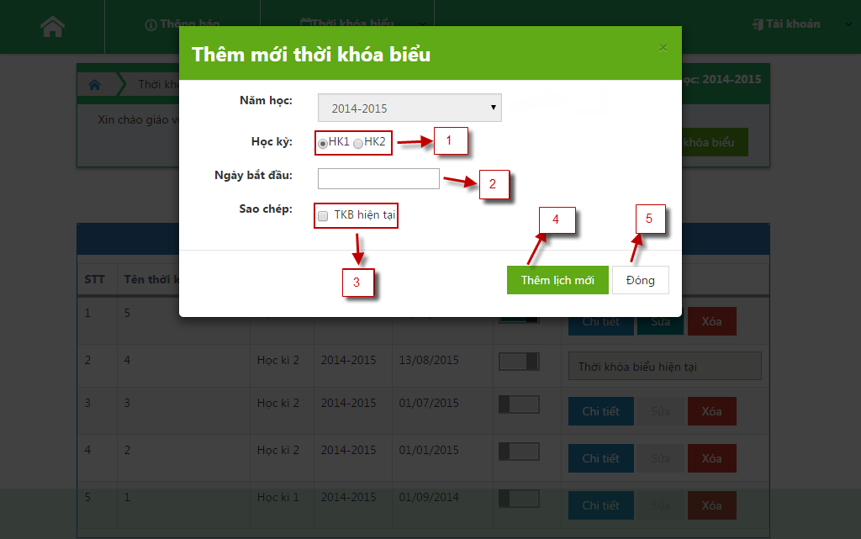

Figure 92: Add New Schedule

|  |  |
| --- | --- |
| **Step** | **Description** |
| 1 | Admin ticks “HK1” or “HK2” radio button to select a semester. |
| 2 | Admin select a date by date picker. |
| 3 | Admin ticks “TKB hiện tại” to copy schedule current. |
| 4 | Admin clicks “Thêm lịch mới” button to add new schedule. |
| 5 | Admin clicks “Đóng” button to cancel. |

### Update Schedule Detail

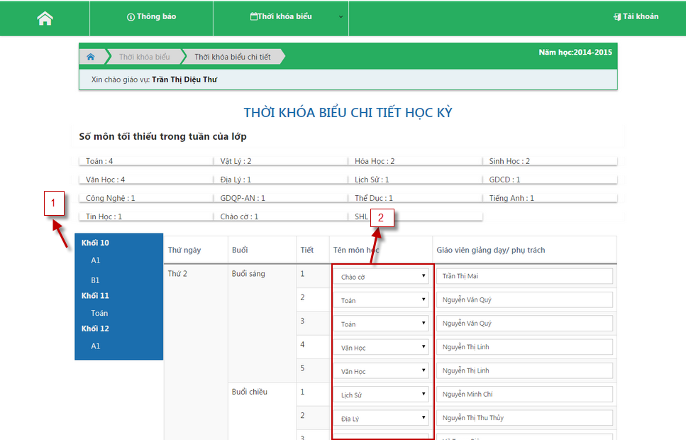

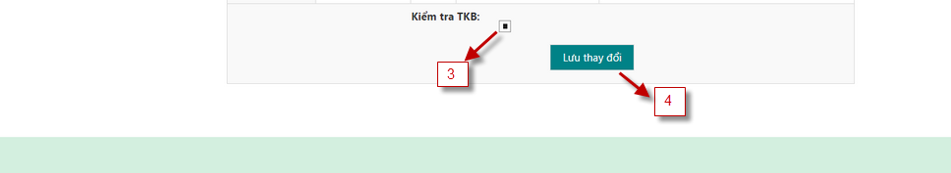

Figure 93: Update Schedule Detail

|  |  |
| --- | --- |
| **Step** | **Description** |
| 1 | Staffs click a class in a grade. |
| 2 | Staff selects subject for a class |
| 3 | Staff ticks “Kiểm tra TKB” check box to check all in put |
| 4 | Staff clicks “Lưu thay đổi” button to save into database |

### Update Attendance

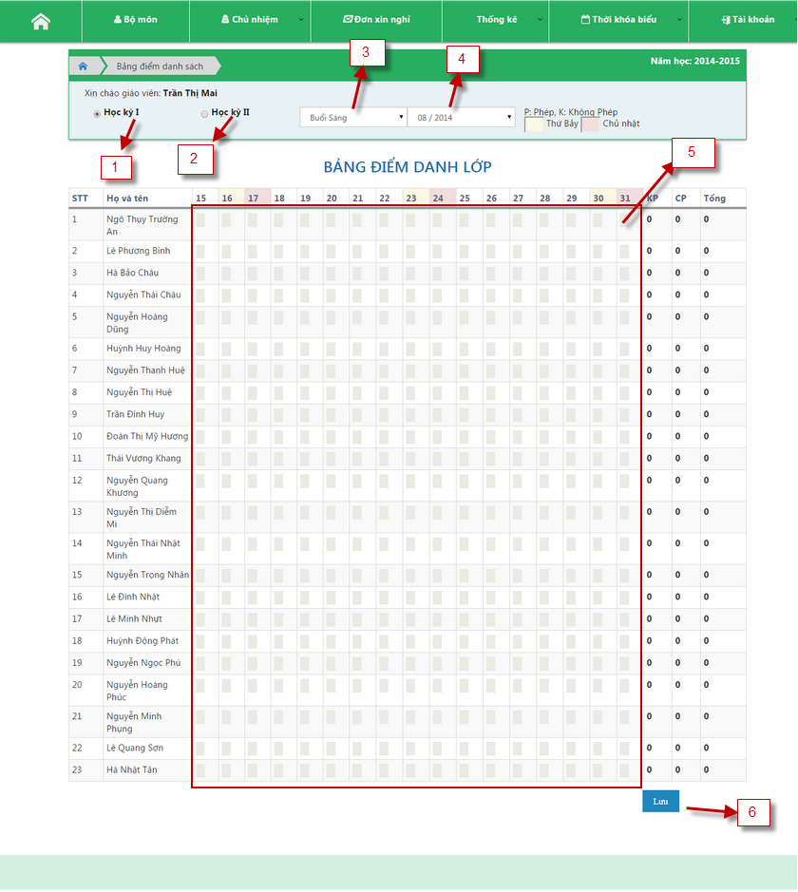

Figure 94: Update Attendance

|  |  |
| --- | --- |
| **Step** | **Description** |
| 1 | Homeroom teacher ticks “Học kỳ 1” check box to view 1st semester. |
| 2 | Homeroom teacher ticks “Học kỳ 2” check box to view 2nd semester. |
| 3 | Homeroom teacher selects “Buổi sáng” or “Buổi chiều” drop down list. |
| 4 | Homeroom teacher selects date time drop down list. |
| 5 | Homeroom teacher fills input to tick day off of student. |
| 6 | Homeroom teacher clicks “Lưu” button to save into data base. |

### Add New Teacher

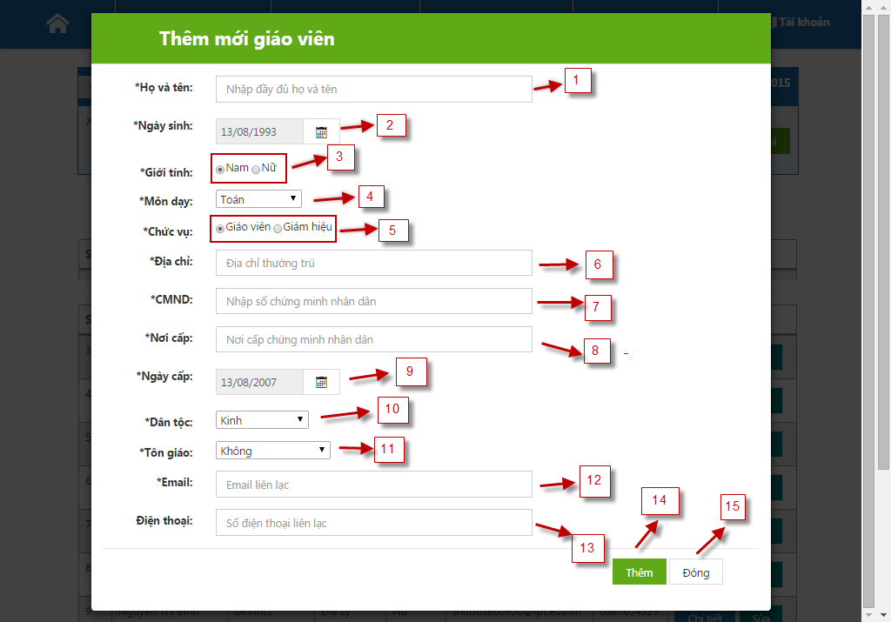

Figure 95: Add New Teacher

|  |  |
| --- | --- |
| **Step** | **Description** |
| 1 | Admin fills full name of teacher. |
| 2 | Admin clicks to select teacher’s date of birth. |
| 3 | Admin clicks to select gender. |
| 4 | Admin clicks to select subject. |
| 5 | Admin clicks to select position. |
| 6 | Admin fills address of teacher. |
| 7 | Admin fills number of identity card of teacher. |
| 8 | Admin fills place of issue of teacher. |
| 9 | Admin clicks to select day of issue of teacher. |
| 10 | Admin clicks to select ethnic. |
| 11 | Admin clicks to select religion. |
| 12 | Admin fills email of teacher. |
| 13 | Admin fills phone number of teacher. |
| 14 | Admin clicks “Thêm” button to add new teacher. |
| 15 | Admin clicks “Đóng” to cancel add new teacher. |

### Add New Announcement

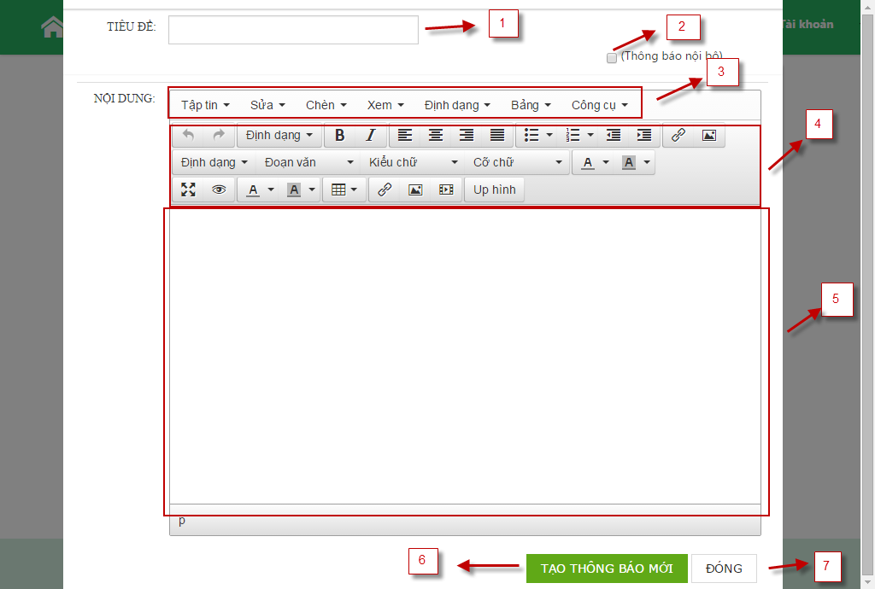

Figure 96: Add New Announcement

|  |  |
| --- | --- |
| **Step** | **Description** |
| 1 | Staff fills title of announcement. |
| 2 | Staff ticks “Thông báo nội bộ” check box for internal notifications. |
| 3 | Staff selects function of announcement. |
| 4 | Staff modifies type of announcement. |
| 5 | Staff fills content of announcement. |
| 6 | Staff clicks “Tạo thông báo mới” button to add new annoucement. |
| 7 | Staff clicks “Đóng” button to cancel. |

### Request Day Off

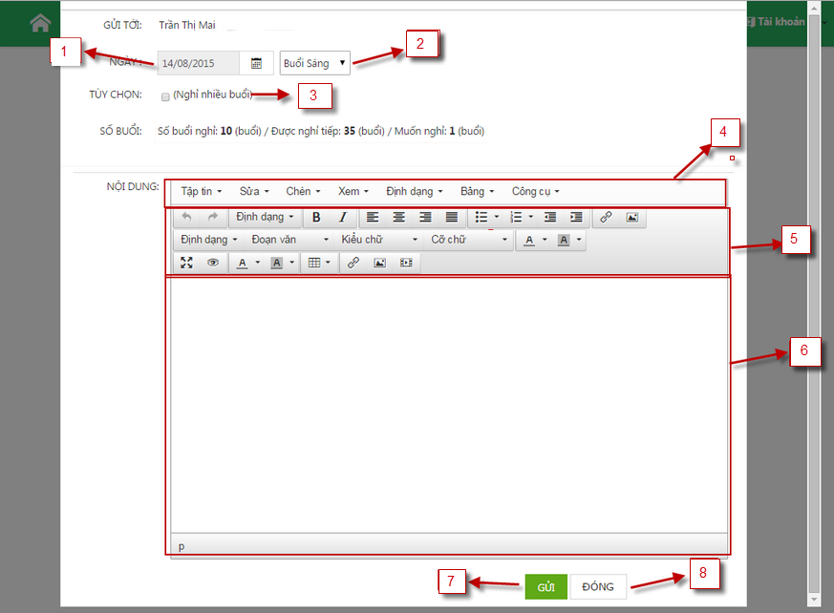

Figure 97: Request Day Off

|  |  |
| --- | --- |
| **Step** | **Description** |
| 1 | Student’s parent clicks to select day off. |
| 2 | Student’s parent clicks to select “Buổi sáng” or “Buổi chiều” or “Cả hai buổi”. |
| 3 | Student’s parent clicks to select “Chọn nhiều buổi”. |
| 4 | Student’s parent selects function of request. |
| 5 | Student’s parent modifies type of request. |
| 6 | Student’s parent fills content of request. |
| 7 | Student’s parent clicks “Gửi” button to send request. |
| 8 | Student’s parent clicks “Đóng” button to cancel. |

### View Statistic of Class

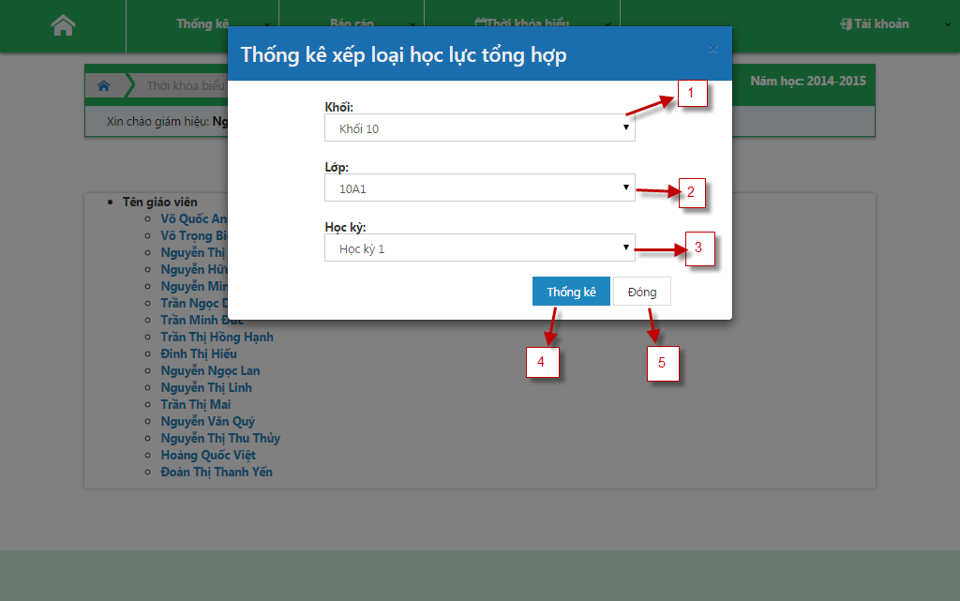

Figure 98: View Statistic Of Class

|  |  |
| --- | --- |
| **Step** | **Description** |
| 1 | Head teacher clicks to select grade in drop down list. |
| 2 | Head teacher clicks to select class in drop down list. |
| 3 | Head teacher clicks to select semester in down list. |
| 4 | Head teacher clicks “Thống kê” button to view the class’s statistic |
| 5 | Head teacher clicks “Đóng” button to cancel. |

# ソフトウェアユーザーマニュアル

## インストレーションガイド

### サーバ側で環境を設定

このソフトウェアが以下のサーバーマシンにインストールされなければならない。

#### ハードウェア要件

最小構成で開発するためのパーソナルコンピュータ：

* プロセッサ：「Core 2 Duo 2.0 GHz」以上。
* メモリ：「2GB RAM」以上。
* 使用可能なディスク領域：「30GB」 ハードディスク以上。
* インターネット：スピード「10Mbps」以上。

#### ソフトウェア要件

* ウェブサーバ：「Internet Information System – IIS 7」 。
* 「OS」: 「Microsoft Windows Server 2008」
* 「SQL Server 2008」：ウェブアプリケーション用のデータベースを作成および管理するために使用します。

### サーバ側で展開

#### 展開のパッケージを準備

サーバのフォルダにデプロイメントパッケージを抽出.

Figure 99: デプロイメントパッケージの準備

#### 展開の前に、サーバを設定

「Internet Information System Manager」を開きます。



Figure 100: 「Internet Information System」 1

「.NET Framework」のバージョンを「4.0」に変更します。

Figure 101: 「Internet Information System」 2

Figure 102: 「Internet Information System」 3

「.NET Framework」のバージョンを「4.0.30319」に変更します。

Figure 103: 「Internet Information System」 4

左画面の「Application Pools」にクリックします。

「ASP.NET 4.0」に右クリック、「Advance Settings」を選択します。

「Enable 32-bit Applications」を「True」に設定。

#### サーバでウェブアプリケーションを展開

「Web.config」にある接続文字列を変更します

「data source」をあなた自身ユーザー名とパスワードと入力します。

Figure 104: サーバのウェバーアプリケーションをデプロイ。

「Internet Information System Manager」の「Sites」に右クリックして、「Add Web Site」を選択します。

Figure 105: 「Add Website」 １

サイトの名を入力して、アプリケーションプールを「ASP.NET 4.0」に変更します。

物理パスを選択して、 「８０」ポートと異なるポートを記載します。

Figure 106: 「Add Website」 2

「OK」 をクリックし、プロセスが完了します。

## ユーザーガイド

### 新しい学年を設定する



Figure 107: 新しい学年を設定する

|  |  |
| --- | --- |
| **ステップ** | **説明** |
| 1 | アドミンは新しい学年の名前を入力する。 |
| 2 | アドミンは開始日付の最初の学期を選ぶためにクリックする。 |
| 3 | アドミンは最初の学期の日付の終わりを選ぶためにクリックする。 |
| 4 | アドミンは2番目の学期の開始日付を選ぶためにクリックする。 |
| 5 | アドミンは2番目の学期の終わりの日付を選ぶためにクリックする。 |
| 6 | アドミンは新しい学年を追加するために、「Thêm mới」ボタンをカチッと鳴らす。 |
| 7 | アドミンはポップアップを閉じるために、「Đóng」ボタンをカチッと鳴らす。 |

### クラスを追加する



Figure 108: クラスを追加する

|  |  |
| --- | --- |
| **ステップ** | **説明** |
| 1 | アドミンはクラスグレードを選ぶ。 |
| 2 | アドミンは入力クラス名。 |
| 3 | アドミンは先生を選ぶ。 |
| 4 | アドミンはクラスタイプを選ぶ。 |
| 5 | アドミンは新しいクラスを追加するために、「Tạo mới lớp học」ボタンをカチッと鳴らす。 |
| 6 | アドミンはポップアップを閉じるために、ボタン「Đóng」をカチッと鳴らす。 |

### 学生リストを輸入する



Figure 109: 学生リストを輸入する

|  |  |
| --- | --- |
| **ステップ** | **説明** |
| 1 | アドミンは「Excel」テ ン プ レ ー ト フ ァ イ ル を ダ ウ ン ロ ー ド す る. |
| 2 | アドミンは「Excel」ファイルをアップロードするために、「Chọn file」ボタンをカチッと鳴らす。 |
| 3 | アドミンは「Nhập」ボタンをカチッと鳴らす。 |
| 4 | アドミンはシステムに追加するために学生を選ぶためにクリックする。 |
| 5 | アドミンは、データベースに保存するために、「Lưu」ボタンをカチッと鳴らす。 |

### グレードを追加する



Figure 110: グレードを追加する

|  |  |
| --- | --- |
| **ステップ** | **説明** |
| 1 | 先生はクラスを選ぶ。 |
| 2 | 先生は1番目の学期を示すために、「Học kỳ 1」をチェックする。 |
| 3 | 先生は2番目の学期を示すために、「Học kỳ 2」をチェックする。 |
| 4 | 先生は年末を示すために、「Cả Năm」をチェックする。 |
| 5 | テーブルへの先生インプットデータ。 |

### 学生の行動を評価する



Figure 111: 学生の行動を評価する

|  |  |
| --- | --- |
| **ステップ** | **説明** |
| 1 | ホームルームの先生は1番目の学期を見るために、「Học kỳ 1」チェックボックスに照合印を付ける。 |
| 2 | ホームルームの先生は2番目の学期を見るために、「Học kỳ 2」チェックボックスに照合印を付ける。 |
| 3 | ホームルームの先生は、夏への訓練を見るために、「Rèn luyện hè」チェックボックスに照合印を付ける。 |
| 4 | ホームルームの先生は眺めに「Cã năm」チェックボックスに照合印を付ける 年を終える 。 |
| 5 | ホームルームの先生は、オートコメントを満たすように、「Xếp cho tất cả」ドロップダウン・リストを選ぶ。 |
| 6 | ホームルームの先生は、学生の行動を評価するために、「XL hạnh kiểm」ドロップダウンリストを選ぶ |
| 7 | ホームルームの先生は、年末を見るために、「Cã năm」チェックボックスに照合印を付ける。 |
| 8 | ホームルームの先生は、データベースに保存するために、「Lưu」ボタンをカチッと鳴らす。 |

### 新しいスケジュールを追加する



Figure 112: 新しいスケジュールを追加する

|  |  |
| --- | --- |
| **ステップ** | **説明** |
| 1 | アドミンは学期を選ぶために、「HK1」または「HK2」ラジオボタンに照合印を付ける. |
| 2 | アドミンはデートピカーによって日付を選ぶ 。 |
| 3 | アドミンは現在のスケジュールをコピーするために、「TKB Hiện tại」に照合印を付ける。 |
| 4 | アドミンは新しいスケジュールを追加するために、「Thêm lịch mới」ボタンをカチッと鳴らす。 |
| 5 | アドミンはキャンセルするために、「Đóng」ボタンをカチッと鳴らす。 |

### スケジュール詳細をアップデートする





Figure 113: スケジュール詳細をアップデートする

|  |  |
| --- | --- |
| **ステップ** | **説明** |
| 1 | スタッフはグレードのクラスをクリックする。 |
| 2 | スタッフはクラスのために主題を選ぶ |
| 3 | スタッフは、すべてのインプットをチェックするために、「Kiểm tra TKB」チェックボックスに照合印を付ける |
| 4 | スタッフは、データをデータベースに保存するために、「Lưu thay đổi」ボタンをクリックする |

### 出席をアップデートする



Figure 114: 出席をアップデートする

|  |  |
| --- | --- |
| **ステップ** | **説明** |
| 1 | ホームルームの先生は、1番目の学期を見るために、「Học kỳ 1」チェックボックスに照合印を付ける。 |
| 2 | ホームルームの先生は、 2番目の学期を見るために、 「Học kỳ 2 」チェックボックスに照合印を付ける。 |
| 3 | ホームルームの先生は、「Buổi sáng」または「Buổi chiều」ドロップダウン・リストを選ぶ。 |
| 4 | ホームルームの先生はドロップダウンリストによって日付を選ぶ。 |
| 5 | 学生の不在日のステータスを変更するホームルームの先生インプット「P」または「K」 |
| 6 | ホームルームの先生はデータベースに保存するために、「Lưu」ボタンをクリックする。 |

# Appendix

1. **UI for businesss web applications - Janko Jovanovic** <http://www.smashingmagazine.com/2010/02/25/designing-userinterfaces-for-business-web-applications/>
2. **Ten principles of effective web design – Vitaly Friedman** http://www.smashingmagazine.com/2008/01/31/10-principles-ofeffective-web-design/
3. **“Thông tư số 58/2011/TT-BGDĐT- Ban hành Quy chế đánh giá, xếp loại học sinh trung học cơ sở và học sinh trung học phổ thông”**

<http://thuvienphapluat.vn/van-ban/Giao-duc/Thong-tu-58-2011-TT-BGDDT-Quy-che-danh-gia-xep-loai-hoc-sinh-trung-hoc-co-so-133268.aspx>

1. **“Quyết định số 1955 /QĐ-BGDĐT - Ban hành Khung kế hoạch thời gian năm học 2014-2015 của giáo dục mầm non, giáo dục phổ thông và giáo dục thường xuyên”**

<http://www.moet.gov.vn/?page=1.10&view=892>

1. **“Thông tư số 12/2011/TT-BGDĐT- Ban hành Điều lệ trường Trung học cơ sở, trường trung học phổ thông và trường trung học phổ thông nhiều cấp học”**

<http://thuvienphapluat.vn/van-ban/Giao-duc/Thong-tu-12-2011-TT-BGDDT-Dieu-le-truong-trung-hoc-co-so-pho-thong-va-truong-120867.aspx>

1. **Login page**

<http://i2.wp.com/themuslimvibe.com/wp-content/uploads/2015/05/muslim-classroom-teacher-islamophobia.jpg?resize=2800%2C1600>

1. **Coding convention**

<https://msdn.microsoft.com/en-us/library/ff926074.aspx>